20171017 from 20210930_80 and _69

10/20/17 Meet w/ FBI re leg.? Issues

Q1 - ….

1023 – b/c source, could use 1023, not 302

302 - ????????????? are not any for xxxxxxxxxxx

Xxxxxxxxxxxxxxxxxxxxxxxxxxxx

Xxxxxxxxxxxxxxxxxxxx

1023 kicks in once opened

*Q1 – no 302s of Steele. Only 1 sub-source was interviewed*. REDACTED.



*First one was perhaps a 302. REDACTED. 302 done for interview in advance of investigation.*

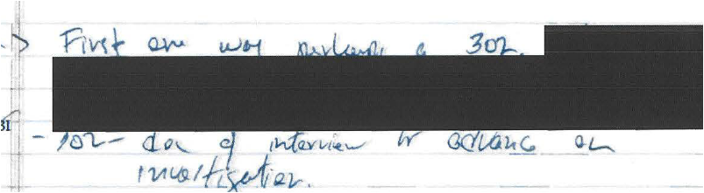

*People will be in physical jeopardy. We don’t turn over sources and methods. Source information.*

Q2 – authorized CI investigation – initial CI investigations Xxxxxxxxx

FBI will find paperwork. Predicating serial? w/ narrative answer of known to Director and subordinates

*Q2. D -*

Q3 – circular reporting question.

A: FBI- no. No connectivity b/w sources

*Q3- No*

*Q4 -*

Q5- who paid Fusion GPS. Did Xxxxxxxxxxxxxxxxxxxxx

Xxxxxxxxxxxxxxxxxxxxxx ever fund Fus GPS activities?

Source file – did not know law firm

Jon Moffa – briefed that xxxxxxxxxxxxxx and then

FBI: was an FBI source, so not as relevant that paid by others source + years of reliable reporting.

Counterargument => took them at face value

*Q5 – REDACTED. Jon Maffa “briefed” both Ds*

Q6= verification of dossier

SC – work is being directed

FBI – extensive efforts -> fact by fact

Xxxxxxxxxxxxxxxxxxxxxxxxxxxx

Xxxxxxxxxxxxxxxxxxxx

*Q6- can talk about efforts to verify ??? ??? fact. REDACTED*

*Q7-*

Q8- personnel. Will not talk about it.

Xxxxxxxxxxxxxxxxxxxxxxxxxxxx

Xxxxxxxxxxxxxxxxxxxx

*Q8 – Personnel matter.*

Q- defensive briefings

Used?? Re written reports

Unclassified for the most part

Script to use [at] the briefing => for just FBI part. Does not include IC element of the briefing

1. 8/17/16/ Trump, Christie, Flynn
2. VP – subsequent briefing in September

Id’d counties of concern: Russia, China

1. Trump, Pence, Clinton, Keane + staff: prior to election

Scott: can we run down who else was actually at the briefings?

Briefings: both campaigns

SOP, not b/c of specific investigation

Xxxxxxxxxxxxxxxxxxxxxxxxxxxx

Xxxxxxxxxxxxxxxxxxxx

FBI – precedential value of providing

Xxxxxxxxxxxxxxxxxxxxxxxxxxxx

Xxxxxxxxxxxxxxxxxxxx

1023 – xxxxxxxxxx reporting

Maybe opening EC

Defensive briefing

FBI Interviews – Requests

1. Ghattas
2. Rybicki

New Baker, Pete, Steinbach

*Aug 17 was candidate Trump, Christie, Flynn. Pence got same brief. Id’d countries. Staff briefings late Aug, early Sep*

*Clinton- probably didn’t take attendance. SOP. Not b/c Crossfire Hurricane.*

*REDACTED reporting not? Different?*

*Never given 1023s. Don’t want to open door*

*Document secure contact ??? info???*