WRITTEN SUBMISSION OF
STEPHEN McINTYRE
BEFORE THE
SUBCOMMITTEE ON OVERSIGHT AND INVESTIGATIONS,
ENERGY AND COMMERCE COMMITTEE
UNITED STATES HOUSE OF REPRESENTATIVES
July 27, 2006

SUMMARY

- little reliance can be placed on the original MBH reconstruction, various efforts to salvage it or similar multiproxy studies, even ones which do not use Mann’s principal components methodology;
- peer review as practiced by academic journals is insufficient due diligence for policy reliance. IPCC reports are only a literature review rather than independent due diligence.
- to enable and facilitate independent testing, paleoclimate research practices need to achieve dramatically improved standards for archiving data and code.
- administrative policies governing work directly funded by the U.S. government can make a direct and immediate difference.
Good morning, Mr Chairman and members of the Committee.
My name is Stephen McIntyre. I appreciate the invitation to appear before you once again. I will recapitulate my testimony from last week, making further reference to the NAS and Wegman reports.
The Wegman report drew attention to a remarkable lack of independence in the proxies used in supposedly “independent” studies. Some sites are used in nearly every study. This raises the spectre that problems with one proxy can spill over to multiple studies. One such situation has already been identified. The NAS panel agreed that strip-bark bristlecones should be “avoided in temperature reconstructions”. Last week, we showed that this reversed medieval-modern levels in the Crowley and Lowery 2000 reconstruction. Figure 1 below shows the impact on MBH, where conclusions of 20th century uniqueness do not withstand removing the bristlecones. Wegman showed that bristlecones were used in multiple studies and each one will have to be reconsidered in light of the NAS recommendation.
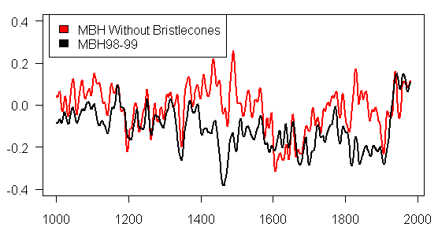
Figure 1. MBH99 reconstruction and estimate of MBH99-type reconstruction without bristlecones. 20-year gaussian smooth.
By coincidence, the key bristlecone and foxtail proxies that establish the pattern in Mann’s critical PC series are located in almost the exact area studied by Christy, as shown in the location map on the left. As you see, there is little correlation on either a smoothed or unsmoothed basis – actually a slight negative correlation – between temperature and Mann’s PC1. You can readily see why the NAS panel said that this data should be avoided as a temperature proxy.

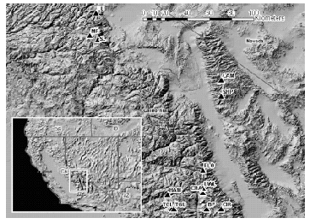 | 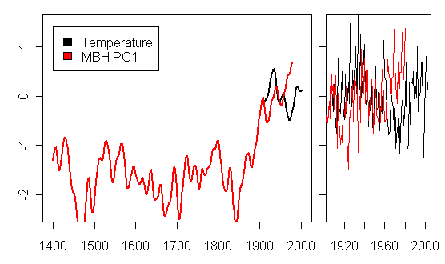
Figure 2. Left - location of foxtail and bristlecone sites in the Sierra Nevada and White Mountains. Right - Black – annual mean of maximum and minimum temperatures (data, Christy, pers. comm.); red – MBH98 NOAMER PC1.
Further grounds for concern about using Mann’s PC1 as a temperature proxy comes from the evidence of fossil trees well above modern tree lines, dated to the Medieval Warm Period. Millar et al. 2006 concluded that annual minimum temperatures in this area were then significantly warmer (+3.2 °C) than at present.
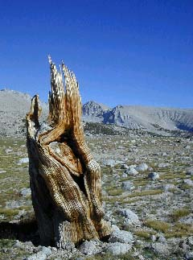
Figure 3. A dead trunk above current treeline from a foxtail pine that lived about 1000 years ago near Bighorn Plateau in Sequoia National Park.
Dr Mann likes to say that any problems do not arise simply from the flawed PC method. However, it’s not true that the flawed PC method has nothing to do with the problems. A simple average of Mann’s proxies does not yield a hockey stick shaped series, as shown in Figure 4 below. If you have proxies of ideal quality, even a bad PC method can yield meaningful results – which is what von Storch and Zorita observed, using idealized data generated in a climate model. However, the problem is that Mann’s PC method was applied to low-quality data, where the flawed method caused a minor pattern in bristlecones to be exaggerated as a “dominant pattern” in worldwide climate.
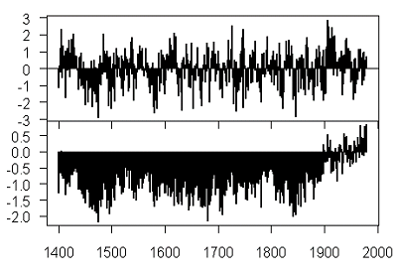
Figure 4. Left: Top – Average of all 415 MBH proxies; bottom – MBH reconstruction. Both in standard deviation units.

In the MBH data set, the hockey stick shape is dependent on the bristlecones. All the statistical salvage jobs Dr. Mann cites are variations on schemes to load the final weight on the very data the NAS panel said should not be used.
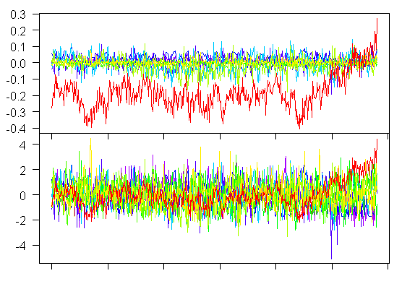
Figure 5. Top – Contribution (deg C) of proxy groups (proxy type x continent e.g. Asian tree rings; South American ice cores) to the MBH reconstruction, with bristlecones and foxtails in red. Bottom – Same series in standard deviation units. The bristlecone contribution closely matches the final MBH reconstruction.
There are many ways of processing the MBH data – some result in hockey-stick shaped series; some do not. Bürger and Cubasch 2005 showed a bewildering variety of outcomes based on slight variations in MBH methodology.

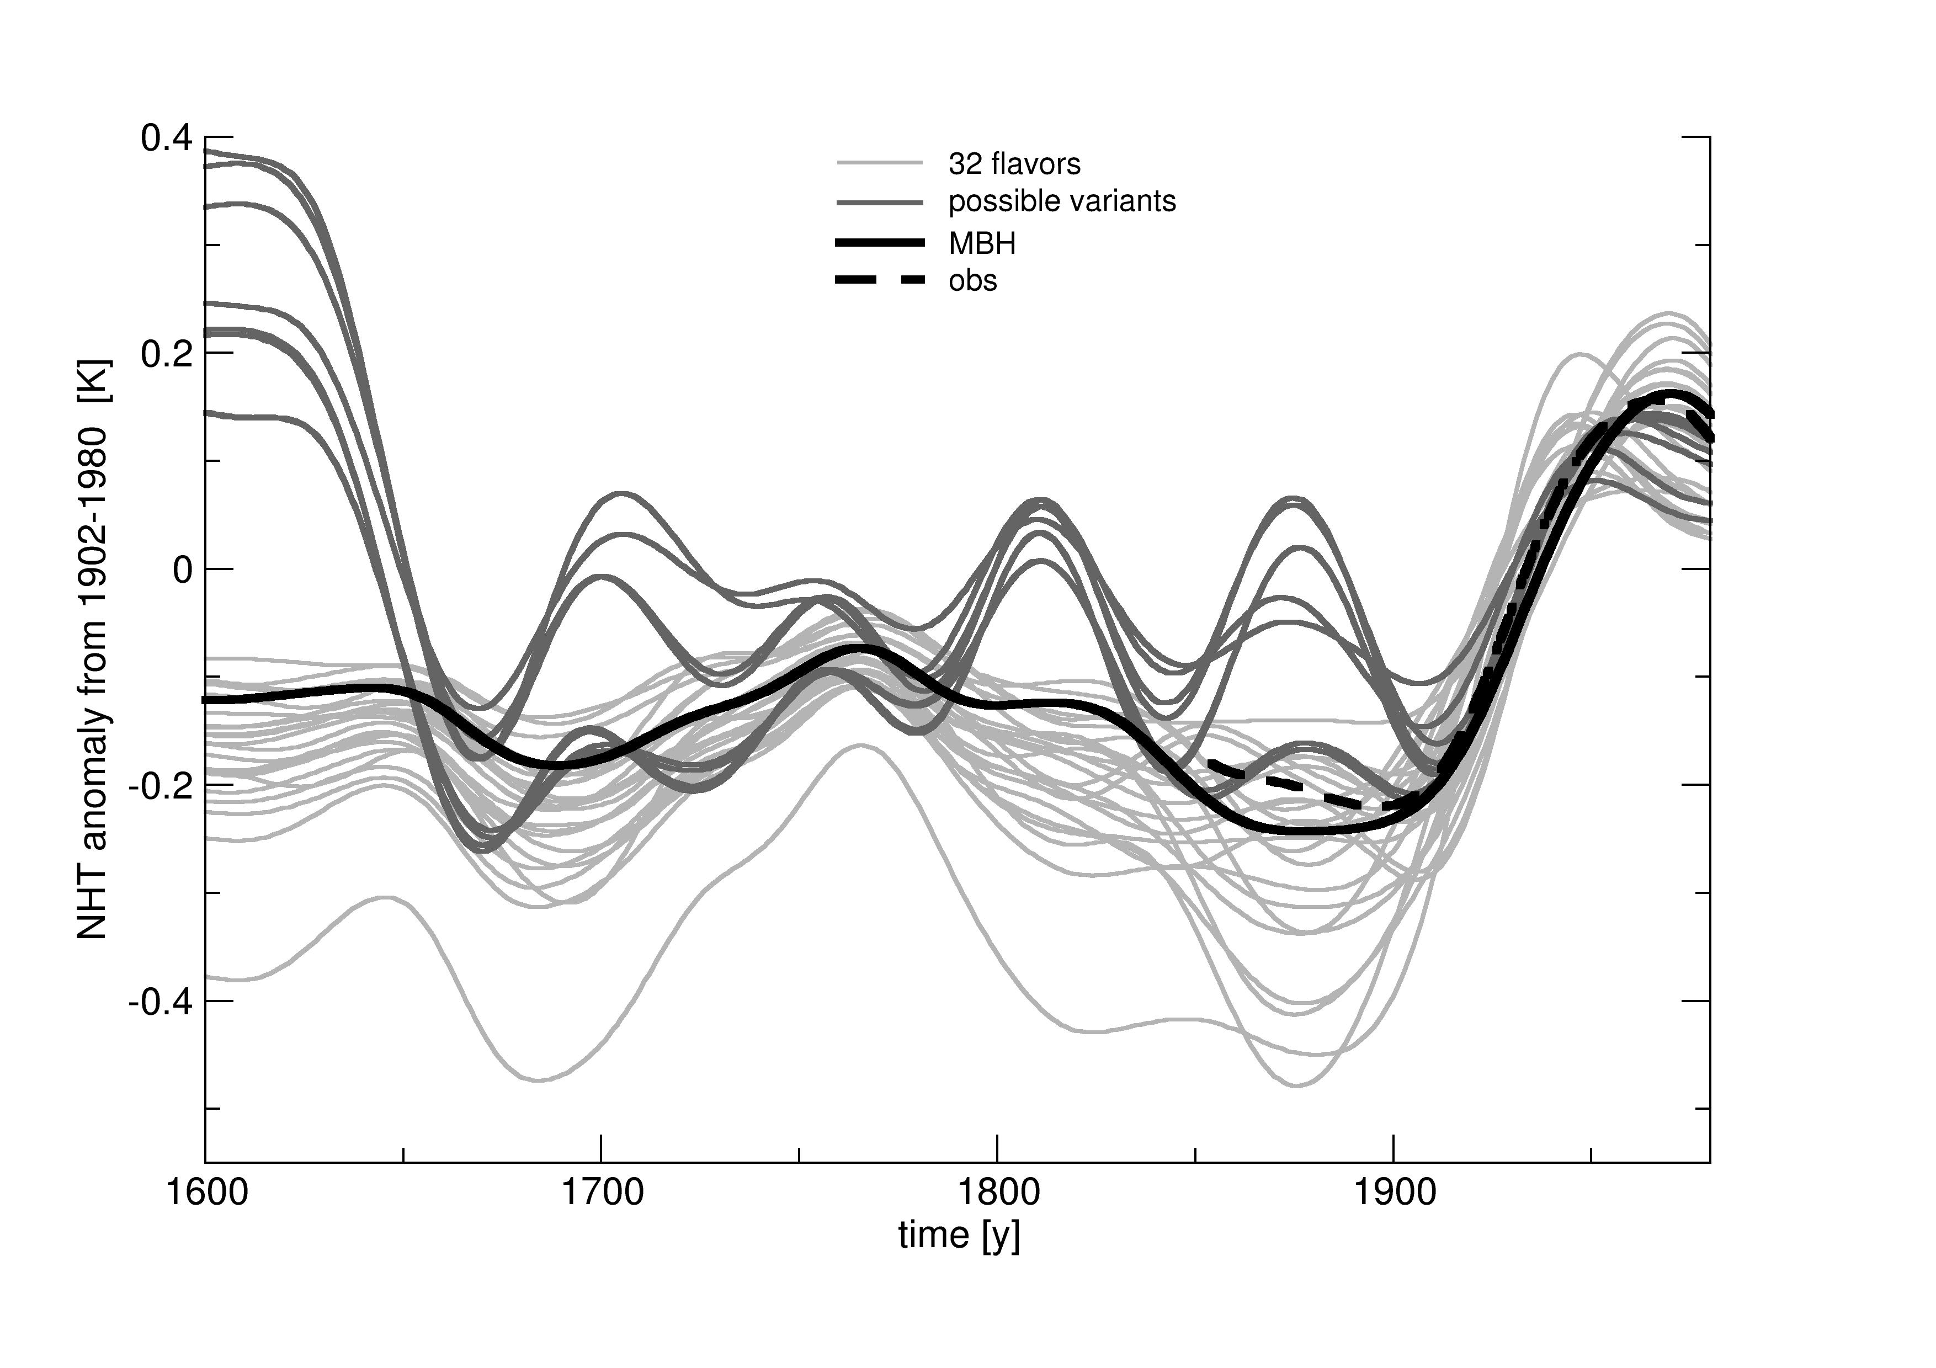
Figure 6: Different MBH-type results from slight methodological differences from Burger and Cubasch [2005] SI Figure 1.
Sometimes you’re told that scientists have “moved on” and that the methods criticized by Wegman and the NAS panel are no longer used. However, this is not the case. Rutherford et al., coauthored by Dr Mann and published in late 2005, used the identical PC method as the 1998 paper.
Although 415 individual proxy series were used, data reduction by using leading PCs of tree-ring networks results in a smaller set of 112 indicators in the multiproxy–PC network available back to 1820 (Fig. 1a), with a decreasing number of indicators available progressively further back in time. Twenty-two of the indicators (representing 95 individual proxy series) extend back to at least A.D. 1400.
Mann’s PC1 was also used in Osborn and Briffa 2006. And despite criticisms of the PC methodology by the NAS panel, they themselves used it, perhaps inadvertently, in one of their illustrations as a temperature proxy – see the top panel of Figure 6 of the NAS report.
An important control on any statistical study is reporting of adverse results. The verification r² statistic is commonly used in paleoclimate studies and was said to have been considered in MBH98. However, its early periods had insignificant values of this statistic, a fact that was never reported. At the NAS press conference, Dr Bloomfield said that he found nothing unusual about reporting of results in MBH. If paleoclimate research practices do not require scientists to disclose results adverse to their claims, then this reduces the ability of policy-makers to rely on these studies.

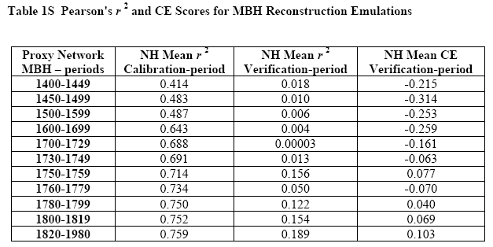
Source: Wahl and Ammann 2006.
Last week, we pointed out many problems with data and code access in paleoclimate. In the MBH case, much relevant data did not become available until the 2004 corrigendum, 6 years after the original study, and only then after a formal complaint to Nature. The efforts of your committee led to Dr Mann disclosing a considerable amount of source code. Unfortunately, as Dr Wegman reported to you, the source code does not work with any data sets presently archived and is inoperable. It also does not include code for some important steps, such as MBH99 confidence intervals or PC retention rules, which neither ourselves nor Wahl and Ammann have been able to replicate. Since Wahl and Ammann are recent coauthors and collaborators with Mann, their efforts hardly can be described as “independent” replication.
Dr Mann and his associates are by no means the worst in the paleoclimate field in archiving data. It is undoubtedly frustrating for Dr Mann to be the center of attention when many of his colleagues are much worse. For example, despite over 2 years of effort, I have been unsuccessful in learning what sites were used in one of three paleoclimate studies illustrated in the IPCC Third Assessment Report (Briffa et al 2001). These sites were recently been used by Mann and coauthors, who have also failed to even disclose the location of the sites.
The reason why data access and replication should be of concern to you is that:
- peer review at journals is very limited and does not constitute sufficient due diligence for policy reliance;
- IPCC does not carry out due diligence on articles.
- In order to properly assess a study, it needs to be replicated. Placing obstacles in the way of access to data and code makes this either impossible or simply impractical for people with less than infinite patience.
- Because much of the work is funded by the U.S. federal government, there are direct and practical steps that can be taken with NSF and DOE that would have an immediate impact in improving the quality of due diligence in this field.

