PSS Interview

P 1
FEDERAL BUREAU OF INVESTIGATION
Electronic Communication

Title: XXXXXX Interview of Igor Danchenko Date: 02/09/2017
From: xxxxxxxxx
-CD1

Contact: xxxxxxxxxxxxxxxxxxxxxxxxxxxxxxxxxxxxx

Approved By: xxxxxxxxxxxxxxxxxxxxx

Drafted By: xxxxxxxxxxxxxxxxxxxxxx
xxxxxxxxxxxxxxxxxxxxxxx

Case ID #: ****xxxxx xxxxxx Crossfire Hurricane;
FOREIGN AGENTS REGISTRATION ACT –
RUSSIA;
SENSITIVE INVESTIGATIVE MATTER
****XXXX 1234567890 DRAGON 1234
FOREIGN AGENTS REGISTRATION ACT –
RUSSIA;
SENSITIVE INVESTIGATIVE MATTER
****XXXX 1234567890 CROSSFIRE FURY
FOREIGN AGENTS REGISTRATION ACT–RUSSIA;
SENSITIVE INVESTIGATIVE MATTER

Synopsis: 12345678 Interview of Igor Danchenko. Danchenko was
interviewed for three days, this is a consolidated write-up of the
interview.

Full Investigation Initiated: 07/31/2016

Enclosure (s): Enclosed are the following items:
- 1234567 Info from Danchenko;
- (U) Proffer Agreement signed by Igor Danchenko

Pdf 4
xxxxxxxx During the course of three days, Igor xxxxxxxxx Danchenko
was interviewed in the FBI’s Washington Field Office (WFO) by FBI
personnel along with attorneys from the US Department of Justice,
National Security Division. Danchenko was accompanied by his attorney
Mark E. Schamel of Womble. Below is a consolidated write-up of the
three days of interviews.

24 January 2017 (1330-1700)

FBI Washington Field Office Interview Room
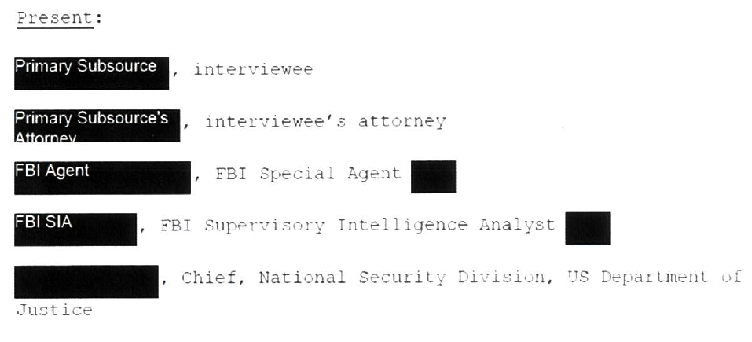
Present:
Igor Danchenko, interviewee
Mark E. Schamel, interviewee’s attorney
Stephen M. Somma, FBI Special Agent NYFO
Brian Auten, FBI Supervisory Intelligence Analyst WFO
David Laufman, Chief, National Security Division, US Department of
Justice

I. Danchenko’s Background

(U//FOUO) Danchenko was born in the Russian city of Perm on 05/05/1978.
He describes his family as mixed nationality which included Russian
and Ukrainian. Danchenko completed his high school course in Perm in
1996. He indicated that his xxxxxxxxxxxxxxxxxxxxxxxx is probably tied

Xxxxxxxxxxxxxxxxxxxxxxxx
Proficiency in languages

Pdf 5

to the fact that Perm was a 123456 city. During his high school years,
he traveled to the xxxxxxxxxxxxxxxxxxxxx for 1234567 and was also an
xxxxxxxxxxxxxxxxxxxxxxxxxxxxxxxxxxxxxx. In 199x-9y, he attended a high
school in xxxxxxxxxxxxxxxxxx. In 199z, he also spent some weeks in
xxxxxxxxxxxxxxxxxxxx, which at that time was “xxxxxxxxxxxxxxxxxxxx.”

(U//FOUO) For university, Danchenko attended Perm State University,
between 1996 and 2000, at which time he graduated with a degree in law.
Danchenko began work during and after college with a number of Russian
firms. He worked for PermTex (xxxxxxxxxxxxxxxxxxxxxxxxxxxxxxxxxxx),
xxxxxxxxxxxxxxxxxxxxxxxxxxxxxxxxxxxxxxxxxxxxxxxxxxxxxxxxxxxxxxxxx
xxxxxxxxxxxxxxxxxxxxxxxxxxxxxxxxxxxxxxxxxxxxxxxxxxxxxxxxxxxxxxxxxxxxxx
xxxxxxxxxxxxxxxxxxxx. While with PermTex, he made friends with a number
of individuals in the field of petroleum engineering. He was also
employed by a Siberian construction company, UralSubSoetStroy, during
which time he traveled to Iran. Also, during and immediately after his
time at Perm State University, he traveled to the United States with an
Open World Leadership Program and served as a facilitator. The Open
World Program is associated with the Library of Congress, and during
the 200x trip, he assisted and traveled with the delegation in DC and
other cities in the United States.

(U//FOUO) Danchenko’s desire had always been to obtain a graduate
degree in the United States. He applied to a number of schools, and
received the best – and one of the only – offers from the University of
Louisville. He said that his choice of Louisville didn’t involve
Xxxxxxxxxxxxxxxxxxxxxxxxxxxxxxxxxxxxxxxxxxx, but it just happened that
the school gave him a full fellowship for his Master’s studies in
Political Science. He graduated from Louisville and wanted to stay and
work in the United States, with the hope of getting his Ph.D. He
eventually was accepted not to a PhD program, but to Georgetown’s

1234567890123456789012
Perm State University
Open World Russian Leadership Program

Early in his career, Danchenko worked at Lukoil subsidiary Permtex in Perm and at UralSubSoetStroy in Iran.^{[dead link]} Between 1999 and 2005, he was a facilitator for the Open World Russian Leadership Program, US Library of Congress and a leader for senior Russian federal and regional delegations to the US
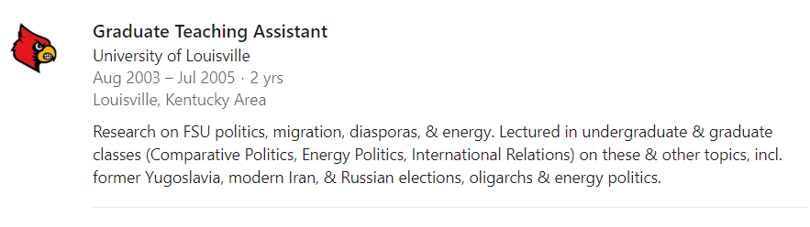
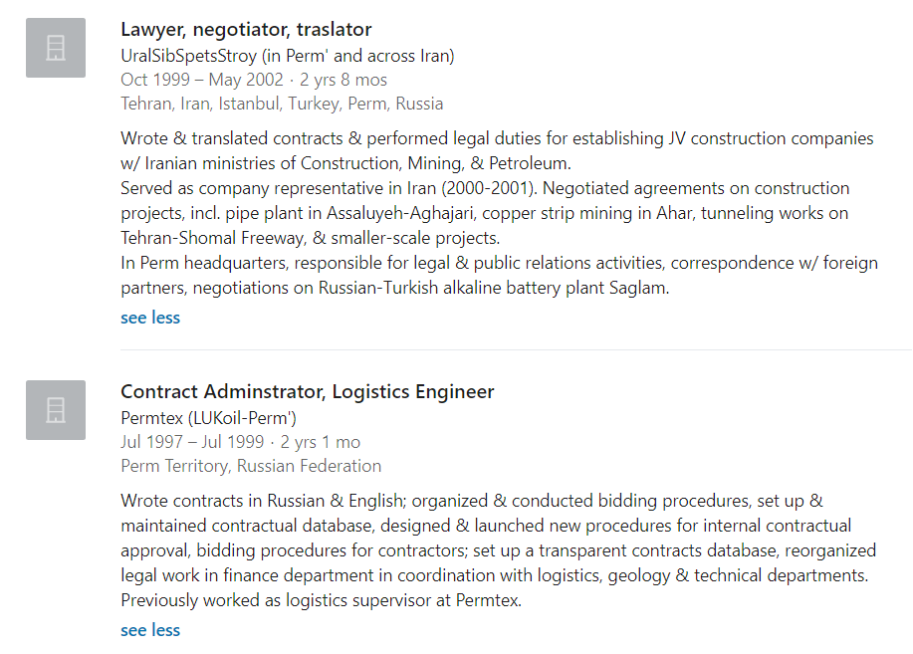
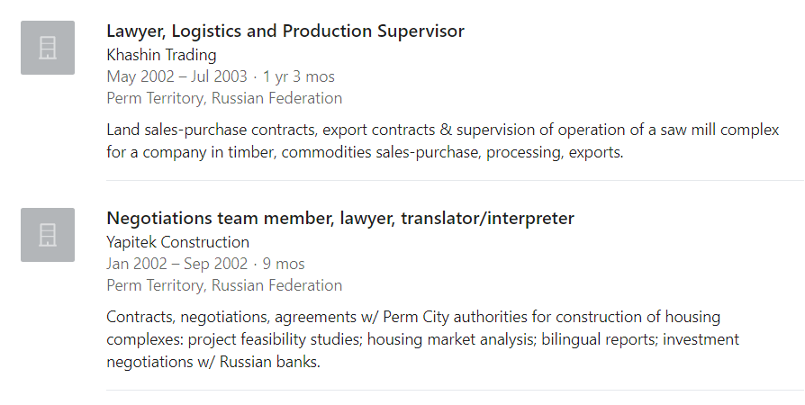
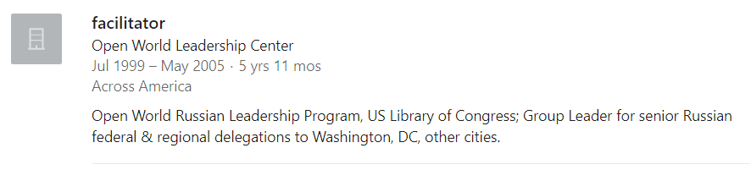

pdf, 6

School of Foreign Service - CERES xxxxxxxxx program with a focus on
Xxxxxxxxxxxxxxx and 1234567 (as he described it, xxxxxxxxxxxxxxxxx
1234567”). During and after his time at Georgetown University,
Danchenko worked at the Brookings Institute xxin varying ranks -
Analyst; and then Senior Analyst. He worked on research projects for
Fiona Hill and Clifford Gaddy. [ANALYST NOTE: Later in the debriefing,
Danchenko’s attorney asked if we’d all heard about Danchenko’s work on
uncovering Vladimir Putin’s thesis plagiarism. We indicated that we
had, and that it was our understanding that he had done that work with
Gaddy. Danchenko confirmed that.]

(U//FOUO) Danchenko explained that he soon hit a glass ceiling at
Brookings because of his nationality and his lack of a Ph.D. At that
time, he was also xxxxxxxxxxxxxxxxxxxxxxxx. Xxxxxxxxxxxxxxxxxxxxxxxx
Xxxxxxxxx, who was xxxxxxxx and was noted as xxxxxxxxxxxxxxxx on his M.A.
thesis. He left Brookings circa 2010, stayed xxxxxxxxxxxxxxxxxxxxxxxx in
Washington D.C. and began to try his hand at independent consulting.
For a time, he did various analytical pieces on Russian risk analysis
with Eurasia Consulting LLC. In time, some of the work moved into the
area of due diligence and business intelligence. Danchenko says that he
saw opportunities to use his existing network of friends and colleagues
in the United States and Russia – e.g. high school (Perm); 12345678
12345, 1234566789, xxxxxxxxxxxxxxxxxxxxxxxxxxxxxxxxxxxxxx. In 2011, he
began work for Sidar Global Ventures, again doing research and analysis
and due diligence work. At Sidar Global Ventures, he served as the
Russia and Eurasia Program Manager, which meant that he directed others
in doing business intelligence on various topics/sub-regions, including
Russia, xxxxxxxxxxxxxxxxxxxxxxx. He helped analysts under him figure
out how best to handle assignments and talk to clients. He also put
together weekly, bi-weekly and monthly reports. Danchenko worked for

Xxxxxxxxxxxxxxxxxxxxxx
1234567890123456789012
Eurasia Consulting LLC
Xxxxxxxxxxxxxxxxxxxxx
Russian risk analysis
Xxxxxxxxxxxxxxxxxxxxxxx
Ukraine, and Kazakhstan.

Jane’s
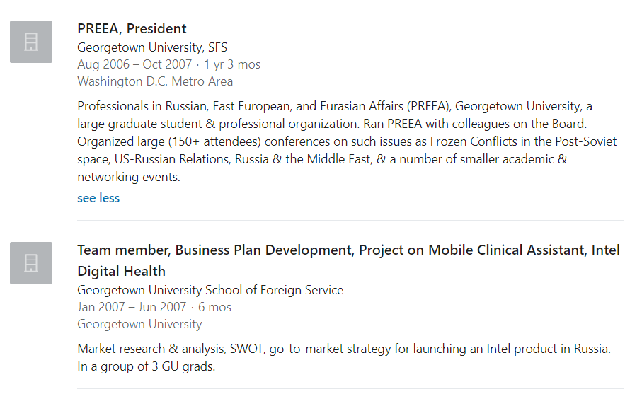

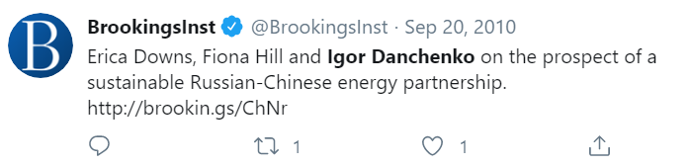
Nov 2009 Danchenko was back in the Perm region of Russia on November 7, 2009 and married 22yr old Elena Alekseevna on that date, and both were living in the US by some date in 2011. https://twitter.com/Larry_Beech/status/1310061947950333952 What I can also tell you is that on March 31st, 2017 (following round 2 of PSS interviews) Danchenko filed for divorce. Both appeared pro se, no attorneys, no dispute, no custody issues, no child dispute, and it was granted upon initial hearing 5/15/17.

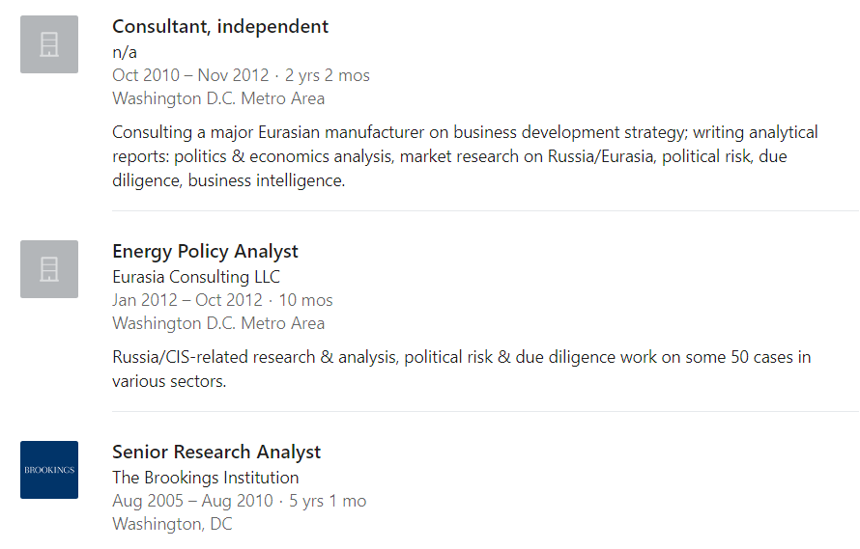
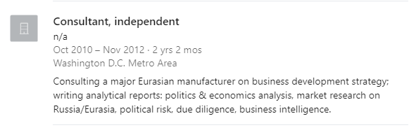
- Yaroslav Zhalilo Nataliya Lakiza Sachuk
- https://web.archive.org/web/20110201180515/https://www.eurasiaconsulting.com/
https://web.archive.org/web/20110130231943/http://www.eurasiaconsulting.com/page.asp?page_id=370
https://web.archive.org/web/20110130232010/http://www.eurasiaconsulting.com/page.asp?page_id=400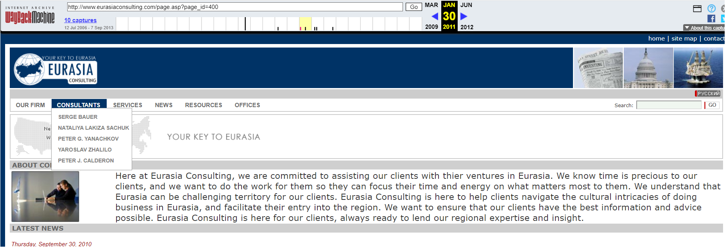
Zhalillo, Ukraine
Serge Bauer, Ukraine

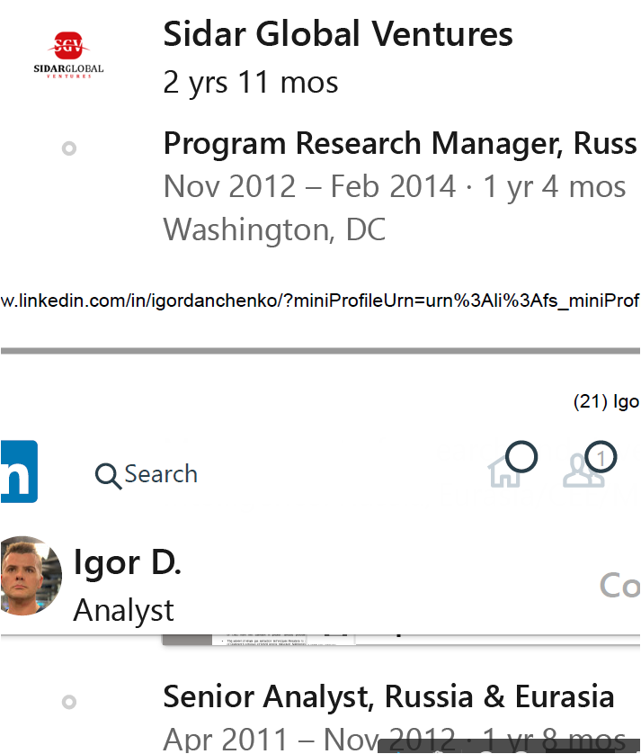
http://www.sidarglobal.com/ CEO Cenk Sidar,

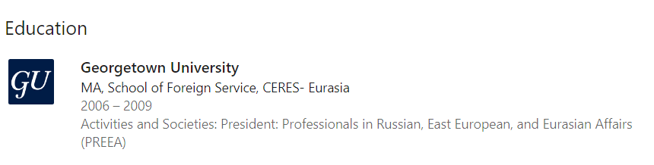

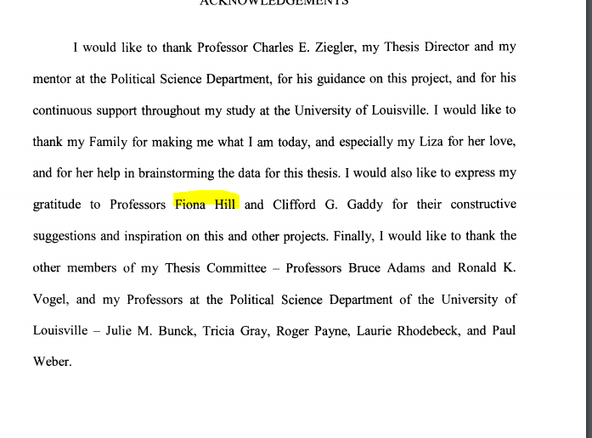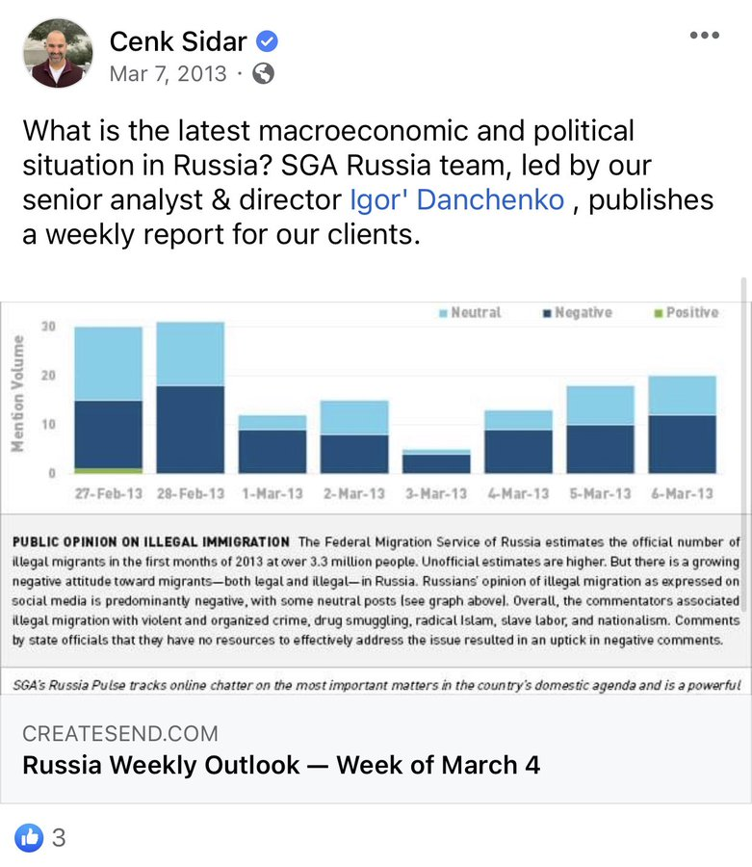

Pdf 7

Sidar through the summer of 2014, at which time Sidar’s parent company
went bankrupt and Sidar Global closed.

(U//FOUO) Danchenko described his travel to Russia up through the 2013
period as sporadic and personal. He took a trip back to Russia during
200x in order to do research for his Georgetown MA thesis. The rest of
his trips to Russia during this time – which he said took place every
two years or so – were centered on 12345678901234567, 12345678901 and
celebrating New Year’s.
1234567890123
Georgetown MA

II. Early Relationship with Steele and Orbis
II. Danchenko’s Early Relationship and Eventual Employment with
Christopher Steele and Orbis Business Intelligence
(U//FOUO) Danchenko first met Christopher Steele [hereafter Steele] in
the mid-to-late summer of 2010. The introduction was brokered through
Fiona Hill, who, according to Danchenko, was acquainted with Steele’s
wife. In the period that Danchenko was looking for work, following the
end of his tenure at Georgetown. Brookings was involved with helping
Danchenko to try and find new employment opportunities. Gaddy found out
that Steele was setting up a new business, Orbis, and that he was on
the lookout for analytical help. Gaddy suggested that Danchenko might
consider looking at Orbis, and helped to broker an email introduction
to Steele. According to Danchenko, this was just one of the companies
Gaddy helped to broker introductions.

(U//FOUO) Danchenko met in person with Steele at a Starbucks in
****xxxxxxxxx. They met for about an hour in the coffee shop, and then
went to Steele’s hotel, where they sat and talked for about 30 minutes.
Danchenko said that they really didn’t talk in-depth about Danchenko’s
background, but rather discussed Danchenko’s basic biographical

Pdf 8

Steele and Independent Consultant, 2010-2011
information, his contacts/network, and his connections in ****. No work
was offered at this time, but Steele said that “If we [Orbis] get a
project, we’ll get in touch.”

U//FOUO) In circa ****xxxxxxxxxxxxxxxxxxx, Steele contacted Danchenko
and asked that he fulfill a project – an open source analysis of what
Danchenko thought were three of the best sectors of low-risk investment
xxxxx****. Danchenko wrote a few pages, highlighting risks and
opportunities, and submitted them to Steele. Danchenko still wasn’t
sure at this time what Orbis’ primary focus was – he (Danchenko) said
that it was not clear if it was about due diligence and business
intelligence. For the short risk assessment report, Danchenko was paid
a few hundred dollars, direct-deposited into his account. He said he
was very appreciative of this, because he didn’t really have an income
at this time.

(U//FOUO) Later in 2011, Steele told him that he had read and liked his
risk assessment and Danchenko was formally brought on board with Orbis.
He signed a confidentiality agreement, which he didn’t think twice
about signing because it was fairly standard – he compared it to the
types of paperwork he signed at Brookings, including sexual harassment
policy, etc. All contact with Steele was being done at this time via
email and Skype. Danchenko signed the confidentiality agreement,
scanned it, and sent it back to Steele via email. Danchenko did not
sign a “non-compete” agreement with Orbis, and he described his work
with Orbis initially as “***x work” and “***x projects” as he was still
with ****xxxxxxxx. Orbis was just part of his overall portfolio at this
time.

(U//FOUO) Initially, his work with Orbis was in the open source sphere.

Pdf 9
He did not have any visibility into Orbis’ end clients. Danchenko
commented that during his time with Orbis, he was always been trying
to understand the tangible results of his work – Danchenko’s attorney
added that his client, “never asked, and was never told [about final
clients].” The project requirements were always kept vague with few
concrete parameters – e.g. “Can you do some checking on this?” Also,
initially with Orbis, his sole contact was with Steele He was in email
and Skype communication with Steele and was informally introduced to
other Orbis employees during Skype calls, but Danchenko was never flown
out to the UK to meet with Steele and his Orbis team.

(U//FOUO) In ****, Danchenko had his first Orbis-financed trip to
123456. His specific project involved inquiries about a ****xxxxxxxxxx
Xxxxxxx [which Danchenko did not name] and the company’s owner, which
he described as a former Russian senator and Duma deputy. It was a due
diligence assignment, and he was meant to look for company/management
links to organized crime and Russia’s regional and federal power
structures. For this, he was wired $3,000. He used $1,500 to purchase a
round-trip ticket, and $1,500 to cover expenses for the trip. He used
his existing contacts and daisy-chained from them to try to identify
others with relevant information. For example, Danchenko explained, he
would use pre-existing contacts to find out if anyone he knew had
worked in public relations or advertising for a ***xxxxxxxxxxx*.
Danchenko did not pay anyone for information, and reported back to
Steele verbally either via Skype or in-person in London.

(U//FOUO) In circa 201x-xy, Danchenko traveled for the first time in
his life to the United Kingdom. It was both a personal trip and a
business trip. Orbis paid for the trip, and during his time in the UK,
Danchenko met Steele – “for the second or third time in my life” - and

pdf 10
also introduced to other Orbis employees, including James Wallis and
Kieran Porter, about whom Danchenko described as an analyst who had
graduated from an English university. Danchenko described the time with
Orbis as “general meetings, [pitching] potential projects, and
discussing general rumors about Putin and Putin’s new third term as
president. There was talk about what the “biggest rumors” or the
“biggest compromising info” regarding the Russian government was.

(U//FOUO) Danchenko could not remember exactly when he had first
learned that Steele was former MI-6. He thought it was around 2012 or
2013. He couldn’t remember if someone told him that fact, someone
mentioned it, or if it was just “common knowledge” that he had picked
up over time. [ANALYST NOTE: In discussing his knowledge of Steele’s
former intelligence service employment, Danchenko remarked that he
didn’t really care to know such things and wanted to “stay out of the
government’s business” – to which his attorney said, “Well, you haven’t
done a very good job of that.”]

(U//FOUO) Danchenko continued to work on a number of projects for Orbis
on all kinds of subjects, including Russian leadership, banking, and
the ****xxxxxxxxxxxx. He would provide reports every month or every
other month.

Sidar Global
(U//FOUO) Through Danchenko, Sidar Global and Orbis were in a
contractual relationship, and it was Danchenko’s hope that 1234567
Xxxxxxxxxxxxxxxxxxxxxxxxxxxxx would result in 12345678901234’s and
Danchenko’s eventual ability to get a security clearance and set up his
own business. However, with the 2013 bankruptcy of Sidar Global’s
parent company – and the subsequent closing of Sidar Global itself –
Danchenko found himself in a difficult situation, 1234567890123456. He

Sarah Wolff
James Wallis – from Apelbaum on character count
Sam Stainer, Tyson Lee
Elliot Bull
Tatiana Duran
Samuel Stainer
Sam Steiner
https://apelbaum.files.wordpress.com/2018/06/kieran-porter-orbis-and-walsingham-training4.jpg

Sidar Global
123456789012
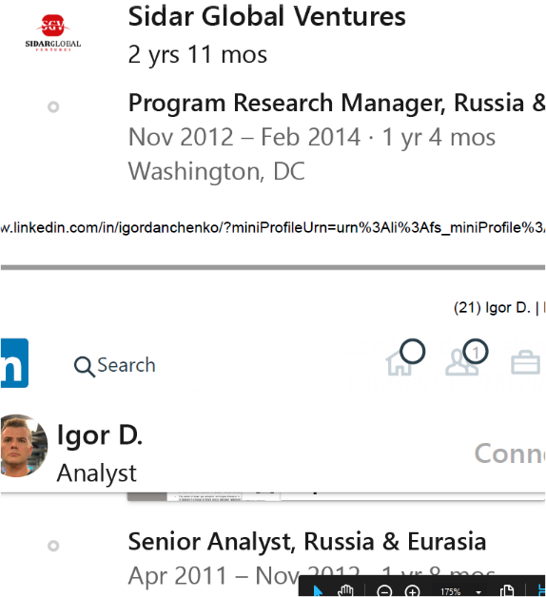

https://www.courtlistener.com/recap/gov.uscourts.mdd.232497/gov.uscourts.mdd.232497.10.0.pdf
May 23 disorderly
Mr. Danchenko is employed by Sidar Global Advisors, as a Development Manager
he is legally present in the United States on a work visa, and currently residing in the District of Columbia with his wife and 2-year old daughter.
Mr. Danchenko had prearranged travel to Moscow, Russia, and Munich, Germany, between the dates of May 20, 2013, and June 9, 2013.
https://www.courtlistener.com/docket/13073488/united-states-v-danchenko/
1234567890123456
Target Labs Inc.
Larry Poltavtsev
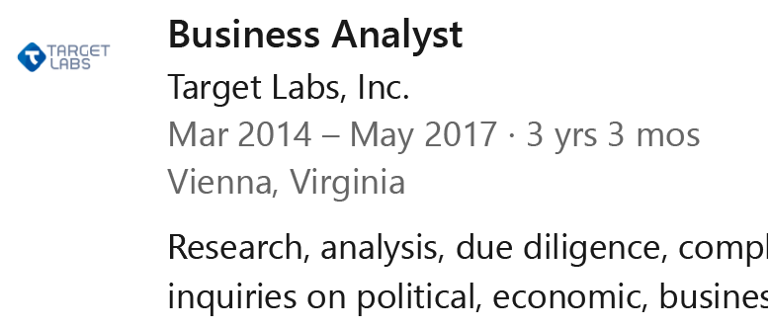
https://www.washingtonblade.com/2013/07/25/opinion-larry-poltavtsev-putin-empire-of-hatred-and-violence-russia-gay-lgbt/ lARRY POLTAVTSEV

p.11

Target Labs 2014-03 to 2017-05

needed an entity to xxxxxxxxxxxxxxxxxxxxxxxxxxxxxxxx – and as Orbis
couldn’t do it [as Danchenko’s attorney put it, because Orbis was a
British company] – Danchenko went to a friend, Larry Poltavtsev, who is
the Chief Executive Officer, Target Labs Inc. Poltavtsev was
receptive about bringing Danchenko on board with Target Lab but said
that they could only help him out if he had a source of income. At that
point, Danchenko introduced Steele and Poltavtsev and a formal
arrangement was set up between Orbis and Target Labs. Target Labs
served as the “contract vehicle” through which Danchenko would be paid
a monthly salary for his work for Orbis. Danchenko became a salaried
employee of Target Labs and xxxxxxxxxxx xxxxxxxxx his xxxxxxxxxxx
Danchenko. Out of the approximately xxx people employed at Target Labs,
Danchenko was the only one – as far as he knows – who was working
solely for Orbis, and Danchenko believes that only Poltavtsev knows of
his work for Orbis. Prior to this arrangement, the only paperwork tie
between Danchenko and Orbis was through the banking/wire transactions,
but after this, the only regular paperwork tie would be between
Danchenko and Target Labs. Danchenko said that he received after
deductions, etc. about $x000 in cash/month. [ANALYST NOTE: Danchenko
also gave a figure of $y000/month, but is not clear how much Target
Labs charges Orbis for Danchenko’s services, which would indicate the
profit Target Labs makes from Danchenko’s Orbis-related work.] Since
Danchenko is on a monthly salary with Target Labs, Steele can reach out
directly, give assignments and direct his (Danchenko’s) travel.

III Policies and Procedures
III. Danchenko Policies and Procedures While Traveling Abroad for
Orbis; Danchenko Contacts with Russian Intelligence and
Security Services

(U//FOUO) Danchenko was asked how he “covers” his queries with his

12
sources. He typically tells his sources that he is working on a
research project or an analytical product. He was also asked if there
were friends, associates and/or sources who knew that he was collecting information for Orbis. He said “yes and no,” and explained that some of
his closer friends understand that he works in the area of due
diligence and business intelligence. Many of them think that he is
doing projects for entities like ****xxxxxxxxxx, the ****xxxxxxxxxxxxx
xxxxxxxxxxxxxxxxxxxxxxxxxxxxxxxxxxxxxxx or think tanks ****xxxxxxxxx.
They don’t know that he works for Orbis, as he signed a non-disclosure
agreement and was told not to talk about the company. He has never
mentioned Chris Steele or Orbis to his friends and associates. He
emphasized that “you [the FBI] are the first people he’s told.”

(U//FOUO) Danchenko was asked if he takes notes on the information he
is collecting from his sources, or if he keeps any kind of records. He
was told by Steele that it is a security risk to take notes; he hasn’t
kept notes or electronic records. He occasionally makes scribbles
and/or chicken scratch notes here and there, but gives verbal debriefs
in ****xxxxxxxxxxxxxx following his trips to Russia. Altogether, with
respect to the election-related reporting, he had three trips ****xxxxxx
xxxxxxxxxxxxxxxxxxxxxxxxxxxxxxxxxxxxxxxxxxxxxxxx****. Xxxxxxxxxxxxxxxxx
xxxxxxxxxxxxxxxxxxxxxxxxxxxxxxxxxxxxxxxxxxxxxxxxxxxx. He also had one
additional United Kingdom trip. While ****xxxx, he was primarily *x
xxx***.

(U//FOUO) Danchenko had no communications with Steele while in Russia.
He was always advised by Steele that they were not to have
communications, or to minimize communications, saving them for only
emergency or urgent matters.

13
(U//FOUO) During the conversation about Sergei Abyshev [see below],
Danchenko was asked if Orbis had ever asked him to broker direct
contact with one of his (Danchenko’s) sources, or whether Orbis was
comfortable keeping Danchenko as the intermediary between the sources
and the company. Danchenko indicated that Orbis has always kept him
(Danchenko) as the intermediary.

(U//FOUO) Danchenko indicated that, to his knowledge, he has not had
any contacts with the Russian intelligence or security services. [ANALY
ST NOTE: His attorney emphasized “to his knowledge” during this part of
the discussion.] Danchenko said that he had contacts with Russian
government officials ****xxxxxxxxxxxxxxxxxxxxxxxx, as he said, in the
xxxxxxxxxxxxx**** - but he denied any contact – again, “as far as he
(Danchenko) knew,” with anyone in the SVR, GRU or FSB.

IV. Initial Election-Related Assignments for Orbis
(U//FOUO) Around March 2016, Danchenko and Chris Steele had a voice
conversation during which time Steele asked Danchenko to see what he
(Danchenko) could find out about Paul Manafort, including his
reputation in the United States, his connections to the Yanukovich regime
in Ukraine, and any corruption ties. He related some of Steele’s
corruption-related questions – “Do you know [about] Manafort? Find out
about Manafort’s dealings with Ukraine, his dealings with other
countries, and any corrupt schemes [to which Manafort is connected].”
Danchenko said that he was “clueless” about who Manafort was, and that
this was a “strange task” to have been given. It was strange because
Danchenko had not done US-related projects for Orbis before, and he was
a bit uncomfortable working on a topic dealing with U.S. elections.
Steele did not give him a tight deadline on this assignment. At this

12345678901234
U.S. elections

14
point, Danchenko was on salary with Orbis through Target Labs, and
there was no difference in financial remuneration for this assignment.
He had no inclinations as to why, or for whom, Steele was asking about
Manafort. Danchenko carefully asked around some of his American
friends. He said he may have asked friends and contacts in Russia, but
he couldn’t remember off-hand. He added that, for this topic, his
friends and contacts in Russia couldn’t say very much because they were
“too far removed” from the matter. Danchenko recalled that he was able
to find articles about Manafort’s ties to Ukraine and the Philippines.
Danchenko reported some of the findings on this assignment to Steele
using Signal, a secure messenger app, which he has used, in addition to
Skype, for communicating with Steele.

(U//FOUO) In the last week of ****5678901234567890123, Danchenko took
an Orbis-related trip to Russia. He was working primarily on a business
intelligence matter – a**** Zzzzzzzzzzzzzzzzzzzzxxxxxxxxxxxx. 12345678
zzzzzzzzzzzzzzzzzzzzzzzzzzzzzz. For this trip, Chris also asked
Danchenko to look for information dealing with the US presidential
election, including compromising materials on Donald Trump. Danchenko
said he could not remember if Steele had asked Danchenko to ask around
for compromising materials on just Trump, or Trump and Hillary Clinton
– at which point Danchenko’s attorney indicated that Danchenko had told
him [the attorney] previously that it had been both presidential
candidates. The request did not shock Danchenko, but it was – again –
outside the normal scope of work and it wasn’t completely comfortable
for him. Like the Manafort assignment, it was not really a
Russia-specific job and it involved, indirectly, his “xxxxxxxxxxxxxxx
xxxxxxxxxxxxxx.” He was nervous and cautious when asking around about
the topic in Russia, but he felt like he had to report something back
to Steele about it. Steele did not place any higher priority on the

15
election-related requirements; it was still a side effort to the
****xxxxxxxxxxxxxxxxxxxxxx. It was, to Danchenko, “unpleasant,” but he
made inquiries and had a few election-related conversations, but it
wasn’t the main focus of his trip.

V. Danchenko’s Contacts on his June Trip to Russia

Source 2 - Ivan Mikhailovich Vorontsov

(U//FOUO) Ivan Mikhailovich Vorontsov
(U//FOUO) Ivan Mikhailovich Vorontsov is in his mid-forties, probably
around forty-five. Danchenko has known Vorontsov for about ten
years. They first met at a xxxxxxxxxxxxxxxxxxxxxxxxxxxxxxxxxxxxxxx,
xxxxxxxxxxxxxxxxxxxxxx. They were together at the xxxxxx and struck
it off well. He is now a good friend. Vorontsov comes from a xxxxx
xxxxxxxxxxxxxxxxxxxxxxxxxxxxxxxxx and, more distantly, xxxxxxxx.
Vorontsov himself is a xxxxxxxxxxxxxxxxxxxxxxxxxxxxxxxxxxxxx, and a
xxxxxxxxxxxxxxxxxxxxxxxxxxxxxxxxx. He runs his own Facebook page, and has
served as xxxxxxxxxxxxxxxxxxxxxxxxxxx of two different xxxxxxx
xxxxxxxxxxxxxxxxxxxxxxxxxxxxxxxxxxxxxxxxxxxxxxxxxxxxxxxxxxxxxxx. He is
xxxxxxx. He has been Danchenko’s source of information regarding
economic sanctions, and actions taken by xxxxxxxxxxxxxxxxxxxxxxxxxxxxxx
xxxxxxxxxxxxxxxxxxxxxxxxxx – a friend of 1234’s - knows a 123
xxxxxxxxxxxxxxxxxx handling the company’s public and governmental
relations (PR/GR). Another of Vorontsov’s close friends works as a
xxxxxxxxxxxxxxxxxxxxxxxxxxxxxxxxxxxxxxxxxxxxxxxxxxxxxxxxxxxxxxxxxx
xxxxxxxx. Vorontsov is an avid collector of foreign currencies. He
often tries to monetize his relationship with Danchenko, suggesting
that the two of them should try and do projects together for money.
Vorontov told Danchenko that there was compromising material on Trump.

Xxxxxxxxxxxxxxxxxxxxxxxxxxx****
Collector of foreign currencies

Source 3
(U//FOUO) Olga xxxxxxxxxxx Galkina

16

(U//FOUO) Olga Galkina was born in 1234567890123456. She is a close
personal friend to Danchenko. She is originally from Perm, and then
xxxxxxxxxxxxxxxxxxxxxxx. They have been friends since [the equivalent
of] the 8th grade xxxxxxx – xxxxxxxxxxxxxxxxxxxxx. Upon reflection,
Danchenko corrected himself, indicating that she had been a year behind
him in the Perm State University Medical School. She moved to Moscow in
20xx, where she worked in the 1234567890 field. She did a bit of
Xxxxxxxxxxxxx, worked in xxxxxxxxx, and also xxxxxxxxxxxxxxxxx
xxxxxxxxxxxxxxx. She went to the xxxxxxxxxxxxxxxxxxxxxxxxxxx [ANALYST NOTE:
what is now called xxxxxxxxxxxxxxxxxxxxxxxxxxxxxxxxxxxxxx, where she took
1234567 as her first language, 1234567 as her second language, and also
studied Bulgarian. Danchenko added that Galkina’s family has a vacation
home in Bulgaria. Galkina worked for 123456789x, xxxxxxxxxxxxxxxx,
xxxxxxxxxxxxxxxxxxxxxxxxxxxxxxxxxxxxxxxxxxxxxxxxxxxxxxxxxx. In the
xxxxxxxxx, Galkina moved to 123456, where she served as 1234567
xxxxxxxxxxxxxxxxxxxxxxxxxxx. For about a year now, Galkina has lived in
Limassol, Cyprus. Danchenko said that he was not exactly sure what
she does now in Cyprus, but she has done ****xxxxxxxxxxxxxx and
works ****xxxxxxxxxxx, a Russian ****xxxxxxxxxxxxxxxxx.

(U//FOUO) Galkina and Danchenko have remained friends for many years.
her father helped him financially years ago – he would borrow money
from her father, and her father wouldn’t ask for repayment. More
recently, he has helped out Galkina financially – probably around
$x0,000 over the past ten years.

(U//FOUO) Galkina has a vast network of people who are employed in the
xxxxxxxxxxxxxxxxxxxxxxxxxxxxxxxxxxxxxxxxxxxxxxxxxxxxxx****. Through
Galkina’s ****xxxxxxxxxxxxxxx, Danchenko has been able to collect

17
information for Orbis across a wide range of topics – major Russian
firms; Russian state entities, including the Kremlin. GALKINA’s “big
connection” – though Danchenko emphasized that it is not necessarily her direct contact – is ****xxxxxxxxxxxxxxxxxxxxxxxxxxxxxxxxxxxxxxxxxxxx
xxxxxxxxxxxxxxxxxxxxxxxxxxxxxxxxxxxxxxxxxxxx. GALKINA may have met him in
person, but she knows a couple of ****xxxxxxxxx who have good access to
123456 and upon whom 123456 has relied to get out his own messaging.
Danchenko wasn’t sure, but he thought these contacts may include
xxxxxxxxxxxxxxxxxxxxxxxxxx**** who Danchenko met while he was at
****xxxxx and who used to head ****xxxxxxxxxx.

(U//FOUO) Through GALKINA, Danchenko has also become good friends with
the ****xxxxxxxxxxxxxxxxxxxxxxxxxxxxxxxxxx, who was assaulted in Russia
for ****xxxxxxx.

(U//FOUO) Galkina is one of the individuals who knows that Danchenko
works for due diligence and business intelligence. [As an aside at this
point, Danchenko insisted that Ivan xVorontsov probably has a better
idea about this than does Galkina because Ivan is always trying to
monetize his relationship with Danchenko. Danchenko reiterated again to
the interviewers that Ivan will often pitch money-making ideas or
projects – “Let’s work together. I (Ivan) can try and get 12345678 to

(U//FOUO) Galkina is one of the individuals who knows that Danchenko
works for due diligence and business intelligence. [As an aside at this
point, Danchenko insisted that 1234567890 1234 probably has a better
idea about this than does Galkina because 1234 is always trying to
monetize his relationship with Danchenko. Danchenko reiterated again to
the interviewers that 1234 will often pitch money-making ideas or
projects – “Let’s work together. I (1234) can try and get 12345678 to
answer a question, but I’ll need some money to do it.”] GALKINA has an understanding that Danchenko is “connected.” In fact, either yesterday
morning or this morning, Galkina reached out to Danchenko and asked him
for help in translating article on how Russian citizens living in the
United States are viewing the Trump administration. She is asking him
to translate it by the weekend, probably so she can sell it to a friend
in Moscow.

18

(U//FOUO) GALKINA was one of the key sources for the “Trump dossier.”
She is directly quoted at points; however, Danchenko is not sure if she
realizes that the questions come from her. Right now, ****xxxxxxxxxxxxx
xxxxxxxxxxxxxxxxxxxxxxxxxxxxxxxxxxxx. She is keeping ****xxxxx with her
xxxxxxxxxxxxxxxxxxxxxxx****. GALKINA used to work in the country of
****xxxxxxxxxxxxxxxxxxxxxx.

Source 4

(U//FOUO) Alexey 123456 Dundich
(U//FOUO) Dundich1is a xxxxxxxxxxxxxxxxx. He is xxxxxxx
XxxxxXxxxxxxxxxxxxxxxxxxxxxxxxxxx. Danchenko met him while he was on an
exchange scholar program at xxxxxxxxxxxxxxxxxxxxxxxxxxxxxx
Xxxxxxxxxxxxxxxxxxxxxxxxxxxx for about x months in 2009-10.
Danchenko spent a lot of time with Dundich during Dundich’s time in
United States.

(U//FOUO) 1234567 specializes in regional politics, particularly
Xxxxxxxxxxxx, but also addresses US-Russian relations, US elections,
and a host of issues involving US-Russian competition and conflict,
including xxxxxxxxxxxxxxxxxxxxxxxxxxxxxxxxxxxxxxxxxxxxxxxxxxxxxxxx
xxxxxxxxx).

(U//FOUO) 1234567’s everyday job duties as a xxxxxxxxxxxxxxxxxxxx
vary. One day, he could be xxxxxxxxxxxxxxxx for a visiting 12345
1234567; the next day, he could be xxxxxxxx a large group of 1234566;
While the next, he could be handling xxxxxxxxxxxx. At 1234, he also
Has contact with friends and associates in the xxxxxxxxxx. As
Danchenko explained, it would not be uncommon for Dundich to remark to
Danchenko things like, “I just heard such-and-such from someone in the

pdf 19
**** ****xxxxxxxxxxxxxxxxxxxxxxxxxxxxxxxxxxxxxxxxxxxxxxxx,” or “I just
heard this from a Deputy Minister,” or “I just overheard such-and-such
about an issue.”

(U//FOUO) Danchenko and Dundich drink heavily together, and Danchenko
always looks forward to getting together with Dundich when Danchenko is
in town. Danchenko knows that Dundich travels to the U.S.

Source 1

(U//FOUO) Sergey Vladimirovich Abyshev
(U//FOUO) Danchenko has known Abyshev since late 2001-02, when
Abyshev was part of a xxxxxxxxxxxxxxxxxxxxxxxxxxxxxxxxxxxxx
xxxxxxxxxx. He has visited both Louisville and Washington DC as part of
exchange visits to the United States. Abyshev is about xx years old and
comes from Nizhniy Novgorod, where he served in city and regional
government positions, including 123456789012345678901234 and Deputy
Mayor. Danchenko explained that things did not work out well for
Abyshev in St. Petersburg, so he moved to Moscow and began working in
the 12345678901234567890123 – particularly with respect to 12345678
1234567890123456789012345678901. From the xxxxxxxxxxxxxxxxxxxxxxxxxxx
20xx, Abyshev worked for Russian Ministry of Energy. Over the last few
years, he had served in the capacity of 12345678901234567.

(U//FOUO) Abyshev’s background as a former ****xxxxxxxxxxx means that,
from a young age, he has been involved in political activities. He’s
been in some form of politics since he was a teenager. He is also a
****xxxxxxxxxxxxxxxxxxxxxxxxxxxxxxxxxxxxxxxxxxxxxxxxxxxxxxxxx but
Danchenko could not recall if it was in economics, political science or philosophy. Danchenko has been taking politics with Abyshev since his (Danchenko’s) days as a graduate student at the University of
Louisville. Now, they meet together whenever Danchenko goes to Moscow.

Russian Federation
Federal Antimonoply Service
1234567890123456789012345
Chairman of the City Duma
An Open World program at the Library of Congress
Leningrad Oblast
Nizhniy Novgorod
Russian Ministry of Energy of the Russian Federation
deputy director
12345678901234567
Assistant director
123456789012345
Communist cadre
Youth Union
Xxxxxxxxxxxxxxxxxxxxxxxxxxxxxxxxxxxxxxxxxxxxxxxxxxxxxxxxxxxxxx
graduate of Moscow State Institute of International Relations
former undergraduate at Barnaul State Pedagogical Institute

20
(U//FOUO) Orbis knows more about Abyshev because, as a favor to
Abyshev, Danchenko reached out to Orbis to see if Orbis could help get
Abyshev’s oldest daughter a scholarship for language courses in the
United Kingdom. Abyshev asked Danchenko for assistance, and Danchenko
turned to Orbis for help. As part of this, Danchenko explained who
Abyshev was, and why Danchenko was asking Orbis for assistance.

(U//FOUO) Abyshev is always trying to get Danchenko to start projects
and make money together. Danchenko related how Abyshev, like others,
is always asking questions like, “Can you get us some projects?” or
“Can you get us financing?” or “Let’s do something together dealing
with 123456789!” Danchenko doesn’t consider this as his source
“tasking him” but as simply the normal course and scope of networking
In these circles. Danchenko did help Abyshev with an academic book
about xxxxxxxxxxxxxxxxxxxxxxxxxxxxxxxxxxxxxxxxxxxxxxxxxxxxxxxxxxxxxx. He
made about xxxxxx for his assistance with the academic book. For it,
Danchenko went to the Library of Congress, performed archival research,
and also talked to academics he (Danchenko) knew.”

(U//FOUO) Danchenko knows that Abyshev travels to the United States.

Trubnikov
(U//FOUO) Abyshev has a good relationship with a former director of the
FSB, Vyacheslav Trubnikov. Abyshev considers Trubnikov a good friend,
and he (Abyshev) hears, from Trubnikov, many things about, and from,
Trubnikov’s circles. From Abyshev’s relationship with Trubnikov,
Danchenko has been able to collect information of interest to Orbis,
including Russian domestic politics and more specialized subjects like
xxxxxxxxxxxxxxxxxxx. Danchenko understands that Abyshev’s relationship
with Trubnikov stems from Abyshev’s tenure in St. Petersburg. There,
Abyshev had contacts with the regional Federal Security Service (FSB),

123456789012345678901234567890
Vyacheslav Ivanovich Trubnikov
1234567890123456789012345
FSB, Vyacheslav Trubnikov
123456789012345678901234
A former director of the

21
as well as with individuals in the 123456789 who were associated with
politically conservative and strongly Russian 12345678 circles. It was
through these connections that Abyshev was introduced to Trubnikov.
Danchenko was asked if Abyshev was a devout Orthodox believer.
Danchenko did not believe so, but thought that he might have been at
the time.
12345678
Religious
Orthodox

(U//FOUO) Danchenko has never met Trubnikov. He’s never been to one of
Xxxxxxxxxxxxxxxxxxxxxxxxxxx, and said that he doesn’t believe he’s ever
been in the same room as Trubnikov.
Xxxxxxxxxxxxxxxxxxxxxxxxxxx
Trubnikov’s public lectures

Source 5 Details
(U//FOUO) Lyudmila xxxxxxxxx Podobedeva
(U//FOUO) Podobedeva1is an xxxxxxxxxxxxxxxxx. Danchenko has met her in
person, and they are also connected through Galkina. They have been
friends xxxxxxxxxxx for about ten years. They have many mutual Russian
friends. She is tied to Russia’s 123456789012345, and she has ties to
the 123456789012345678901, as well as ties to the Russian intelligence
and security services. Danchenko remarked that things have become
“personal” between Podobedeva and Sechin because of stories that have
been written [ANALYST NOTE: This may be a reference to the fact that in
April 2016, Sechin sued Podobedeva and others for libelx. The Carter
Page-Sechin meeting references in the “Trump dossier” would have been
derived from Podobedeva].
Xxxxxxxxxxxxxxx
123456789012345
xxxxxxxxxxxxxxxxxxxxx
123456789012345678901
Xxxxxxxxxxxxxxxxx
RBC reporter

VI. Dossier Report Number 2016/95

(U//FOUO) The interviewers asked Danchenko to review Report 2016/95.
This material was collected during the period where the

pdf 22:

election-related them was still a “side project.” The election-related
material became a much more important project in the July-August 2016
period.

(U//FOUO) This report involves reporting from “Source E” – reporting
which Danchenko ties, at least in part, to Sergei Millian. Danchenko
related the story about his contact with Millian. In either late June
or July 2016 – xxxxxxxxxxxxxxxxxxxxxxxxxxxxxxxxxxxxxxxxxxxxxxxx - he
reached out to Alexey 1234ovich Bogdanovskiy, a Washington DC based
journalist for RIA Novosti. He asked Bogdanovskiy3some of the same
questions Orbis had tasked him with regarding Trump’s Russian
connections, and Bogdanovskiy put him in contact with another of his
(Bogdanovskiy’s RIA Novosti) colleagues, Dmitriy Zlodorev. Bogdanovskiy
said that Zlodorev had Millian’s contact information, and that Millian
was someone with whom Danchenko should speak. Millian was, according to
Danchenko, someone with whom “they” (RIA Novosti) were talking. There
was even talk about Danchenko meeting up with Zlodorev in person, but
it did not happen.

(U//FOUO) Danchenko reached out to Millian via email twice. He never
received a response from the first attempt, but after the second
attempt, he received in circa late July 2016 a very strange phone call
from a Russian male who he believed to be Millian, but who never
identified himself. The individual on the other end of the call never
identified himself. The two of them talked for a bit, and the two of
them tentatively agreed to meet in person in New York City at the end
of July. At the end of July, Danchenko traveled with his daughter to
New York, but the meeting never took place and no one ever called
Danchenko back. Altogether, he only had a single phone call with an
individual he thought to be Millian. The call was either a cellular

Bogdanovskiy
his daughter
his children

@alexbogd https://www.facebook.com/alexey.bogdanovsky

Pdf 23.
call, or it was a communication through a phone app. Danchenko will
look back at his phone to see if he can get caller information.

VII. Dossier Report Number 2016/94
(U//FOUO) This report involves the purported Carter Page meeting with
Sechin, as well as the purported Carter Page meeting with Igor
Diveykin. Danchenko indicated that the sourcing for this report derives
from his (Danchenko’s) conversations with Lyudmila Podobedova and Olga
Galkina.

Sechin
(U//FOUO) As Danchenko recalls, Carter Page was one of 4-5 names that
Steele provided to Danchenko. Carter Page, as Danchenko relates, had
his meetings in Moscow in early July 2016 – either the 6th through the
^{th}, or the 5th through the 9th. PODOBEDEVA told Danchenko that she had
heard that Carter Page was going to meet with Sechin, and then later,
in writing, PODOBEDEVA confirmed that the Page-Sechin meeting had
actually taken place. Danchenko said that he would confirm the date,
time and circumstances under which PODOBEDEVA confirmed to him
(Danchenko) that the Page-Sechin meeting had taken place. He will check
his phone, but he recalls that he received the confirmation from
PODOBEDEVA via text in September 2016 when he was at 12345678901234567
123456789. Podobedeva was able to confirm that the Page-Sechin meeting
took place through one of her contacts - 1234567890123456890123456789
12345678901234567890. Altogether, Danchenko summarized, Podobedeva told
him about the Sechin-Page meeting, and then later confirmed via text
that the meeting had taken place.

(U//FOUO) Podobedeva travels to the United Statesxxxxxxxxxx
xxxxxxxxxxxxx.

1234567890123456890123456789 12345678901234567890
an executive handling public relations at Rosneft
a Rosneft executive in public relations department
an executive in Rosneft’s public relations department investor relations
a public relations executive for Rosneft

Diveykin
Not discussed in first day

Pdf 24

VIII. Media Contact/Outreach to Danchenko

(U//FOUO) Danchenko received two media inquiries on the dossier. One
was from a specialized 12345678901 journal, while the other was from
12345678901234567890123456. He has not responded to either inquiry.

January 25, 2017
FBI Washington Field Office Interview Room
Present:
Igor Danchenko, interviewee
Mark E. Schamel, interviewee’s attorney
Stephen M. Somma, FBI Special Agent NYFO
Brian Auten, FBI Supervisory Intelligence Analyst WFO
Richard Scott, Deputy, National Security Division, US Department of
Justice

Recent Communication by Christopher Steele

(U//FOUO) Danchenko reported that Christopher Steele had reached out to
him today ****cccccccc. He has not replied, but is planning to do so
either tonight or tomorrow. His plan is to simply say that he has been
meeting with his ****cccccccccccccccc.

P25

II. Documents
(U//FOUO) Danchenko brought three documents for the interviewers. The
first was the Russian-language text interaction between Danchenko and
Podobedova regarding the Sechin-Page meeting in July 2016. The second
were copies of 123456789012345 profiles for Ivan Vorontsov, Sergei
Abyshev, Olga Galkina, Lyudmila Podobedova, and Alexey Dundich, with an
added picture of a 12345678901 belonging to Ivan Vorontsov. The third
document was a copied pastiche of a number of profiles, business cards
and pictures, which will be explained in further detail below.

Document 1 – Podobedova Text
(U//FOUO) Regarding Document #1, the text interaction between
Podobedova and Danchenko, he explained that the date he had given
yesterday was incorrect. The text interchange took place in October
versus September, and it would have been during Danchenko’s visit to
London immediately following his October trip to Russia. He was in
the United Kingdom when they had the interaction. Interviewers
indicated that it would be translated, but Danchenko wanted to point
out that the Russian initials [which, transliterated into English would
be I.I.S.] stand for Igor Ivanovich Sechin.

Document 2 – Friends and Network
(U//FOUO) Regarding Document #2, these are pictures and profiles of the friends and associates in Danchenko’s network discussed the previous
day. Danchenko’s attorney balked at the use of the term “network,”
stating that the preferred term was “social circle.” One of the
interviewers noted that GALKINA’s profile shows her as having studied
at ****xxxxxxxxxxxxxxxxxxxxxxxxxxxxxxxxxxxxxxxxxxxxx.

(U//FOUO) Regarding Document #3, the following information was
provided:

Pdf 26

Document 3

1234567 Head_678
(U//FOUO) In the upper left hand corner, Danchenko identified
1234567 12345678 as the head of the Russian 1234567890123456789.
He has never met 12345678 and has never had direct interaction
with him, but Ivan Vorontsov and Head_678 have direct contact.
Vorontsov and Head_678 are on friendly terms.

Deputy Director, 123456789012345678 Department
(U//FOUO) Underneath 12345678’s photo is a business card from
12345 12345678901, noted as Deputy Director, 123456789012345678901
Department. Underneath that business card is what appears to be a
Windows Outlook references to Timur Prokopenko. Prokopenko and
12345678901 work in the same office, and Prokopenko may actually
serve under 1234567890. Xxxxxxxxxxxxxxxxxxxxxxxxxxxxxxxxxxxxx
Xxxxxxxxxxxxxxxxxxxxxxxxxxxxxxxxxxxxxxxxxxxxxxxxxxxxxxxxxxxxxx
Xxxx which Danchenko said stood for 123456789012345678
123456789012. It was from 1234567890 and 12345678901 that
Danchenko heard about the fears and concerns among “[Dmitriy]
Medvedev’s people” about what the Kremlin was doing with respect
to involvement in the US presidential election. Danchenko remarked
how the Russian influence issue was considered an “open secret”
and that he was hearing similar stories from other sources –
probably Olga Galkina.

Banknotes, p 26-27
(U//FOUO) Next to the Windows Outlook screenshot on 12345678901,
there is a list of pricing with the title, translated from Russian
as “collection banknote United States.doc.” Danchenko’s attorney
emphasized that he did not believe this represented anything
illegal of illicit on the part of his client. Danchenko explained
this in reference to Ivan Vorontsov, xxxxxxxxxxxxxxxxxxxxxxxx
and his interest in xxxxxxxxxxxx. During Danchenko’s travel to the
UK, he went to Edinburgh and, while there, withdrew bank notes from

Targets:
1234567 12345678 as the head of the Russian 1234567890123456789.
business card from 12345678901234567, noted as Deputy Director,
123456789012345678901 Department, Deputy Director 5+11 – fears and concerns of Medvedev’s
Underneath that business card is what appears to be a
Windows Outlook references to 1234567890123456.

Associate of Deputy Director 4+10 fears and concerns of Medvedev;s
Vorontsov friend 6+7
Official, head of /she 5+10

1234567890123456789
Konstantin Kosachev 0+8
Mikhail Kulagin 7+7
Andriy Bondarev 6+8
Timur Prokopenko 5+10
Tatyana Voronova (7+8)
Olga Sitnikova (4+9)
Igor Diveykin (4+8)
Anton Siluanov (5+8) , minister of finance
Elvira Nebiullina (6+10) , central bank governor
Tatyana Voronova (7+8)
Olga Sitnikova (4+9)
Igor Diveykin (4+8)
Timur Prokopenko (5+10)
Karpova Ivanovna, (7+8) Ministry of Industry and Trade Head of Legal Department Tatyana Demidova, (7+8) Finance Ministry Head of Budget Policy in Government Procurement
123456789012345678901 Department
Government Procurement Department
Domestic Policy Department
Foreign Policy Department
1234567 12345678
http://en.kremlin.ru/catalog/persons
https://web.archive.org/web/20160817133523if_/http://en.kremlin.ru/catalog/persons

Oleg Smolenkov worked in the Foreign Policy Department of the Presidential Administration.
https://web.archive.org/web/20160925130421/http://en.kremlin.ru/structure/administration/members

Deputy Head of the Administrative Directorate of the President of the Russian Federation Pavel Michailovich Fradkov.

http://en.kremlin.ru/catalog/persons

1234567890123456789
Ministry of Foreign Affairs
Presidential Administration
123456789012345678901234567

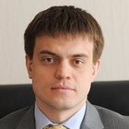Kotyukov, Kvashnin,
Anatoly
Mikhail

Kotyukov, Mikhail
Kvashnin, Anatoly
Lyubimov,
Nikolai
Margelov,
Mikhail
Sergey Kiriyenko
Pavel Zenkovich, the head of the administration’s public projects department.
Denis Stepanyuk, an assistant to the Kremlin’s Domestic Policy Department
Maxim Zhavoronkov was named his deputy.
For example, the head of the executive committee became Pskov Senator Andrey Borisov
Oleg Govorun under Surkov, and Oleg Morozov and Tatyana Voronova under Volodin.
The department is now run by Andrey Yarin, who is by no means a member of Kiriyenko’s inner circle. Domestic Policy Department head in 2016
n April 2018, the former head of the Moscow Region’s Serpukhov District, Alexander Shestun, uploaded to YouTube a recording of a conversation with Yarin, FSB Department “K” director Ivan Tkhachev, and Mikhail Kuznetsov, the deputy head of the Moscow Regional government. In the recording, the three officials demand that Shestun leave office, threatening criminal prosecution if he refuses. After Shestun called their bluff, he was in fact charged with felony corruption.
https://meduza.io/en/feature/2019/10/11/russia-s-technocrat-in-chief

Timur Valentinovich Prokopenko-Deputy Head of the Internal Policy Department of the Presidential Administration of the Russian Federation.

1234567890123456
Timur Prokopenko
5+10, above DD and 5+11, DD
4+11, below DD and 6+10, DD

12345678901234567
Maxim Zhavoronkov

123456789012345678901
International Affairs
Domestic Policy
Government Procurement
International Politics
Interregional Relations
Document Processing
Protocol and Organization

123456789012345678901
123456789012345678901
Presidential Clerical
Foreign Affairs
Directorate
Department
Financial Monitoring’

https://www.rferl.org/a/russia-navalny-wife-tass-pictures-spiked/26941508.html
Prokopenko, a former TASS correspondent and pro-Kremlin youth leader, was appointed deputy head of the Kremlin's domestic politics department in 2012 under Vyacheslav Volodin, a powerful first deputy chief of staff to President Vladimir Putin.

Last week the collective released roughly 40,000 text messages apparently taken from the mobile phone of Timur Prokopenko, manager of the Kremlin’s Internet policy between 2012–2014.

Igor Osadchy, three different email accounts allegedly belonging to Dmitri Medvedev, as well as correspondence from Duma deputy and United Russia member Robert Shlegel

- Medvedev – see report 100 “Speaking in early August 2016, two well-placed and established Kremlin sources outlined the divisions and backlash in Moscow”. Head of Presidential Administration, Sergei IVANOV, was angry at the recent turn of events. He believed the Kremlin “team” involved, led by presidential spokesman Dmitriy PESKOV, had gone too far in interfering in foreign affairs with their “elephant in a china shop black PR”. PESKOV’s position was nothelped by a botched attempt by him also to interfere in the recent failed coup in Turkey from a government relations (GR) perspective (no further details). underlined by a second source, close to premier Dmitriy MEDVEDEV (DAM). S/he said the Russian prime minister and his colleagues wanted to have good relations with the US, regardless of who was in power there, and not least so as to be able to travel there in future, either officially or privately.

12345678901234567
12345 12345678901
Timur Prokopenko
Deputy Director, 123456789012345678 Department

123456789012345
1234 1234567890

\Xxxxxxxxxxxxxxxxxx

Ministry of Foreign Affairs
Presidential Administration

1234567890123456
12345 1234567890

Tatyana Voronova (7+8)
Olga Sitnikova (4+9)
Igor Diveykin (4+8)
Timur Prokopenko (5+10)

http://en.kremlin.ru/structure/administration/members

27 pdf
a number of different bank ATMs, xxxxxxxxxxxxxxxxxxxxxxxxxxxxxxxxxx
Xxxxxxxxxxxxxxxxxxxxxxxxxxxxxxxxxx, Danchenko brought those notes
to Vorontsov, who would exchange the Scottish bank notes for
rubles – using the current exchange rate. As he remarked the
previous day, Vorontsov is an avid collector and has been doing so
for decades. The pricing list is a “wish list.” [As an aside
Danchenko identified another of Vorontsov’s friends, 123456
1234567, Xxxxxxxxxxxxxxxxxxxxxxxxxxxxxxxx

Russian government employee 12345 1234567890 (Female - Official 1)
(U//FOUO) In the upper right hand corner, Danchenko identified
1234567890123456. She is currently serving as the head of 1234
Xxxxxxxxxxxxxxxxxxxxxxxxxxxxxxxxxxxxxxxxxxxxxxxxxxxxxxxxxxxxxxx
Xxxxxxxxxxxxxxxxxxxxxxxxxxxxxxxxxxxxxxxxxxxxxxxxxxxxxxxxxxxxxxxx
Xxxxxxxxxxxxxxxxxxxxxxxx, which is run by 1234567890123 or 1234567.
[ANALYST NOTE: This may be a misidentification. The head of
Xxxxxxxxxxxxxxxxxxxxxxxxxxxxxxxxxxxxxxxxxx], who in turn is
connected with 123456789012345. In her position, 1234567890 has
direct access to 123456789012345. Danchenko said that he has not
used 1234567890 as a source for the reports, but that they are
good friends and that he has known her for at least 12345 years.

123456789012345
Andrei Bondarev

III. Mikhail Kalugin, Andrei Bondarev, Veterans Pensions System, and
Dossier Report 2016/111, including Paragraph #5

Business card of offical
(U//FOUO) Underneath the picture of 1234567890 is a business card
belonging to Mikhail Kalugin, identified on the card as 123456789012
Zzzzzzzzzzzzzzzzzzzzzzzzzzzzzzzzzzzzzzzzzzzzzzzzzzzzzzzzzz. Danchenko
has known Kulagin for several years – xxxxxxxxxxxxxxxxxxxxx. They were
together xxxxxxxxxxxxxxxxxxxxxxxxxxxxxxxxxxxxxxxxxxxxxxxxxxxxxxxxxx
12345678901234, during which time Danchenko recalls that he tried to
get conversation with Kalugin started about Ukraine and sanctions.

123456789012345
Mikhail Kalugin (7+7)
Mikhail Kalugin
12345678901234
Washington, DC

Pdf 28
Danchenko first said that he knows that Kalugin has been back in Russia
since August 2016, but then thought a bit more and said, “maybe summer
2016.” Danchenko described Kalugin as “not a direct source, but he does
appear in the [Trump] dossier.” Xxxxxxxxxxxxxxxxxxxxxxxxxxxxxxxxxxx
xxxxxxxxxxxxxxxxxxxxxxxxxxxxxxxxxxxxxxxxxxxxx. According to Danchenko,
Kalugin is the only person he (Danchenko) knows 12345678901234.
Danchenko believes that xxxxxxxxxxxxxxxxxxxxxxxxxxxxxxxxxx but he isn’t
positive about that. He recalls that they had a conversation later in
spring 2016 during which time Kalugin said that he (Kalugin) had “put
In a word” and wondered if it had helped. They had a 5-10 minute chat [
ANALYST NOTE: It is unclear if it was the same spring 2016 conversation
or a later conversation] during which time Kalugin confided in
Danchenko that he (Kalugin) was getting tired of doing what he wasn’t
Really supposed to be doing in his job – zzzzzzzzzzzzzzzzzzzzzzzzzzzzzz
Zzzzzzzzzzzzzzzzzzzzzzzzzzz – and that he (Kalugin) didn’t want Russia
“exposed” in the US election. It was Danchenko’s understanding that
Kalugin was moving back to Russia and hoped for an xxxxxxxxxxxxxxxxxxx
Xxxxxxxxxxxxxxxx.

Embassy Assistant Secretary 6+8
(U//FOUO) As an aside while talking about Mikhail Kalugin, Danchenko
explained that since his time at Brookings, he has maintained distance
from diplomats at the Russian Embassy. He and Clifford Gaddy had
contact with a 123456789 secretary at the Embassy – a strange guy who
was pestering them. They gave this individual open source information.
Danchenko identified this individual as 123456 12345678, xxxxxxxxxxxxxxx
Xxxxxxxxxxxxxxxxxxxxxxxxxxxxxxxxxxxxxxxxxxxxxxxxxxxxxxxxxxxxxxxxxxxxxxx
Xxxxxxxxxxxxxxxxxxxxxxxxxxxxxxxxxxxxxxxxxxxxxxxxxxxxxxxxxxxxxxxxxxxxxxx
200x. Danchenko knew 12345678 about xxxxxxxxxxxxxxxxxxxxxxxxxxx while
Danchenko was working at Brookings. 12345678 asked for information
about Ukraine and the Orange Revolution, and Clifford Gaddy recommended

Pdf29
that they keep him at a distance. Danchenko did talk to 12345678 – he
related to the interviewers that 12345678 xxxxxxxxxxxxxxxxxxxxxxxxxxx
xxxxxxxxxxxxxxxx. [This was how, explained Danchenko, he picked up
information about how the xxxxxxxxxxxxxxxxxxxxxxxxxxxxxx.] 12345678 had
to travel to 123456789012345678901 – sometimes driving and sometimes
flying – to deliver cash 1234567890123. 12345678 completely dropped off
the map sometime around 2007-2008.

(U//FOUO) Looking at Report 2016/111, Danchenko was asked about the
report’s use of the descriptor, “a trusted compatriot.” – as in
paragraph one, “Speaking in confidence to a trusted compatriot in
mid-September 2016…” Danchenko was asked if he was the “trusted
compatriot” in these reports. Danchenko said that it might be him, but
that it could also be others. Danchenko’s attorney then jumped in,
stating that the “literary device” used by Steele in the dossier was
not consistent and not clear, so he wanted to be careful about matching
that descriptor to his client. Danchenko said that, to the best of his
knowledge, he is not sure if he was the only one working on this issue
for Orbis [and therefore he is not clear if he is always the “trusted
compatriot” mentioned in the documents].

(U//FOUO) Interviewers drew Danchenko’s attention to paragraph 5 of the
same report, where Mikhail Kalugin [written as Kulagin] is mentioned.
Danchenko is not clear how this paragraph was put together. Danchenko
indicated that no MFA official told him ****xxxxxxxxxxxxxxxxxxxxxxxxxxx
because of the election issue. About ****xxxxxxxxxx, Danchenko knows that
***xxxxxxxxxxxxxxxxxxxxxxxxxxxxxxxxxxxxxxxxxxxxxxxxx* Danchenko that 12345678
was his replacement – xxxxxxxxxxxxxxxxxxxxxxxxxxxxxxxxxxxxxxxxxxxxxxxxxx
xxxxxxxxxxxxxxxxxxxxxxxxxxxxxxxxxxxxxxxxxxxxxxxxxxxxxxxxxxxxxxxxxxxxxxxxx
xxxxxxxxxxxxxxxxxxxxxxxxxxxxxxxxxxxxxxx. Kalugin had described Bondarev as

http://search.globescope.com/indexp~2.htm
DMITRY Y. BABAKHIN
ALEXEY G. TIMOFEEV
ALEXEY Y. ZINOVIEV, first secretary
ANDREY Y. BIRYUKOV
DMITRY N. ADAMENKO
ANATOLY V. KULESHOV
ANDREY N. SHABALIN

SERGEY B. VESELKIN
VALERY I. SCHASTNY
2005
https://books.google.ca/books?id=fnQqcGGPUnMC&pg=PA68&dq=oleg+smolenkov+diplomatic+lists&hl=en&sa=X&redir_esc=y#v=onepage&q=oleg%20smolenkov%20diplomatic%20lists&f=false
ALEXEY G. TIMOFEEV first
ALEXEY Y. ZINOVIEV, first secretary
Sergey Bababkhin THIRD
DMITRY N. ADAMENKO
ANATOLY V. KULESHOV
SERGEY BELYUTIN
SERGEY MEDVEDEV
VALERY I. SCHASTNY

https://2009-2017.state.gov/s/cpr/rls/dpl/winter/62955.htm
ALEXEY G. TIMOFEEV first
ALEXEY Y. ZINOVIEV, first secretary
Sergey Bababkhin THIRD
DMITRY N. ADAMENKO
ANATOLY V. KULESHOV
SERGEY BELYUTIN
SERGEY MEDVEDEV
VALERY I. SCHASTNY
ANDREY N. SHABALIN
https://www.mcclatchydc.com/news/nation-world/national/article132761149.html he former head of the Economic Section at the Embassy of Russia in Washington, has

replaced by Andruy Bondarev

Pdf 30
“a bright young guy.” Danchenko has no idea where the language in this
paragraph regarding Bondarev being “clean in this regard” (with respect
to knowledge and involvement in US election matters ****xxxxxxxx).

IV. Dossier Report 2016/94

Sechin
(U//FOUO) Regarding Paragraphs 1 and 2, interviewers went back over
Danchenko’s explanations from the previous day, particularly the issue
of whether Danchenko had heard from Podobedova that the Page-Sechin
meeting was going to happen, that it had happened, or both. Danchenko
explained that he didn’t recall who had told him that the meeting was
going to happen – it might have been through Podobedova, but the more
he thought, the more he thought it was from someone else, and he
couldn’t recall who. He reported the meeting to Steele in July, and
then, in October, he received Podobedeva’s text with the confirming
information from someone who is a Rosneft executive. Danchenko does not
know the identity of the Rosneft executive.

Diveykin
(U//FOUO) Regarding Paragraph 3 on Carter Page’s meeting with Igor
Diveykin, Danchenko said that this information came from Olga Galkina.
Danchenko and Galkina had a phone conversation, or maybe Skype, but
Danchenko remembers it was a voice communication which lasted
about 30 minutes. Danchenko said it was during the summer, because he
remembers having the conversation while was at the public swimming pool
123456789012345678901234567 and “whatever” with his daughter. Galkina
was relating information that she was hearing from her sources –
Danchenko did not ask her about the identities of these sources.
Danchenko could probably follow up with Galkina about the sources but
he explained that he has no reason to doubt Galkina. He trusts Galkina
100%.

123456789012
His daughter
12345678901234
of the Rosneft
12345678901234567890123456
who is a Rosneft executive
in Rosneft public relations
in Rosneft’s administration
in Rosneft administration

Page also testifies that he met with Andrey Baranov, Rosneft's head of investor relations and a senior aide to Rosneft CEO Igor Sechin.

pdf 31
(U//FOUO) On the Divyekin identification, this was the name her sources
gave her. He was in the Domestic Policy section entity and was one of the
people in charge of US-Russia relations [ANALYST NOTE: Danchenko’s
description was someone unclear here, because he added,
“election-related stuff,” but then went back referring to it as
“US-Russia relations.”] Galkina suggested that there was an attempt to
masquerade things or craft a façade because “the folks who were in
domestic policy were working external [foreign] policy, while the folks
doing external were working domestic matters.”

(U//FOUO) Danchenko explained that, on the whole, his conversations
with Galkina were done in an opaque way, so as to be careful
security-wise. Galkina and Danchenko knew that when they talked, they
were talking about the US election issue, but wouldn’t necessarily
refer to it.

(U//FOUO) 1234567 is the one who told Danchenko that the Russian
government was sitting on “kompromat” as stated in paragraph 4.

(U//FOUO) Danchenko’s attorney stated that it was his client’s
assessment that this information from Galkina was credible and
accurate. It is Danchenko’s conclusion that the information in
paragraph 3 came from his conversation with Galkina.

(U//FOUO) Danchenko is “inconclusive” about where exactly the
information in paragraph 4 came from. He thinks he and Galkina may have
spoken about it – Galkina is tied to both 123456 and Ivanov – but he
would not have described Galkina as “an official close to Ivanov.” When
asked by interviewers how he (Danchenko) described Galkina to

P 32
Christopher Steele, Danchenko said that he described her as “my friend
who knows someone in the Kremlin with direct/indirect access to Sergey
Ivanov.”

IV Dossier Report 2016/134
(U//FOUO) The information in the first paragraph of this report came
from Danchenko’s text interchange with Podobedova in October 2016.

(U//FOUO) Danchenko was less conclusive about the construction of
paragraph 2. The final sentence about the lifting of sanctions was
taken from Podobedova’s text in October, but Podobedova never mentioned
to Danchenko that Page had been offered any brokerage of the 19%
Rosneft stake. There were speculations and “open secrets” about Rosneft
and foreign offerings. For example, 123456789012345678, an energy
analyst and professor [ANALYST NOTE: This appears to be identical to
123456789012345678, who as of **** was the 12345678 of Russia’s 123456
1234567890123456789] suggested in broad terms to Danchenko in ****
during the ****xxxxxxxxxxxxxxx that once sanctions were lifted, Rosneft
could find itself in a “privileged” state. As an aside, Danchenko
remarked that 1234567 is often dismissed intrinsically as being a Gazprom lobbyist.

123456 1234567890123456789
Energy Institute of Moscow
Gubkin Energy Institute

123456789012345678
1234567890 1234567
Viacheslav Morozov

http://ceurus.ut.ee/home/people/director-executive-board/411-2/
https://www.facebook.com/viacheslav.morozov.14

V. Cohen, Prague,and Dossier Reports 135, 136 and 166

(U//FOUO) Danchenko began his explanation of the Prague and Michael
Cohen-related reports by stating that Christopher Steele had given him
4-5 names to research for the election-related tasking. He could only
remember three of the names: Carter Page, Paul Manafort and Michael
Cohen. When he talked to GALKINA in the fall of 2016 – he believes

P33.
it was a phone call – he rattled off these names and, out of them, he was surprised to hear that GALKINA immediately [later Danchenko softened this to “almost immediately”] recognized Cohen’s name.

(U//FOUO) In Report 2016/135, Danchenko did not know the origins of
paragraph 1. He said that it didn’t come from him, and that he doesn’t
know where the information is from. He described it as “too general.”

(U//FOUO) In paragraph 2 of the same report (2016/135), Danchenko
recognized material from his conversations with GALKINA in the
middle of the paragraph. GALKINA had told Danchenko that Cohen and
three other unidentified people had flown [or, as Danchenko put it
later, “assumed they had flown”] into Prague in August-September 2016
and had met with a group from Russia. Danchenko asked her who else
besides Cohen had come into Prague from the US side – she didn’t know,
but she was willing to go back and find out. She never got back to him
about this. Danchenko also asked about the participants on the Russian
side. She didn’t know, but she indicated that her “best guess” or “her understanding” was that they were from “Legal Affairs” or “Legal
Department.” Danchenko indicated that GALKINA did not say why she
thought that. Danchenko wasn’t aware that such an entity existed – he
was not able to find it through research.

(U//FOUO) Reflecting on the Prague-related material, Danchenko
believes he had 2, maybe even 3, conversations with GALKINA on
this topic later in October. Nothing on Prague and Cohen was
collected during the 1234 trip in August. The first conversation
is the one during which he believes GALKINA noted her recognition
of Cohen’s name. The second conversation is the one in which she
discussed Prague, the visit of Cohen plus three other individuals,

34
and the meeting with the Russian side. There may have been a third conversation on the topic, but Danchenko could not recall exactly
and said that they had also talked about “a private subject.”

(U//FOUO) In paragraph 2, Danchenko doesn’t believe he discussed Paul
Manafort with GALKINA. GALKINA didn’t bring up Carter Page or Manafort
during these October conversations. The direct quote “…to sweep it all
under the carpet…” is from GALKINA. GALKINA did not say, however, why Cohen
went to Prague instead of Carter Page.

Rosstrudnichestvo
(U//FOUO) In Dossier Report 2016/166, Olga Galkina is the one who
provided the Rossotrudnichestvo information and the identification of
Oleg Solodukhin. Danchenko said that during either the second or third
conversation with Galkina about the Cohen matter, Galkina had initially
thought the meetings involved the “legal department” but then
identified Solodukhin and Rossotrudnichestvo. Danchenko kept pushing
Galkina for information about the identities of the US participants,
but she did not know. On the Russian side, Danchenko requested that she
go back to her sources, and it was after that she came back with the
identification of Solodukhin. However, Danchenko said that Galkina never
mentioned or said that Solodukhin was working “under Rossotrudnichestvo
cover,” as is stated in the report. Danchenko had done his own research
and confirmed that Oleg Solodukhin existed.

(U//FOUO) In the same report, OLGA GALKINA is the one who mentioned
“deniable cash payments” and “wires.” Danchenko pushed GALKINA for the
substance of the meeting in Prague, but he is not sure if GALKINA was brainstorming here, or if she is relating information from her sources.

(U//FOUO) As an aside here, Danchenko spoke about some personal
details regarding GALKINA. Xxxxxxxxxxxxxxxxxxxxxxxxxxxxxxxxx. xxx

Oleg Solodukhin
123456789012345

35

**** xxxxxxxxxxxxxxxxxxxxxxxxxxxxxxxxxxxxxxxxxxxxxxxxxxxxxxxxxxxxxxxxxxx
Xxxxxxxxxxxxxxxxxxxxxxxxxxxxxxxxxxxxxxxxxxxxxxxxxxxxxxxxxxxxxxxxxxxxx
xxxxxxxxxxxxxxxxxxxxxxxxxxxxxxxxxxxxxxx. Danchenko reiterated a
story from the previous day – Galkina had just reached out to him
the other day to ask him to 12345678901 an article about Russian
speakers and Trump. Galkina currently has a visa to come to the
United States. To questions posed by FBI SA Somma and comments
made by his attorney, Danchenko indicated that he could carefully
cultivate Galkina, perhaps even meet her in a third country. To
try and get additional information of interest to the FBI would
require in-person conversation, and Danchenko quipped that he’d
never been an agent. Danchenko said that he had plans to visit
her earlier this year in Cyprus, but that it didn’t work out.
Danchenko said that she knew that he had plans to visit her in
Cyprus, because the two of them had talked through the plans. When
asked if Galkina would be comfortable talking to the FBI,
Danchenko said that he wasn’t sure.

(U//FOUO) Danchenko summarized that, when it comes to the dossier, the
Page material regarding Sechin came from PODOBEDEVA, while the
Cohen/Prague material came from GALKINA.

(U//FOUO) In paragraph 3 of Report 2016/166, Danchenko said that he
believes that the material “strongly corresponds” to a recent, December
2016 conversation that he had with GALKINA. This was a separate,
follow-on conversation to the October conversations mentioned before.
The material is not word-for-word from his conversation with GALKINA,
but partially-based on their December 2016 telephone conversation. For
example, in their conversation, while he doesn’t remember her saying
12345, he does recall her saying 1234567890. He recalls that she talked

Pdf 36
about Webzilla’s “affiliates” but she did not mention the Democratic
Party in the way that the report says. As he mentioned earlier, he
stated their conversations were held in the overall context of the US
elections and hacking, but he is not sure if she mentioned a specific
political party or candidate at this time. She did mention “porn
traffic” as mentioned in this paragraph. Danchenko does not recall
GALKINA’s reference to a specific time frame of March through September
2016.

(U//FOUO) GALKINA did mention both Webzilla and Seva Kapsugovich, who
she mentioned – as stated in the report – work “under the FSB.” She
mentioned Gubarev and all of his smaller subsidiaries and companies.
Danchenko said that GALKINA ****xxxxxxxxxxxxxxxxxxxxxxxxxxxxxx, which
Danchenko said was one of Gubarev’s companies. Danchenko admitted to
the interviewers that his understanding of this topic (i.e. cyber) was
“zero” and that GALKINA is not an IT specialist herself. GALKINA never
said that 1234567890 was involved in any of this. He said that
paragraph 3 has references and keywords involving payments and cover-up
from his conversation with GALKINA.

(U//FOUO) With respect to paragraph 4, OLGA GALKINA gave this as a kind
of example. She didn’t offer any specific information or evidence, but
that this (e.g. Romanian hackers heading to Bulgaria to lay low) is a
kind of example [ANALYST NOTE: It seemed by Danchenko’s description
that this might be GALKINA’s analysis]. Danchenko is not sure where the
term “bolt hole” is from, and tried, unsuccessfully, to think about
what Russian term this might be representing. When asked if everything
in this paragraph came from GALKINA, Danchenko said that it was
difficult to say with certainty. It sounds like material that GALKINA
would say. Looking back through this paragraph, Danchenko said that

Pdf 37:
everything before the term “lay low” is definitely from GALKINA, while
he is not sure about everything after that term. Danchenko is not sure
about the specifics in this paragraph and agreed with interviewers that
the report has more specific language (place names; ethnicity of
hackers) than other reports. Interviewers brought up the fact that
Danchenko had mentioned the previous day that GALKINA spoke Bulgarian
and had a family vacation home in Bulgaria. Danchenko did not know if
the family home was in 1234567, but asked if 1234567 was “on the coast”
because that’s where typical family vacation homes were located.

VI. Source 6, RIA Novosti, and 2016/95

(U//FOUO) Danchenko was asked to go back over the reports discussed in
brief the previous day regarding his interaction with Sergei Millian.
Danchenko said that Christopher Steele had asked him to find sources
linked to the Trump team, who could answer the overarching questions
regarding Russia’s connections to the team, etc. Danchenko turned to
his contacts at RIA Novosti, and his contacts there told him
(Danchenko) that there was “this guy, Sergei Millian” that he
(Danchenko) should talk to.

(U//FOUO) Danchenko first met in person with Alexey Bogdanovskiy, a RIA,
Novosti reporter in D.C., who is still around (as Danchenko
understands) and who is one of Danchenko’s xxxxxxxxxxxxx. Danchenko
said that Bogdanovskiy has offices in Washington D.C., and the two of
them met over lunch at a Thai restaurant. He didn’t want to ask
Bogdanovskiy very targeted or revealing questions for the election
assignment, so he kept them broad in scope (“Do you (Bogdanovskiy)
know anyone who can talk about all of this Trump/Manafort stuff, or
Trump and Russia?” Bogdanovskiy commented about how there was a great

Pdf 38

amount of speculation about Russian influence and Russian ties, but
that he was skeptical and nothing substantive had turned up.
Bogdanovskiy said Danchenko should also speak with his RIA Novosti
colleague, Dmitriy Zlodorev. Bogdanovskiy said that “there [is] this
guy Zlodorev interviewed and he (Zlodorev) could probably get his
contact information.” Danchenko said that he believes, in the end,
Bogdanovskiy gave him (Danchenko) Sergei Millian’s email, and that he
(Danchenko) never met with Zlodorev. [Danchenko added that he will see
if he still has the email]

(U//FOUO) Danchenko emailed Millian in either June or July 2016 – but
it was after Danchenko’s trip to Russia and U.K. Danchenko did not
receive a response from this email, but says that it was at that point
that “things got strange”. In July 2016, he received a telephone call
from an unidentified Russian guy. He thought it was Millian – he still
thinks it was Millian – but the individual never identified himself as
Millian. They talked for about 10 minutes, and then arranged to meet
together up in New York City.

(U//FOUO) Danchenko remembered that they made plans to meet in NYC,
and that Danchenko offered to come up “anytime” Millian was available.
Millian wouldn’t commit to a specific time, but Danchenko said that he
could be [in] NYC “for a couple of days”. Danchenko could not recall if
Millian said the lived in New York City or not, but Danchenko guessed
that he did. Following this, Danchenko – together with his daughter –
traveled to NYC with prepared questions, but Millian was a no-show. The visit would have been near the end of July. Later, Danchenko spoke with
Dmitriy Zlobodev, who mentioned to Danchenko that Millian had been
asking about him (Danchenko). Zlobodev said that Millian had asked him
(Zlobodev) "who the hell you (Danchenko)0were” and that it would be

https://www.linkedin.com/in/alexey-bogdanovskiy-95ba1516

Pdf 39
hard to reach out to him (Millian) now because he was in 123456789012345
12345. Danchenko remembers providing Christopher Steele with the
information about Millian’s whereabouts in 123456789012345678901.

(U//FOUO) Danchenko tried one more follow-up with Millian in September
2016. He decided to use his friend from 123456789012345678, who is
involved in xxxxxxxxxxxxxxxxxxxxxxxxxx. She has a xxxxxxxxxxxxxxx
project, so, knowing that Millian xxxxxxxxxxxxxxxxxxxx, Denchenko sent
him a brochure about 123456’s project in the hope that it would
generate a response. Millian never responded. At some point, Millian
and Danchenko became LinkedIn associates, but Danchenko could not
remember which of them initiated the LinkedIn invitation.

real estate
123456789012345
Real estate project

(U//FOUO) Altogether, Danchenko and the person he believed – and still
believes – to be Millian had one 10-15 minute conversation. Danchenko
says that “Source E” in Report 2016/95 sounds like it is from this
conversation. During the phone call, he remembers mentioning Manafort
and Page. Danchenko recalls that this 10-15 minute conversation
included a general discussion about Trump and the Kremlin, that there
was "communication" between the parties, and that it was an ongoing
relationship. Danchenko recalls that the individual believed to be
Millian said that there was "exchange of information" between Trump and
the Kremlin, and that there was "nothing bad about it." Millian said
that some of this information exchange could be good for Russia, and
some could be damaging to Trump, but deniable. The individual said that the Kremlin might be of help to get Trump elected, but Danchenko did not recall
any discussion or mention of Wikileaks.

(U/FOUO) Besides the 10-15 minute conversation, Danchenko had no
Further contact with Millian (or the person he believed to be Millian).

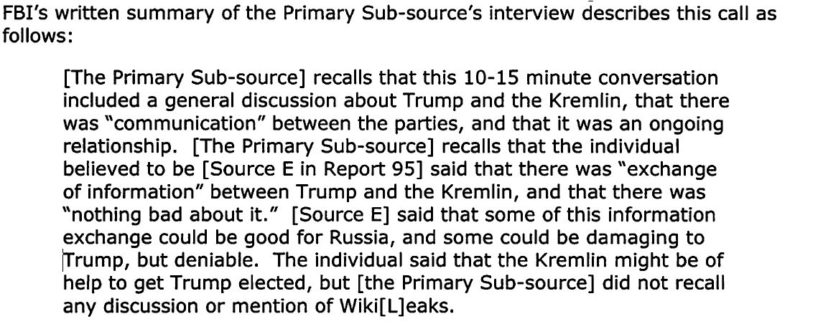

Xxxxxxxxxxxxxxxxxxx
Early August, 2016

P40

VI. Report 2016/80 Trump, the Ritz Carlton and Report 2016/80
(U//FOUO) The interviewers brought Danchenko’s attention to the report
regarding Trump’s alleged unorthodox sexual activity at the Ritz
Carlton Hotel – specifically paragraph 3 of Report 2016/80. Danchenko
said that this information came, partially, from Ivan Vorontsov.
Vorontsov’s circle of associates and friends, Danchenko explained once
more, is primarily in the financial sphere, but his social network is
vast, and he has other, random associates. In fact, as another example,
Vorontsvv travels to xxxxxxxxxxxxxxxxxxxxxxxxxxxxxxxxxxxxxxxxxxxxxxxxx
xxxxxx.

(U//FOUO) When Danchenko asked Vorontsov in early June 2016 (the June
trip to Russia) about whether he knew of any compromising materials on
Trump, Vorontsov said that there was a “well known story” about Trump’s
activities in the very hotel xxxxxxxxxxxxxxxxxxxxxxxxxxxxxxxxxxxxxxxx –
the Ritz Carlton. xxxxxxxxxxxxxxxxxxxxxxxxxxxxxxxxxxxxxxxx to make
preparations for the 1234567890123456 event. The “well known story”
involved the allegation that Trump was “into water sports” and had
engaged in that activity “in the presidential suite” at the Ritz
Carlton. In terms of whether the story was true, Vorontsov explained
that people “know” but that it “only becomes fact if people come
forward.” Vorontsov said that the hotel is bugged, and “heaven only
knows” who or what has been filmed by the FSB. Vorontsov said to
Danchenko xxxxxxxxxxxxxxx****xxxxxxxxxxxxxxxxxxxxxxxxx. Go and check
out the story.” ****

(U//FOUO) As Danchenko explained it, the fact of hotel bugging and the

1234567890123456
Miss Universe
Beauty contest
12345678901234
Trip to Russia

Pdf 41
use of filmed “kompromat” is not uncommon. Danchenko related the names
of those who have been targeted in this way – [Yuriy] Skuratov,
[Mikhail] Kasyanov, and Vladimir Rushkov [unclear, maybe Ryzhkov].
Danchenko has also been able to comment on hotel bugging because it is
generally known, as he explained to interviewers, that if you want to
visit Moscow and not be vulnerable to being bugged, you have to stay
away from the Ritz Carlton, the Hotel Moskva, and the Hotel Peking.

(U//FOUO) Regarding paragraph 4 in Report 2016/80, ****,
Xxxxxxxxxxxxxxxxxxxxxxxxxxxxxxxxxxxxxxxxxxxxxxxxxxxxxxxxxxxxx, he had a
meeting with the managers xxxxxxxxxxxxxxxxxx. During a free minute, he
asked about “this stuff about Trump at the hotel.” His interlocutors
laughed it off, stating that “all kinds of things happen at the hotel”
and with celebrities, “one never knows what they’re doing.” Danchenko
said that it wasn’t a denial. And asking the hotel staff who were
assisting with the 1234 arrangements, one girl commented that “anything
goes” at the hotel, and added that, “officially, we don’t have
prostitutes.”

(U//FOUO) For this story, Christopher Steele was given the names of the
management at the Ritz Carlton. Danchenko said that he reported Trump’s
unorthodox sexual activity at the Ritz as “rumor and speculation” and
that he had not been able to confirm the story.

(U//FOUO) In the same report, paragraphs 1, 4 and 5, Danchenko
identified “Source B” as Vyacheslav Trubnikov through Sergei ABYSHEV.
ABYSHEV reported that he and Trubnikov had “had a conversation” about
the content in the report. Trubnikov said that they had “embarrassing
stuff– sexual/pornographic material” on a number of folks, “including
Trump.” Danchenko said that the end of paragraph 4 regarding the

Horowitz
For example, the Primary Sub-source told the FBI that, while Report 80 stated that
Trump's alleged sexual activities at the Ritz Carlton hotel in Moscow had been
"confirmed" by a senior, western staff member at the hotel, the Primary Sub-source
explained that he/she reported to Steele that Trump's alleged unorthodox sexual
activity at the Ritz Carlton hotel was "rumor and speculation" and that he/she had
not been able to confirm the story.

WFO Agent 1 said that the Primary Sub-source explained that his/her
information came from "word of mouth and hearsay;" "conversation that [he/she]
had with friends over beers;" and that some of the information, such as allegations
about Trump's sexual activities, were statements he/she heard made in "jest."341

According to WFO Agent 1, the Primary Sub-source told him that he/she spoke with at
least one staff member at the Ritz Carlton hotel in Moscow who said that there were stories
concerning Trump's alleged sexual activities, not that the activities themselves had been confirmed by
the staff member as stated in Report 80.

42
ability to blackmail Trump was “logical conclusion” rather than
reporting. The conversation with ABYSHEV took place in June 2016 at xxxxxxxxxxxxxxxxxxxxxxxxxxxxxxxxxxx – the particular cafe near the
****xxxxxxxxxxxxxxxxxxxxxxxxxxxxxxxxxxxxx. Danchenko remarked that
TRUBNIKOV insists on having meetings in ****xxxxxxxxxxxx himself].
Danchenko said that the mention of the file in paragraph 5 was part of
a conversation between TRUBNIKOV and ABYSHEV, but Danchenko has no idea
where the mention of “Department K of the FSB” is from. He does not
recall hearing that, or mentioning that to Christopher Steele.
Additionally, the years over which the “kompromat” file was collected
were also never mentioned, to Danchenko’s recollection.

26 January 2017

FBI Washington Field Office Interview Room
Present:
Igor Danchenko, interviewee
Mark E. Schamel, interviewee’s attorney
Stephen M. Somma, FBI Special Agent NYFO
Brian Auten, FBI Supervisory Intelligence Analyst WFO
Richard Scott, Deputy, National Security Division, US Department of
Justice

Recent Communication by Orbis Representative: Overall Wellbeing

43

(U//FOUO) Danchenko and his attorney related that Chris Steele had
“signaled” to Danchenko this morning. One of Steele’s associates at
Orbis, 123456789012345 789012 – an analyst who Danchenko said he has
seen approximately 12 times – called Danchenko. Porter remarked that
Danchenko “had been lying too low.” Porter said that “[Orbis] hadn’t
heard from him over the past 10 days, and that they wanted to know what
was going on.” Danchenko told Porter that he’d been staying in a hotel
and at his 1234567890’s place 12345678901234567, and that he had been
talking to an attorney about his xxxxxxxxxxxxxxxxxxxxxxxxxxxxxxxxxx
xxxxxx.

[Kieran] Porter

(U//FOUO) Danchenko did not speak with Steele during this conversation.
Danchenko heard from Porter that Steele was still “lying low” but that
“everyone” was concerned about Danchenko’s wellbeing. [ANALYST NOTE:
The attorney commented that the fact that Porter reached out is yet another
indication of how his client was put through the recruitment cycle –
initially recruited by Chris Steele, but passed off to underlings for
day-to-day management.] Porter and Danchenko discussed some possible
future assignments – “small due diligence assignments unrelated to
politics” – and Porter indicated that they would run stuff by him if
something came up – but [and it was not clear if this was Porter’s
actual comment or Danchenko’s reflection] probably nor much in the area
of Russia. There was talk about wiring past due monies for Danchenko to
Target Labs. Or, Danchenko added, there was also discussion about
getting him money through “someone we know [in the United States]”
Danchenko was hesitant about arranging payments in any way that “looked
strange”.

(U//FOUO) Porter told Danchenko that since the Buzzfeed story hit the
news, Orbis had received 20,000 emails.
UO) **** told Danchenko that since the Buzzfeed story hit the news, Orbis had received 20,000 emails.

44:
(U//FOUO) No one from Target Labs has reached out to check on
Danchenko’s welfare. That said, Danchenko typically works from his
home. He works off-hours, given the time difference between D.C.,
Moscow and London. There is space and some desks he can use at Target
Labs, but most of his work is done at home.

(U//FOUO) Danchenko commented that, unless his name goes public, he is
fine when it comes to his source network. He doesn’t believe he can
travel to Russia - he feels that he would be in danger and, as he put
it, ****xxxxxxxxxxxxxxxxxxxxxxxxxxxxx.

44. Orbis knows, p44
(U//FOUO) Danchenko indicated that Orbis does know the identities of
some of his sources – they have some first and last names. For example,
Orbis knows the identity of Ivan Mikhailovich Vorontsov, who, Danchenko
added, ****xxxxxxxxxxxxxxxxxxxxxxxxxxxxxxxxxxxxxxxxxxxxxxxxxx.

(U//FOUO) Danchenko said that he had gone back to check for electronic communication records, but he said that he had deleted most of the
election-related communications “months ago.” He also has a different
phone from the one he used previously. He didn’t delete communication
involving Dmitriy Zlodorev [see previous day’s interview], and he had
reported that communication to Christopher Steele.

Dossier Report 2016/86
(U//FOUO) Danchenko was asked a number of questions regarding the
sourcing and information about the FSB cyber-related dossier report.

(U//FOUO) In paragraph 1, the “former senior intelligence officer” is
Vyacheslav Trubnikov, through Sergei Abyshev. Abyshev told this
information directly to Danchenko in Moscow at the 12345678901234567890

45
cafe.

(U//FOUO) Some of the material in paragraph 2 was not familiar to
Danchenko. In general, the material tracks with comments made to
Danchenko by Sergei Abyshev, with corroboration via open source
material. Looking more over the paragraph, Danchenko said that the
Trubnikov material begins with the sentence, “To compensate for this shortfall…” Danchenko does not recall using the term “first tier” (in
the first sentence) in his reports to Steele – he is not sure that
information came from him (Danchenko).

(U//FOUO) The material in paragraph 3 could be referencing material
gleaned from one of Danchenko’s xxx friends from Perm, 123456789012345
1234567890. When he was nineteen years old, 1234567890 was caught
“facilitating payments for a pornographic website.” He was offered a
deal – cooperate with the FSB or potentially go to jail. He ended up
doing some work for the FSB, but Danchenko doesn’t know what type of
work 1234567890 did for the FSB [ANALYST NOTE: This is in contradiction
to Danchenko’s statement the first day, at which time he indicated that
he did not have any contacts associated with the Russian intelligence
and security services.] 1234567890 is a couple of years younger than Danchenko, and he (1234567890) returned to “normal life” [that is, post FSB activity] around 123456789012. 1234567890 told Danchenko that he
knew of many other people who have been put in a similar situation
[with the FSB]. Presently, 1234567890 works in 123456; however,
Danchenko is unclear for whom – he (Danchenko) thought that 1234567890 might be working for 1234567890123456789012345, for the banking
industry, and/or doing something in the way of 1234567890123. When
asked if Danchenko would consider 1234567890 a “contractor,” Danchenko said “yes, like myself, but in a different [sector].”

1234567890123456789012345
Renaissance Capital
12345678
Eighteen
Seventeen
Nineteen
Панч джуди

46:
(U//FOUO) In the same paragraph – paragraph 3 – the portion that begins with “In one case a US citizen…” was derived from a conversation with Sergei Abyshev. Abyshev related this story, indicating that the US citizen was Abyshev’s friend who does work with “educational apps or something.”

(U//FOUO) For paragraph 4, Danchenko could not attribute it to any
source in particular. The “foreign director of a company,” recalled Danchenko, is a foreign director on the board of 1234567, but he did
not know the exact identity.

(U//FOUO) For paragraph 5, Danchenko said that some of the information came from his discussion with the Russian 12345678901, RUSSIAN CONTACT –
who, Danchenko reiterated, ****xxxxxxxxxxxxxxxxxxxx [****xxxxxxxxxxxxx
xxxxxxxxxxxxxxxxxxxxxxxxxxxxxxxxxxxxxxxxxxxxxxxxxxxxxxxxxxxxxxxxxxx
xxxxxx.] Danchenko said that “an FSB cyber operative” is an incorrect source characterization and that 123456 had mentioned to him
(Danchenko) that Telegram had been compromised.

(U//FOUO) Regarding paragraph 6, Danchenko could not attribute it conclusively to any particular source. He said that he can’t confirm
it, but he believes the source may have been Ivan Vorontsov. Some of it is open source, however.

General Summarizing About Danchenko’s Sources

(U//FOUO) The interviewers asked Danchenko if, generally speaking about
the dossier as a whole, the mentions of Dmitriy Peskov [Putin’s press secretary] and Sergey Ivanov can be typically sourced to Olga Galkina. Danchenko said yes – Galkina has direct and indirect contact with a
deputy, or multiple deputies, in 123456789012345. As stated earlier,

123456789012345
The State Duma
The Foreign Min

47,
she is also tied into 1234567890123456789012345678901234567. Danchenko
said that, through Galkina, he could try and get the names and the
deputies and assistants she uses for getting her information.

1234567890123456789012345678901234567
The Ministry of Foreign Affairs

Vorontsov friend, primary source on Russian official 123456789012345678
(U//FOUO) When it comes to any material on 123456789012345678,
Xxxxxxxxxxxxxxxxxxxxxxxxxxxxxxxxxxxxxxx is the primary source.
Vorontsov is friends with xxxxxxxxxxxxxxxxxxxxxxxxxxxxxxx, Danchenkov
related a story from circa 2015-2016. For a different assignment,
Danchenko got Vorontsov to talk to the 1234567890123. During that
Interaction, the 1234567890123 indicated that power and authority when
It came to press relations had centralized on Peskov. Vorontsov’s
friend indicated that “[we’re] all under Peskov now”, which Danchenko
took to mean that authority within the Presidential Administration’s
PR/GR circles had entered a pyramid-type stage with Peskov at the top
of the pyramid.

(U//FOUO) On the material regarding the replacement of Sergei Ivanov
with Anton Vaino, this was also derived from GALKINA, as well as “two other friends: [which Danchenko left vague and didn’t identify]. The
part of the reports connecting Ivanov’s replacement by Vaino to the fallout over Russia’s influence efforts against the US election was, according to Danchenko, his analytical conclusion. GALKINA “confirmed
that it had to be true,” said Danchenko. GALKINA told him something
like “[Ivanov’s dismissal because of US-election related fallout] just
had to be true” or else she said something like “Of course, it has to be that…”

General Summarizing of Danchenko’s Debriefings by Orbis
(U//FOUO) The interviewers asked Danchenko about how Christopher Steele would go about debriefing him after his visits, specifically about how

1234568901234
Araz Agalarov

Artem Kirilenko
Rustam Inoyatov
Zarakh Iliev
Araz Agalarov

48
Steele asked him about distinguishing between what his sources have
told him versus his (Danchenko’s) analytical judgements. Danchenko said that Steele would often ask him, “Are you sure [about what your source
is telling you],” and sometimes would repeatedly press him about a
certain report – emphasizing “Are you (Danchenko) sure? Are you sure?” Danchenko said that he (Danchenko) was very careful about caveating
during debriefs with Steele. He would tell Steele if something was his analytical judgement (“As an analyst, I think…”), explain his confidence levels (“It is possible vs. likely” or “It is plausible”), and even
tell Steele whether something had just not been explicitly denied (“No
one has denied it when I’ve brought it up.”) At times he would tell
Steele that “I’ve told you what I know.” When pressed by Steele to try
to get additional information, Danchenko would explain that he did not want to go back to his friends “3 or 4 times” to try to get additional material – it would look bad and it would raise suspicions. Steele
might ask, for example, “Do any of your (Danchenko’s) sources know if Ivanov was sacked because of the US presidential election?”

(U//FOUO) Not wanting to cause suspicions with friends and associates, Danchenko would try and corroborate the reporting he (Danchenko)
received in other ways. The interviewers also asked if Danchenko would characterize his sources to Steele (“OLGA told me X” or “SERGEI told me Y”). Danchenko said that was not always the case.

(U//FOUO) Danchenko said that his verbal debriefings with Christopher Steele were held at Orbis’ office, not at hotels. Steele would debrief Danchenko solo, and would take handwritten notes of what Danchenko was telling him. Danchenko remarked that it [Steele taking handwritten
notes] was just like “you [the FBI interviewers] are doing today.”

P49
(U//FOUO) Going back over his note-taking, Danchenko said that he would not really write detailed notes about his source meetings. Even on the Moscow-to-London flight, returning from trips, he might scratch out a
few tentative points – i.e. “5 days, 17 meetings” – and maybe some
cryptic reminders. He might even write a text message to himself, but
he compared it to preparation to a conference panel presentation – a
few notes jotted on a notecard before one heads to the panel. He told
the interviewers that he had destroyed any of these scribbled notes.

(U//FOUO) Danchenko was asked how Steele tasked him – by email, Skype
or phone. Danchenko said it was a combination of these things.
Danchenko described the US election-related tasking came in three
waves: (1) the initial tasking about Paul Manafort; (2) the tasking about any compromising materials on Donald Trump; (3) tasking about Sergey Ivanov’s involvement in the US election; and (4) later on, in the fall of 2016, 4-5 names to ask about [which Danchenko talked about earlier, including Carter Page and Michael Cohen].

(U//FOUO) Danchenko was asked if Steele had ever mentioned going to the press about with the election-related information. To Danchenko’s
knowledge, Steele never went to the press about this material.
Danchenko never heard Steele voice anything suggesting that this material needed to get into the hands of the press.

(U//FOUO) Danchenko was asked if he was tasked with anything else
similar to what was in the dossier, but does not appear in the dossier.
He said no, and repeated that these types of taskings [on the election matter] made him uncomfortable. Steele pushed Danchenko to try and
either follow-up with people or corroborate the reporting, but
Danchenko wasn’t able to do so. Moreover, Danchenko added, attempts at

50
getting corroboration on these subjects made him uncomfortable – he was very nervous about the Russians finding out about it.

(U//FOUO) The interviewers later asked Danchenko to review his
annotated version of the dossier, asking specifically if there were any additional source names that had not been covered in the 3-day interview. Danchenko said that there were no other source names.

(U//FOUO) Danchenko said that he did not have any UK-based friends or social network connections from whom he collects information.

More Information on Danchenko’s Trips in 2016 to Russia

(U//FOUO) More Information about Danchenko’s Trips to Russia
(U//FOUO) Danchenko talked about his 12345 trips 123456789 – 123456789
xxxxxxxxxxxxxxxxxxxxxxxxxxxxxxxx ****. Danchenko also had a trip to
Italy in 123456789 2016.

(U//FOUO) June 2016

(U//FOUO) The June 2016 was completely paid by Orbis.

(U//FOUO) August-September 2016

(U//FOUO) He remarked that the August trip was “odd”, explaining that,
upon entry, he was interviewed more pointedly than usual. This was the
only time it has happened. For about five minutes, he was peppered with questions and statements like, “What exactly are you planning to do
here? Who are you visiting” Your photo looks different.” Danchenko kept his answers vague – he said he was visiting his ****xxxxxxxxxxxxxxxx
xxxxxxxxxxxxxxxxxxxxxxxxxxxxxxxxxxxxxxxxxxxxxxxxxxxxxxxxxxxxxxxxxx
xxxxxxxxxxxxxxxxxxx. All the while, his questioners at entry were checking on the computer. He reported this incident to Steele.

123456789 To Moscow
1234567890123456
August–September

51, saw on trip
(U//FOUO) Going back over the August trip, the interviewers asked if he
made it up to St. Petersburg, particularly since some of the material
in the dossier mentions St. Petersburg. He did travel to St.
Petersburg. He went for a “private weekend” to St. Petersburg that had
Nothing to do with work. He flew 123456789 from St. Petersburg.
Danchenko said that none of the material in the dossier was derived
from his weekend trip to St. Petersburg.

(U//FOUO) The August-September trip was completely paid by Orbis.

(U//FOUO) October 2016

(U//FOUO) What alarmed Danchenko most about his 12345678901 2016 visit
was “how perfectly it all went.” Nothing bad happened. There were a
number of events for which he was the facilitator. He had to make sure
people were where they were supposed to be, and he also gave a
xxxxxxxxxxxxxxxxxxxxxxxxxxxxxxxxxxxxxxxxxxxxxxxxx. xxxxxxxxxxxxxxxxxx
xxxxxxxxxxxxxxxxxxxxxxxxxxxxxxxxxxxxxxxxxxxxxxxxxxxx, but it went off
without a hitch.

(U//FOUO) During the October trip, Mikhail Kalugin gave a brief
presentation to the delegation 123456789012394567890123456. Kalugin was
one of 3-4 speakers during a set of talks 12345678901234567890123456
Mikhail Kalugin is the only person during this trip whose name made it
into the dossier; however, the material on Kalugin was not derived from
the October trip. Danchenko did not spend any time with Kalugin during
the October trip. Danchenko said that he saw Alexey Dundich, Ivan
Vorontsov, and 123456789012345678901234567890123.” Danchenko did not
collect anything on the October 2016 trip.

Xxxxxxx 1234567
Energy Forum, Roscongress Fund
12345678901
xxxxxxxxxxxxxxxxxxxxxxxxxx
12345678901234567890123456
From YPO to the conference
At the YPO meeting in Moscow

Young Presidents’ Organization
123456789012345678901234567890
xxxxxxxxxxxxxxxxxxxxxxxxxxxxxxxxx
123456789012345678901234567890123

52

(U//FOUO) Steele debriefed Danchenko after the October trip. Nothing
specific was provided; he and Steele just had “ongoing conversations”
about the general situation. Orbis contributed to the costs of the
October trip, but the trip was paid by YPO. It was during this layover
period in London that Danchenko received the text confirming Page’s
visit with Sechin.

(U//FOUO) November 2016
(U//FOUO) Danchenko traveled to the UK at the end of November 2016. The
trip was jointly financed by Orbis and Danchenko himself. He met with
Steele, but most of the rest of Orbis staff was on a retreat in Dublin.
He and Steele went out, had a glass of champagne, and had only general
conversations. There was no discussion of the election, and no
discussion of the election-related project.

52, St Petersburg and Dossier Report 2016/112

(U//FOUO) Danchenko explained that the overall subject of this report –
Govurun, Alfa Bank – has been a topic he (Danchenko) has been working
for over ten years. It hearkens back to his time at Brookings with
Clifford Gaddy, where they would hypothesize about relationships
between Russian corruption and the Alfa Fellowship.

Marat Bashirov
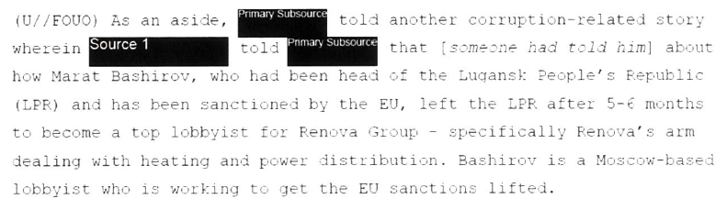
(U//FOUO) As an aside, Danchenko told another corruption-related story
wherein Sergey Abyshev told Danchenko that [someone had told him] about
how Marat Bashirov, who had been head of the Lugansk People’s Republic
(LPR) and has been sanctioned by the EU, left the LPR after 5-6 months
to become a top lobbyist for Renova Group – specifically Renova’s arm
dealing with heating and power distribution. Bashirov is a Moscow-based
lobbyist who is working to get the EU sanctions lifted.

12345678901234
St. Petersburg

53

St. Petersburg-Related Information [2016/113]
(U//FOUO) The material regarding St. Petersburg and Trump real estate
deals came from Ivan Vorontsov. Vorontsov suggested that one person to
look at regarding compromising material on Trump was [Aras] Agalarov,
as well as 1234568901234, one of the biggest real estate developers.

Talk to Agalarov, 53
(U//FOUO) Danchenko also talked to a friend of his who [ANALY
ST NOTE: either had or knew someone who had] escorted Trump while
in St. Petersburg. 1234567890123456789012, who he knew as a
teenager in Perm, was a 12345678901234567 who lived in Moscow. She
was about ** years old when she died, suddenly, last year.
Danchenko heard the bad news from her boyfriend, who sent him a picture
of her gravesite. She wrote stories which were on the critical side
of the Russian government. ****xxxxxxxxxxxxxxxxxxxxxxxxxxxxxxxx.
Xxxxxxxxxxxxxxxxxxxxxxxxxxxxxxxxxxxxxxxxxxxxxxxxxxxxxxxxxxxxxxxxx
Xxxxxxxxxxxxxxxxxxxxxxxxxxxxxxxxxxxxxxxxxxxxxxxxxxxxxxxxxxxxxxxx
xxxxxxxxxxxxxxxxxxxxxxxxxxxxxxxxxxxxxxx. He saw her in Russia
during a project circa **** 2013 ****xxxxxxxxxxxxxxxxxxxxxxxxxx
xxxxxxxxxxxxx adding that it was about 6-7 months before the
Olympics. He also saw her ****56789012 in ****xxx 2015 at a
get-together ****xxx. He said she was also ****xxxx. ****xxxxxxxxxxxxxx.
Xxxxxxxxxxxxxxxxxxxxxxxxxxxxxxxxxxxxxxxxxxxxxxxxxxxxxxxxxxxxxxxxx
Xxxxxxxxxxxxxxxxxxxxxxxxxxxxxxxxxxxxxxxxxxxxxxxxxxxxxxxxxxxxxxxx
Xxxxxxxxxxxxxxxxxxxxxxxxxxxxxxxxxxxxxxxxxxxxxxxxxxxxxxxxxxxxxxx
Xxxxxxxxxxxxxxxxxxxxxxxxxxxxxxxxxxxxxxxxxxxxxxxxxxxxxxxxxxxxxxx

Reaction of Friends to the Dossier
(U//FOUO) Reactions of Danchenko’s Friends to the Dossier
(U//FOUO) Danchenko has had friends reach out to him about Trump and
the dossier. He’s considered it normal joking – ****xxxxxxxxxxxxxxxxx
xxxxxxxxxxxxxxxxxxxxxxxxxxxxxxxxxxxxxxxxxxxxxxxxxxxxxxxxxxxxxxx.

Little Octobrist

54
12345678901. He simply jokes back. None of his friends or social
network has broken off contact because of the election or the release
of the dossier.

(U//FOUO) Friends’ Travel to the United States; Approachability

(U//FOUO) Olga Galkina

(U//FOUO) Danchenko was asked if he’d ever met GALKINA in the
United States. Danchenko said that he met GALKINA in the United States
during her visit in April 2016. She had a trip to a number of
destinations in the United States, and she stopped over in Washington,
DC. She, Danchenko, and 123456789012345678901234567890, went shopping
and to a restaurant together. Danchenko said that she came out for her
12345678901234567890. He doesn’t know exactly where she visited
while in the United States, but he thought it was ****xxxxxxx
xxxxxxxxxxxxxxxxx.

(U//FOUO) Danchenko believes that GALKINA had also traveled previously
to the United States – perhaps as many as ****x times. He knows that
she was on a ****xxxxxxxxxxxx visiting ****xxx in the mid-2000s. She
has stayed at hotels as well as at Danchenko’s place.

(U//FOUO) Danchenko is not sure if GALKINA would talk to the FBI. He
can’t speak for her. He said that she is in a ****xxxxxxxx right now
[****xxxxxxxxxxxxxxxxxxxxxxxxxxxxxxxxxxx]. Danchenko thinks if GALKINA
received a plausible job offer, she might come over. Danchenko offered
that he would carefully inquire about her plans over the coming year
(2017) and see if there are possibilities – he reiterated that he owes
GALKINA an ****xxx over the next few days about the views of Russian
speakers in the United States towards Trump.

55
(U//FOUO) Alexey Dundich
(U//FOUO) Dundich has not been to the United States in probably ten
years.

(U//FOUO) Sergei Abyshev

(U//FOUO) Abyshev traveled to the United States in circa **** - not
long after ****xxxxxxxx. Danchenko met him in the United States.
Danchenko reiterated Abyshev’s ties with Trubnikov.

(U//FOUO) Lyudmila Podobedova

(U//FOUO) Podobedova has occasional travel to Europe and Southeast Asia
****xx. She would probably be willing to travel to the United States;
however, Danchenko reiterated that she reportedly has “senior
connections” in ****xxx and ****xxx. Off-handedly, Danchenko said that
Podobedova has her own “kurator” [handler] but when interviewers
pressed him on this point, he softened that statement, indicating that
Podobedova “projects an image that she has these types of [secret]
connections and “knows the intelligence lingo.” He never reported to
Steele that Podobedova had a “kurator.”

(U//FOUO) Danchenko’s Contacts with Russian Intelligence and Security
Services (Redux); Danchenko and 123456789012345678

(U//FOUO) Given his language ability and his overseas travel as an
exchange student, Danchenko was asked if he had ever been approached by
Russian intelligence and/or security services when he was a student in
Perm. Danchenko said no. The only individuals with whom he has contact
who were connected to Russia’s intelligence and security services were

56
- his friend, 12345678901234, who worked for the FSB in order to
stay out of jail 123456789012345, (2) 123456789012345, the 12345678 in
DC who mentioned in the previous interview; and (3) FNU [1234567890],
who interacted with him and Clifford Gaddy in Washington DC. 1234567890
was the head of ****xxxxxxxxxxxxxxxxxxxxxxxxxxxxxxxx and would pester
Danchenko and Gaddy for information. [ANALYST NOTE: This contradicted
Danchenko’s earlier statements regarding having no contact with
Russia’s intelligence and security services, and it also contradicted
his earlier statements regarding not really knowing if 12345678 was
actually connected to Russia’s intelligence and security services.]

Interaction with FSB, p56
(U//FOUO) Danchenko also related a story regarding IVAN VORONTSOV’s
interaction with the FSB. Danchenko said that he remembered this story
“right before I talked to you [the FBI] this week.” Circa ****xxxxxxx,
VORONTSOV was ****xxxxxxxxxxxxxxxxxxxxxxxxx. VORONTSOV told him
(Danchenko) about this, and also ****xx a picture of the doors at
****xxxxxxxxxxxxxxxxxxxxxxxxxxxxxx. At FSBHQ, VORONTSOV was questioned
xxxxxxxxxxxxxxxxxxxxxx**** he (VORONTSOV) had made about the leadership
of Russia’s ****xxxxxxxx. VORONTSOV was also lightly threatened.
According to Danchenko, he (VORONTSOV) was told that “he (VORONTSOV)
should be more careful; that he (VORONTSOV) should watch his mouth and
act responsibly.” VORONTSOV ended up ****xxx about his interaction,
and received a lot of joking about ****xxxx.

57
(U//FOUO) Danchenko brushed aside the idea of being approached by the
intelligence and security services as a student. He explained that it
was the late ****xxxxxxxxx, and the university setting was rather lax.
He did not really attend English class all that often because his
language was already good and the classes weren’t that useful. People
smoked in class and dressed down.

(U//FOUO) Danchenko and Russia’s Diplomatic Corps

(U//FOUO) Danchenko was asked if he had ever considered a career with
Russia’s diplomatic corps. Danchenko explained that he went to a
xxxxxxxxxxxxxxxxxx**** for ****xxxxxxxxxxxx, which he identified as
****xxxxxx. Most of the graduates were told, ****xxxxxxxxxxx, for
example, that they were slated for big things in life and would be
aimed towards university at MGIMO, Moscow State, or Saint-Petersburg
University, with future careers in diplomacy, interpretation or “going
abroad.” XX years later, Danchenko remarked, probably 1/2 of the students
are abroad, in places like London and elsewhere.

(U//FOUO) Danchenko told the interviewers that he never seriously
considered going into the diplomatic corps. He never tested for it, and
he never applied for any of the major universities listed above [which
would feed into Russia’s diplomatic corps].

123456789012
Moscow State
1234567890123456 1234567890
Saint-Petersburg University

Additional Danchenko Contacts from Perm

(U//FOUO) Additional Danchenko Contacts from Perm
(U//FOUO) Danchenko was asked if – beside GALKINA and others he has
mentioned – if he has used other old friendships, schoolmates, and
known associates from Perm as sources of information. Danchenko balked,
meandered in the conversation, and did not really answer the question.
The interviewers did not press him on this at this point.

58 Contacts in the MFA
(U//FOUO) Danchenko Contacts in Russia’s Ministry of Foreign Affairs
(MFA)

(U//FOUO) Danchenko was asked about his contacts in the MFA. He
remarked that, over the years, he has collected numerous business cards
of MFA personnel, usually through contact at conferences and events. He
met Yuriy Ushakov a few times at Brookings – and remarked how Ushakov
is known to operate “independent” of Lavrov. Danchenko also met Sergey
Kislyak at a couple of events – he recalled one event that happened on
his xxxxxxxxxxxxxxxxxxxxxxxxxxxxxxxxxxxx.

(U//FOUO) After thinking about it a bit more, Danchenko whispered out
loud to himself, “Newmann.” The interviewers asked him for additional
details. Danchenko could not remember the individual’s surname at
first. He said that “Newmann” was from Perm, and that he [Pavel] was a
“strange character” Danchenko met last year. He met Pavel briefly in
Moscow. Pavel’s background was in PR/GR with the xxxxxxxxxxxxxxxxxxx.
Pavel studied 1234567890, and then took a career with the MFA.
Danchenko described 12345’s MFA job as “a delivery boy” but added that
it was strange because 12345 “did not seem to be qualified for the job
that he had [at the MFA].” Eventually, Danchenko recalled that 12345’s
surname was 1234567890123.

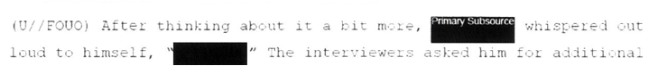

(U//FOUO) After thinking about it a bit more, Danchenko whispered out
loud to himself, “Newman!” The interviewers asked him for additional
details.

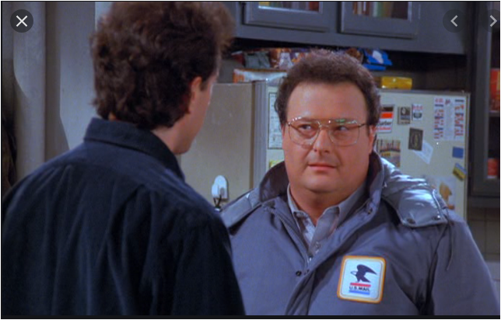

2010 per Indictment, 15
Orbis was founded in 2009. https://orbisbi.com/about-orbis
Indictmnet, 16
Married to Tanya Demydenko
Department K of the FSB In April 2018, the former head of the Moscow Region’s Serpukhov District, Alexander Shestun, uploaded to YouTube a recording of a conversation with Yarin, FSB Department “K” director Ivan Tkhachev, and Mikhail Kuznetsov, the deputy head of the Moscow Regional government. In the recording, the three officials demand that Shestun leave office, threatening criminal prosecution if he refuses. After Shestun called their bluff, he was in fact charged with felony corruption. https://meduza.io/en/feature/2019/10/11/russia-s-technocrat-in-chief https://warsawinstitute.org/top-fsb-officials-jailed-oligarchs-struggle/

