Are you looking for more adventure in your life? Do you need to find new ways to excite yourself? Are you running out of exciting summer activities? ZORBING is the answer.

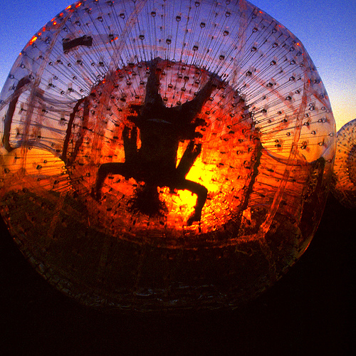

Hours of Operation
9- 11
12- 2
2- 4
4- 6

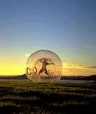
Zorbing at the Haliburton Sustainable Forest
Haliburton Forest at: RR #1, Haliburton, Ontario, K0M 1S0
Phone: (705) 754-2198 Fax: (705) 754-1179
Zorbing at the Haliburton Sustainable Forest
“It’s not everyday you can go on a wild adventure ride in a life size hamster ball!”

Harness Zorbing
The Zorbonaut is strapped into a harness and rolls down the hill. This gives you maximum G force as you tumble head over heels. There is a sensation of weightlessness at the top of the Zorb, and the view of green grass followed by blue sky followed by green grass followed by blue green blue green and then the water ride.

Hydro-Zorbing
The Zorbonaut is not harnessed in the Zorb but is completely loose in there with a bucket of water (Yes we have warm water too!) You (and two of your closest friends if you want) slide on the bottom of the Zorb, face first, feet first, arms, heads, and legs first, sitting down, standing up, backwards or inside out.

.

For those of you who may be hungover, try hydro-zorbing it will be just the cure!!

Get yourself videotaped or a blown up photo of you flying off the ramp!!!


Some Interesting Facts for you:
- It’s an extreme sport without the competition and the risk of getting hurt.
- No real athletic skill required.
- Since 1990 there have been 500 zorbs made.
- You and your two friends can go in a zorb together!!!!

Its Your Chance To become a ZORBONAUT and experience our Zorbing Adventure!!!!!!

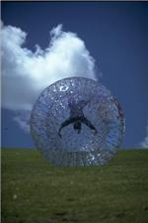

Call (705)714-2198

How to Customize This Brochure
You’ll probably want to customize all your templates when you discover how editing and re-saving your templates would make creating future documents easier.
- In this document, insert your company information in place of the sample text.
- Choose Save As from the File menu. Choose Document Template in the Save as Type: box (the filename extensions should change from .doc to .dot) and save the updated template.
- To create a document with your new template, on the File menu, click New. In the New Document task pane, under Templates, click On my computer. In the Templates dialog, your updated template will appear on the General tab.

About the “Pictures”
The “pictures” in this brochure are Wingdings typeface symbols. To insert a new symbol, highlight the symbol character and choose Symbol from the Insert menu—select a new symbol from the map, click Insert, and Close.

How to Work with Breaks
Breaks in a Word document appear as labeled dotted lines on the screen. Using the Break command, you can insert manual page breaks, column breaks, and section breaks.
To insert a break, choose Break from the Insert menu. Select one option. Click on OK to accept your choice.

How to Work with Spacing
To reduce the spacing between, for example, body text paragraphs, click your cursor in this paragraph, and choose Paragraph from the Format menu. Reduce the Spacing After to 6 points, making additional adjustments as needed.
To save your Style changes, (assuming your cursor is blinking in the changed paragraph), click on the down arrow for the Style in the Styles and Formatting work pane. Select Update to match selection to save the changes, and update all similar Styles.
To adjust character spacing, select the text to be modified, and choose Font from the Format menu. Click Character Spacing and enter a new value.

Other Brochure Tips
To change a font size, choose Font from the Format menu. Adjust the size as needed, and click OK or Cancel to exit.
To change the shading of shaded paragraphs, choose Borders and Shading from the Format menu. Select a new shade or pattern, and choose OK. Experiment to achieve the best shade for your printer.
To remove a character style, select the text and press Ctrl-Spacebar. You can also choose Default Paragraph Font from the Styles and Formatting work pane (accessible from the Format menu).

Brochure Ideas
“Picture” fonts, like Wingdings, are gaining popularity. Consider using other symbol fonts to create highly customized “Icons.”
Consider printing your brochure on colorful, preprinted brochure paper—available from many paper suppliers.

At Fees You Can Afford
We can often save you more than the cost of our service alone. So why not subscribe today?

Call 555-0000

