Alexander, J. (2000). Adaptive strategies of nonprofit human service organizations in the era of devolution and new public management. Nonprofit Management and Leadership 10(3), 287–303.

Bramwell, B. & Lane, B. (2000). Tourism Collaboration and Partnerships: Politics, Practice and Sustainability. Great Britain: Biddles Ltd.

Chavez. D., and Selin. D. 1995. Developing an evolutionary tourism partnership model. Annals of Tourism Research., 22(4).

Gonz, G. (1997). Guide to Management of Entrepreneurial Organizations. London: SAGE Publications Ltd.

Howell D.W., Bateman Ellison, M., Ellison, R. & Wright, D. (20003). Passport: An Introduction to the Tourism Industry. Scarborough: Nelson, a dision of Thomson Canada Limited.

Jamal, T. & Getz, D. (2000). Rethinking Collaboration and Partnership: A Public Policy Perspective. In Bramwell, B. & Lane, B., Tourism Collaboration and Partnerships: Politics, Practice and Sustainability. Great Britain: Biddles Ltd.

Kuniyal, J. C. (2005). Solid waste management techniques for the waste generated and brought down from campsites in the hill spots, trails and expedition tops. Waste Management & Research, 23(3), 182-198.

Lacy, T. & Boyd, M. (2000). An Australian Research Partnership Between Industry, Universities and Government: The Cooperative Research Centre for Sustainable Tourism. In Bramwell, B. & Lane, B., Tourism Collaboration and Partnerships: Politics, Practice and Sustainability. Great Britain: Biddles Ltd.

Plummer, R. & Fitzgibbon, J. (2004). Co-Management of Natural Resources: A Proposed Framework. Environmental Management 33(6), 876-885.

Reed, M.G. (2000). Collaborative Tourism Planning as Adaptive Experiments in Emergent Tourism Settings. In Bramwell, B. & Lane, B., Tourism Collaboration and Partnerships: Politics, Practice and Sustaiability. Great Britain: Biddles Ltd.

Robinson, M. (2000). Collaboration and Cultural Consent: Refocusing Sustaianble Tourism. In Bramwell, B. & Lane, B., Tourism Collaboration and Partnerships: Politics, Practice and Sustaiability. Great Britain: Biddles Ltd.

Selin, S. (2000). Developing a Typology of Sustainable Tourism Partnerships. In Bramwell, B. & Lane, B., Tourism Collaboration and Partnerships: Politics, Practice and Sustainability. Great Britain: Biddles Ltd.

Sofield, T.H. (2002). Australian Aboriginal Ecotourism in the Wet Tropics Rainforest of Queensland, Australia: Mountain Research and Development 22 (2), 118-122.

The World Bank Carbon Finance Unit (n.d.). About World Bank Carbon Finance Unit. Retrieved November 15, 2007 from http://carbonfinance.org/Router.cfm?Page=About&ItemID=1

Timothy, D.J. (2000). Cross-Border Partnership in Tourism Resource Management: International Parks along the US-Canada Border. In Bramwell, B. & Lane, B., Tourism Collaboration and Partnerships: Politics, Practice and Sustainability. Great Britain: Biddles Ltd.

United Nations Environmental Programme, 2001. Negative socio-cultural impacts from tourism. Retrieved November 6, 2007, http://www.uneptie.org/pc/tourism/sust-tourism/soc-drawbacks.htm.

United Nations World Tourism Organization (n.d.). UNWTO-Sustainable Development of Tourism. Retreived November 15, 2007 from www.unwto.org/frameset/frame_sustainable.html

Wall and Mathieson (2006). Tourism: Change, Impacts and Opportunities. Essex: Pearson Education Unlimited.

World Bank (2007). Development and Growth in Northeast India: The Natural Resources, Water and Environment Nexus (Report No. 36397). Retrieved November 3, 2007 from http://www.mdoner.gov.in/writereaddata/sublink3images/WBWaterStrategyJan26073424960695.pdf

Yandle, T. 2003. The challenge of building successful stakeholder organizations: New Zealand’s experience in developing a fisheries co-management regime. Marine Policy 27, 179–192.

(Reed, 2000).

For leahs partnership part, can add, see appendix for further benefits of partnerships

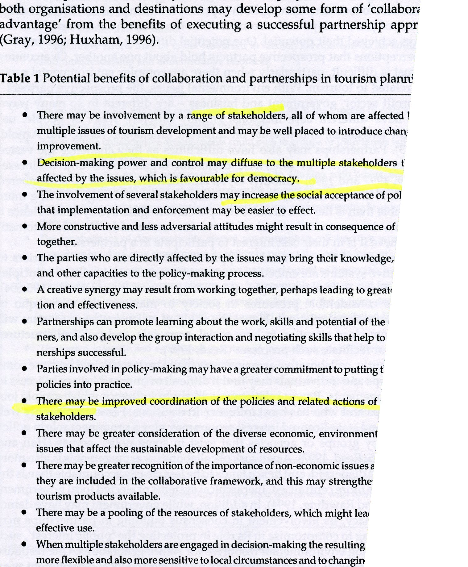

(Bramwell and Lane, 2000, p.7) – may want to rescan because this is cut off

