Destination Management Models
•There are a number of critical questions that destination
managers want answers to:
•What is the most desirable spatial configuration to facilitate
the flow of tourists, goods, and services to and within a
destination region?
•How can a destination's spatial structure be manipulated
to enhance its ``sense of place'', to promote a sense of
security, and to heighten environmental ``legibility'' for
tourists who find themselves in an unfamiliar environment?
-* get this note*

Destination Management Models
•Can the spatial structure be manipulated in order to
facilitate the protection of natural, social, and built
attributes which make a destination appealing?
•
•Destination managers need tools in the form of
–
–
–
–
in order to facilitate destination region design and
development

Waiter Christaller (1963) Central place theory:

-how tourism attractions develop over time:
-Destinations develop and change over time
-There are different types of visitors at different times
-The tourist experiences the tourism product) changes over time
-The impacts on the destination change over time
-the involvement of locals in tourism destinations changes over time
-New cycles involving new tourist destination will occur
-From Christaller’s ideas came a number of models that help us understand the evolution growth and management of tourism destinations

-Models tourist travels flows between regions, identifying 3 distinct types : access routes, return routes and destinations

Point A---------- point B ------------point A

(know its not as simple, theres a transit route)

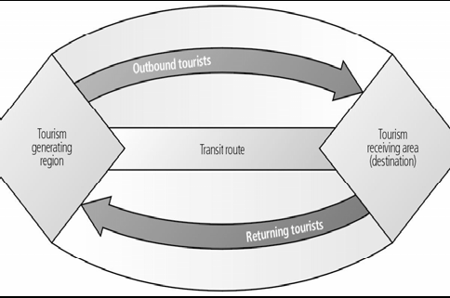

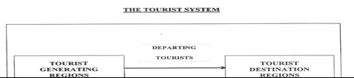
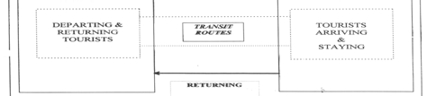
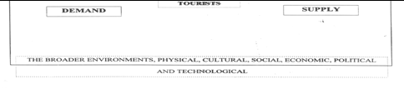

Personality Type Models
•Propose a model of the evolution of tourism in a destination based on a succession of tourist personality types
•Cohen (1972): Segmented tourists by motivation, degree of independence and experience sought
– _Organized Mass Tourist: Package tours where itineraries are fixed; and all major decisions are left to the organizer
–Individual Mass Tourist: Some control over itinerary; but all major arrangements are made through a travel intermediary
– Explorer: Plan their own trips; avoid developed tourist attractions; complete freedom of choice at destination; do not use intermediaries (Avoid the beaten path)
- Drifter: Completely immersed in host culture (Backpackers live in culture)

Personality Type Models
•Plog (1974): A ‘psychographic’ typology, by attitudes to
travel and type of destination sought

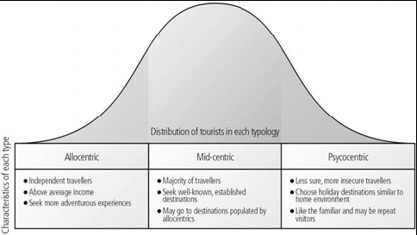

psychocentric- Florida , Vegas, mid-centric- Dominican, cuba Allocentric- Ice hotels in Sweden, Artic, Africa, Scuba Diving in Indonesia

Destination Lifecycle Model
•Adapts the product lifecycle model to explain why
destinations rise and fall in popularity A

(See chart)

Rejuvenation (Bottom to top) (Critical range of elements of capacity)
Decline
Stagnation
Consolidation- Established, physchocentrics, but not really new people, number of tourists begins to flatten
Development
Involvement
Exploration

This model has some strengths:

Strengths:
-The model provides a conceptual framework for understanding change within a destination
-Highlights the idea of a carrying capacity

(social, env., built env., cultural carrying capacity)

Weaknesses:

-Difficult to apply model to destinations because the model is really destination specific---each stage is variable in length, generating different shapes and patterns for the model…therefore not universal model

-Difficult to operationalize (i.e. measure)

-it’s utility for tourism planning still needs to be demonstrated

Determining carrying capacity:
-Simple concept…difficult to implement and measure (came from looking at ecosystems and sustainability)
-Dynamic nature of ecosystems makes it difficult to calculate
-It can be increased/decreased by management actions/human use
-it’s NOT a fixed value (no magic number)
-It’s different for different uses (social vs. env.)
-Varies spatially and temporally
- *

-

An evolution of carrying capacity which was considered by many is:

-Centered on biological factors and not considering people’s behaviour
-Demanding too many conditions (information, data)
-The Limits of Acceptable change approach is based on three major assumptions:
- Impact is inevitable, so the focus is on identifying how much impact is acceptable
- Diversity of environments and social conditions exist: tourism may generate different outcomes for different situations
- Sustainability is reached through the establishment of management practices to reach desired outputs

LAC (Limits of Acceptable Change) consists of 4 major components:

-Specification of acceptable and achievable conditions
-Analysis of existing conditions and acceptable change
-Identification of management actions to achieve desired conditions
-A programme of monitoring to evaluate management effectiveness
(That’s where benchmarking comes into practice)

-Conceptual difference LAC and CC:

-Carrying Capacity is aimed at deciding how much impact a resource can sustain:
-LAC tries to define how much change the stakeholders are willing to accept in the use (or not) of a resource through the identification of the desired social, env., economic and cultural conditions

-Describes the spatial evolution of coastal beach resort in eight stages from rural settlement to resort community

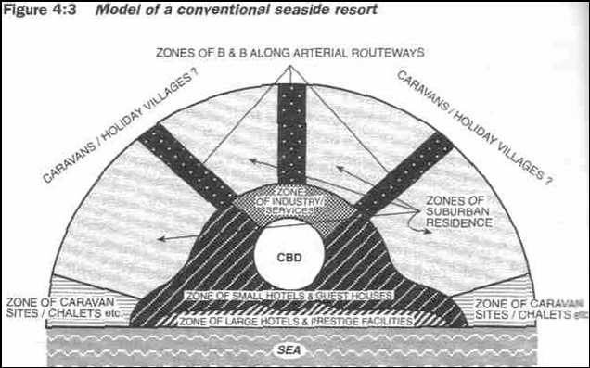

-Most popular type of tourist resort
-Sea, beach and landscape as physical resource
-Land patterns determined by growth
-Growth may be spontaneous and unplanned
-Generally follow a linear pattern along the coastline
-Smith’s model of beach resort development:

Stage 1: Pre-tourism (1920’s…when it became socially acceptable for women to wear bathing suits)
2: Second Homes, Cottages
3: First Hotel (Jobs in tourism)
4: Resort Established (Strip development)
5: Business Area Established (More accommodation, for workforce)
6: Inland hotels (too expensive to stay by beach)
7: Transformation (Urbanized resort)
8: City Resort (Distinct commercial and recreation areas)

(Not every single situation, but gives a sense of how tourism would develop at a very specific destination)

-Factors influencing degree of socio-cultural impacts in a community
-Prosser (1998): four things that affect intensity of socio-cultural impacts of tourism-
- Ratio of visitors to locals ( the higher the ratio of visitors the higher the impact)
- The “cultural distance” between hosts and guests (The More the “cultural distance” the higher the impact
- The speed at which tourism is introduced (The higher the speed of introduction, the higher the impact)
- Size of host population/land mass (Would large communities/land mass or small communities/ land mass would be able to better adopt to the impacts of tourism?)

Doxey’s (1985) Index Model of the stages of social impacts of tourism:

Stage 1- Euphoria : first stage, excited by influx of visitors
2: Apathy: Initial enthusiasm Is gone tourists are seen as common and ordinary
-Host-Visitor * *
3: Annoyance/imitation : residents become concerned and irritated by tourists
-community is saturated by tourists and may start planning to isolate tourist activity to tourism sectors or corridors
4: Antagonism: Residents develop mengative stertypes of tourist
-residents no longer welcome tourst in their community

(Model too linear? Not all residents feel this same way about tourism (When working may be more excited because personally affected as a stakeholder)
-Desintation can skip stages)

Spatial Model of Potential Socio-Cultural Impacts in Areas of
Canada


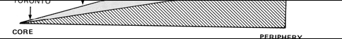


The larger the cultural and economic difference between tourists and local residents, the more obvious and significant cultural changes are

Problems and Promises
•Problems with these models:
•Travel patterns models primarily based on North American
destination regions where the automobile travel dominates
•Thus these models have limited applicability to other types of
destination regions
•Models like the Beach resort model have tended to reflect what is there (descriptive) and not what should be (ideal)
•Models that attempt to describe some evolutionary process but are neither explanatory nor predictive and hence of limited use in planning destination regions
-Many models lack wide ranging appliciability across different types of destiatnions such as island and land-based destinations or those of different scales (e.g. regions or nations)

