What is a destination?

According to the WTO think tank definition:

A local tourism destination is a physical space in which a tourist spends at least one overnight. It includes tourism products such as support services and attractions and tourist resources within one day‘s return travel time.

It has physical and administrative boundaries defining its management and images and perceptions defining its market competitiveness. Local destinations incorporate various stakeholders often including a host community and can nest and network to form larger destinations.

Ex- no host community- In a resort.

What are some of the characteristics of a destination?

-Basic unit of analysis in tourism
-A distinctly recognisable area with geographic of administrative boundaries that tourists visit and stay in during their trip (geographic boundaries)
-Destinations offer an amalgam of products and services under the destination brand
-A local point in the development and delivery of tourism products and the implementation of tourism policy
-Destinations can vary by jurisdiction, authority
-E.g. nation or country, provine orstae, localized region – Costa de Sol
city or town, unique location (national park), unique attraction (Disney world)

-Destinations can vary by type of experience

e.g. –Sun/Sea expeirnce, adventure experience, family travel experience, educational or learning expeirnece, quick get away experience, VFR experience, special event experience

Destinations within destination
E.g. continent, region, country, district, route, city, town, attraction, etc.

-Range of destination products and services that covers the entire tourism value chain
(From A-B and back to A)- not the destination itself but the airport delay on way home

Basic elements of a tourism destination:
-Attractions the motivation for the visit
-built eg. Monuments, cathedrals
-Cultural e.g. museums
-Emotional or experiential triggers

Amenities:
-basic infrastructure e.g. utilities and roads
-Direct services e.g. accommodation, visitor info, catering, shopping info

-Serviced by both public and private sector- highly interdependent
-Destinations are physical , but also intangible (image, identity, personality)

-Often perceptions overshadow reality (cheap vs. exclusive, safe vs. dangerous)

Spatial characteristics:
Scale and Boundary
host community elements
Management (supply) orientation
Marketing (visitor) orientation

The “What” and “Why” of destination management:

-What is destination management?
-The co-ordinated management of all the elements that make up the destination
(env. , culturally sustainability, politics, linkages with other destinations, economics, in our defined administrative boundaries)

Tourism Related Economic Activities

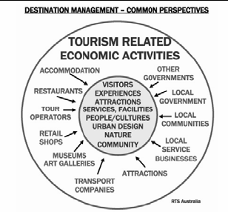

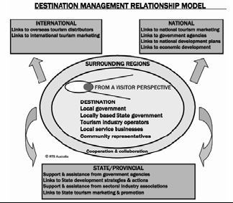

Destination managers addresses key functions:
•Adding value to the longer term prosperity and development of the llocal communities

•Ensuring satisfactory visitor experiences (ideally the expectations of
visitors will be exceeded)

-Optimizing th eprofitability objectives of the business sector (which is often the ____ of any destinations tourism industry

•Optimising the economic,social and environmental impacts by ensuring a responsible and sustainable balance between economic, socio-cultural and environmental interests

Success in destination management

-Positioning and differentiating the destination and image management are key factors
-Providing ‘through the chain’ positive visitor experience

-knowledge and understanding of the needs of our target markets
-product innovation and management
-professionalism in service levels and overall human resource management
-Creating meaningful public –private sector partnerships
-Capitalising on the opportunities provided by new technologies
-Balancing the strategic goals of the stakeholders and optimizing the economic, social and impacts on the destination

Conclusion:

-What is a destination?
-What are some of the characteristics of a destionation?
-Why do we manage tourist destinations?
-What is managed at a destination?
-Destination management is very complex
-Leadership, co-ordination and partnerships necessary to make tourism work at destinations
-Competiveness vs. Sustainability

