Contest rules.

If your package plays Elvis’s classic song “Hound Dog”, then you will win the ultimate prize of a trip to North New Zealand to help aid in the search of finding his long lost son.

Secondary winners will hear the song “Don’t be Cruel”, and they will
win a set of his discography and an Elvis t-shirt.

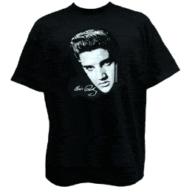

If you are a winner, please visit www.elvisegg.com for further details

