Running head: KALEDUPA FIELD JOURNAL

Field Journal: Research Based Eco-tourism at Kaledupa Island
Emily McIntyre
3378148
TREN 3P90
John Middleton
July 12, 2007

June 26 (Day before journey to Kaledupa in Southeast Sulawesi):

I still do not know what to expect when I arrive to my research base, although I do know that I am destined for one of, if not the most unique trip of my life. The extensive medical list that I had to purchase before I left is quite intimidating, although I do know the research group just wants to take the proper safety precautions.
If people were aware of the beauty, remoteness and diversity on the island, I’m sure there would be a draw to come this area of Indonesia. Although because it is so expensive, a long, long journey and so away from everyday, westernized life in everyway possible, it does not entail ‘soft’ eco-tourist to travel here. Therefore, this trip is only appropriate for ‘hard’ eco-tourists who have high levels of commitment, and therefore research-based eco-tourism seems to be an appropriate form of tourism that Operation Wallacea has introduced to the island. The marine park contains one of the most diverse eco-systems in the world. Therefore, dive training offered by Operation Wallacea is also an excellent way of incorporating divers and research. Although, it may be hard to market this destination as there are other scenic and diverse reefs in Indonesia and Southeast Asia that do not involve a two and a half days of travel on local ships and planes that are far from westernized comfort.
Considering the nature of travel to this destination, it may be hard for the tourist, student or researcher to have someone accompany them and therefore may end up on their own. Which is why I deemed it important to document my travels to this site, as being a white female with blonde hair, blue-eyes and an American accent in a third-world Muslim country, not knowing Indonesian, I knew I was bound for an interesting and difficult journey.
I arrived in Bali, at 10 p.m., although I envisioned the Balinese, as a friendly and happy culture despite being faced with poverty, arriving at an international airport late at night was quite a scary feeling for me. I was not in anyway reassured when I was in the departure line and the first Balinese to speak with me asked, “Are you alone?” in a tone as though I was out of my mind. When I stepped foot outside the airport, I was bombarded by many men holding signs for taxi’s, some dodgy characters as well as the homeless, which if I wasn’t being met by a driver from my hotel, I would have had a minor anxiety attack.
During the drive to the hotel, I was envisioning going for a nice swim, then going to bed, but I was thwarted to find that I was scared to leave my room. As I figured 18 Great British pounds would take me a long way in Indonesia I landed with the first room, on the ground floor, right by the parking lot, exactly where any guidebook and Canadian government document tells you not to get a room. I simply chose to avoid any weird noises that I heard outside my hotel room, double checked that my door was locked and envisioned the beaches and jungles I was about to set foot on in Kaledupa.
June 27 (Bali-Makassar-Kendari):
When I woke up to have breakfast, I figured there would be no harm in double-checking what the time was. Upon doing so, I found out it was 8:30 a.m. and my flight was at 9 a.m. I have never rushed that much to get ready or lack there of, and one of the hotel members raced me to the airport. This is when I realized how thankful I was that Operation Wallacea had worked with local tour operators to ensure everything was set up in advance, so I did not have to worry about paying in money that I was still not very familiar with. Miraculously, I made the flight even after an extensive bag check of being accused of having a knife, where an extensive bag check was followed. My thoughts at this time resembled one of the over-paranoid adults that I have spoken to about watching my bags and checking them over and over again. Although, I know I cannot be naïve about horrendous situations, which may very well happen, I always just look at the odds? On my plane ride there was an empty seat in between me and the other passenger, which soon after the Indonesian man decided to switch to the middle seat, which was in my mind a little uncomfortable as well as unnecessary as he was acting as though he was in the way of the stewardess.
When I arrived in Makassar I had no idea I was meeting other group members from Operation Wallacea and I was lost and confused. I was asking several airlines if they have my name scheduled to fly with them, none of them knowing any English, when I finally came across a man who knew enough English to say ‘Operation Wallacea’ and point in the general direction. I decided to confront the only other Caucasian’s that were in the airport. I was very thankful they had waited for me, because what I thought was going to be a five-hour wait in a very local airport turned out to be a day trip to the waterfall. This was a wonderful way to break up the trip for these tourists (as it is an extremely long journey, the flights are unpredictable due to the weather and it gives the group a chance to relax and see yet another of the beautiful Indonesian islands from a different angle). I found this area very beautiful, as it was in no way a Westernized tourist area, which was quite refreshing. In fact, it was quite the opposite, I almost felt as though they were the tourists in their own country, as my picture was taken almost fifty times. I know that white skin represents status, and I honestly felt like Angelina Jolie when I was around them as both genders of various ages were taking photos with me, including some family shots with me in them. It was quite possible that they have never come across a white person before, and if so, in very rare cases. It was very pleasant experience and the locals carried an eager sense of charisma to them. As this is a very new experience for me I was especially swept away by the friendly cultural greetings, but the waterfall was also amazing as well as the hike alongside it. Which was particularly appreciated as my original plan for the day was to be in the airport dealing with a day of muscle cramps.
Makassar to Kendari:
This was a very local flight, which was carried out in the rain by the end of it the stewardess was walking around with torches as the lights were out of commission. I collected my luggage to find that it was dropped in a dirty muddy puddle, and had all sorts of dirt all over it. As I look back now, this is only a minor detail of some of the rough circumstances, that many Westerners would let hamper their experience.
June 28: The 2 and a half-day Ship Journey Begins:
-Little boy sick the whole trip and holding composure, couldn’t imagine a Western kid acting in the same manner
-Workout mats squished together for beds
-Squat toilets in the dark (which was literally a hole in the wood)
-Live chickens everywhere
-The trade that happened along the way (Men in canoes and little motor boats waiting for our ship, where live chickens were traded and other supplies, even a motorbike).

Background and Prior Understanding of Kaledupa:
-As there is a lot of political unrest in Indonesia, which involves a corrupt government who just wants to pocket money for their own economic benefit, this threatened the Wakatobi
-75% of the parks revenue went to Jakarta and 25% to the park
-Now it is the other way around so the park is seeing the benefits
-There will not be a complete takeover by Operation Wallacea (pertaining to Hoga), as government regulations do not allow foreigners to be landowners, which will keep the Indonesians that have become landlords on Hoga employed
Perceived view of Kaledupa from journals where outside companies evaluated them:
-Perceived them as a research-based eco-tourism venture
-Found it to be positive, other then the social implications of seeing the Westerners way of dress and alcohol consumption patterns
-See the activities as sustainable if the tourists act appropriately
-Concerned about the transportation factor as it involved an international flight and four domestic flights (there and back)
-I did not really know what to expect of the local culture itself, other than their religious customs or comparing them to Balinese, which although are both Indonesian live a completely different lifestyle

June 29: Arrival at Hoga
We started out on Hoga so we could do our paperwork and have a lecture on rules, safety and acting as sustainable tourists and so on.
Introduction by the Western manager on the island some of the issues covered:
-Respect corals and land environment
-Smoking
-Drunkenness
-Dress
-Leave no trace
Sustainable Tourism Introduction in more depth:
-Not just researchers, but also tourists
-Social Benefits: Loads of local staff that receive economic benefits in areas such as the Kitchen, library, boats, security, etc.
-The Indonesians are enthusiastic about Westerners learning the language and like to learn English. (Although does not seem to be prevalent on Hoga, considerations of optional courses led by the Indonesians may be a recommendation)
How to reduce: Awareness of how we are a big group and putting lots of pressure on water (having mandys that are only 1-2 litres) as well as our pressure on food sources
-How fish is offered once a day to not overuse stock
-Keeping power consumption down, have a generator on at peak hours, not electricity in housing
-Squat toilets: That volunteers use salt water in a bucket to flush down (Although, we do use toilet paper, which is tossed in a bin, which does not seem that hygienic to me)
-Although this is far better than integrating westernized toilets
-Two computers that supply Internet and this is the first year this has been offered, so that keeps away from power consumption
-Asking the volunteers to take home what they can such as batteries and plastic bottles (should be reinforced before they leave)
-Cigarette areas far away from wood housing
-Talks about how the locals pollute and how the Westerners should set an example, act like you would in your own country
Positive: When managed properly great local contributions
-The payment for the expedition goes to the families involved (Although this fails to mention that 50% of the money goes to the office in the UK and the families that it goes to are mostly the ones that are already wealthy)
-Source food locally with the odd exceptions (tea, jams, pineapples) – Stopped using peanut butter as they thought there would be better usage for the money spent on it
-Local shops- snacks, sarongs, drinks
(This shows that many of the benefits are economic and not environmental, but in many cases, the only positive impact that tourism has on the environment is reducing it from further damage. In this case, Operation Wallacea has done so by proving from their research that the marine park is one of the most diverse in the world and therefore a no fishing zone was set in place. And has offered scuba diving as a way of differentiating the economy)
Cultural Sensitivity:
-Largest Muslim country in the World
Tips 1) Dress 2) Shoes off in building 3) Learn new secret handshake (very rude to involve left hand, as it is the one they use to clean themselves in the bathroom) 4) Respect elders and betters (status) 5) Learn about the culture 6) Share food, drinks and cigarettes 7) Can’t actually experience true culture unless you live like them (used for research but also true for tourism) 8) Spread your money to local villages- handicrafts, dance demonstrations, consider going to different markets not just the most convenient ones
Week One: Based at Kaledupa and partaking in a community and conservation course
Week Two: Based at Hoga where I am doing my Open Water Dive course while observing the tourists and interviewing them on their beliefs and behaviours
Homestay:
Took a boat over to Kaledupa the same day where we were immediately placed in our homestay. Luckily I had brought a phrase book, which my roommate did not have, or it would have caused for a pretty difficult week. For my Mamma Ate’s English was as limited as my Indonesian. As I knew they are very proud of their culture and in all due respect we spoke only in Indonesian in her home. This was of course unless she wanted to hear the English word or she was not around and we spoke to each other. My vocabulary consisted of the basic words, phrases, useful terms that would help me around the house and tried to tie in the culture in my speech, such as “Is this fish the local specialty?” It was quite hard considering I had trouble understanding her answers.
The experience was so amazing and so different, and I love how positive it felt for everyone on that island. It was definitely an eye-opening experience to write home about.
Pros:
-Direct money from the expedition to the homestay
-As well as additional ways of earning income such as laundry, selling goods and sarongs
-More appreciation and better understanding of their culture when you truly live with and like them
-Enforces positive relationships
-Improvements in language (both Indonesian and English)
-Therefore Westerners show they are making an effort to learn more about their culture and it helps to remove barriers when a level of understanding to the language is learnt.
-Help understand needs more after you get to know them
-See people for who they are
-Breaks down barriers between different cultures
-A lot more of an effort is put into immersing with the culture, rather than just sticking with the Westernized group
-Helps them get a better understanding of the Westernized and therefore reinforces positive relationships and therefore will be happier about tourism on their island
-Money is not outsourced from outsiders and hotels but goes directly to the community
-Brought biodegradable laundry soap, for them to use, rather then the chemicals they use their laundry with that goes directly into the sea (All the Western staff didn’t seem to follow this rule)
-Learning about culture which reinforces the importance and gives them a sense of pride
-‘Mamma’ at the home stay is paid to make breakfast and dinner for tourist, which allows for the tourist to indulge in local culture as well as helps the ‘Mamma’ make some money.
-Many of the tourists brought gifts, particularly for the children-such as toys.
Negative:
-Most of the families involved are those that are already considered rich on the island, and are family that the males have government jobs or fishing jobs in Malaysia.
-Money is not spread around enough (could give laundry to different families, or support other markets rather than the most convenient or individual sarong makers)
-Westerners have taken a lot of steps but have not completely adapted to the lifestyle of the Kaledupans. For example: Using toilet paper, or those who accidentally drop it down the toilet.
-Too much water consumption, as Westerners feel the need to shower and wash their hair everyday, which requires way more water. At Kaledupa, shampoo and conditioner is a foreigner concept to them, and even if you wanted some would not be able to buy it on the island. My Mamma Ate was so curious what was in all my bottles. She wanted me to give her some in a cup, which can be considered negative, as it is imposing Western ideals, although, it was in my bedroom and she grabbed them, and asked for some, so I felt bad saying no.
Most of the Westerners were really surprised at the quality of housing and did not have that high expectations.

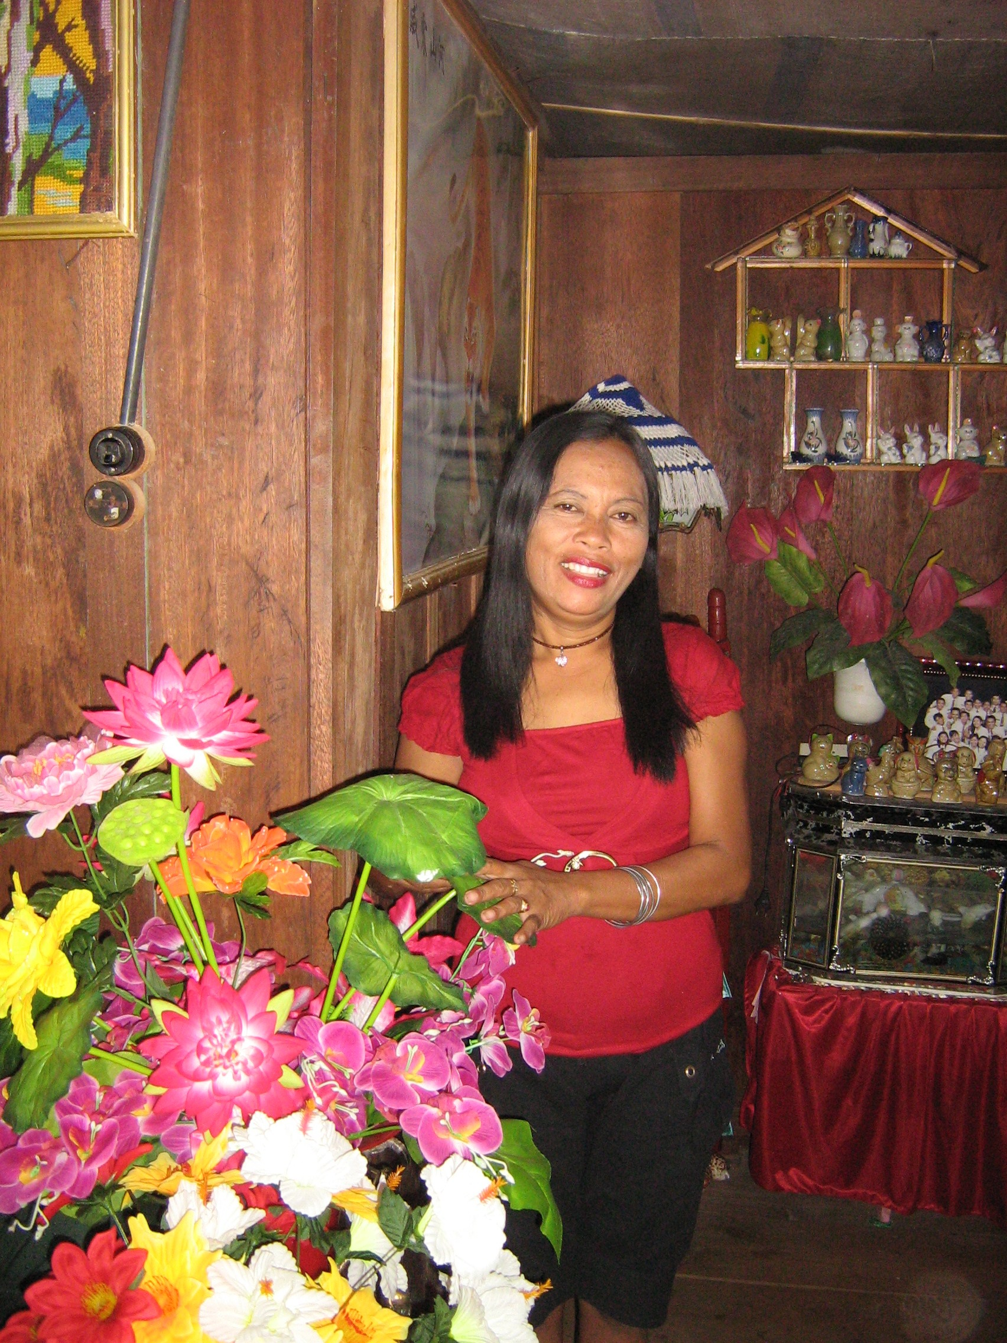
(Above: Mamma Ate, in her wonderfully decorated home and the necklace I gave her)
Energy consumption: There is electricity at the office although they do use energy efficient light bulbs.
-Using the generator for laptops although it is only seldom turned on. (Therefore energy consumption was not that bad, as modelling the Kaledupans the generator was turned on after 6, when it was too dark and light was required and was not on during the day).
-Money just going to Ambuea, Kaledupa and not being spread to other villages
-Everything is heavily concentrated in that area, which happens to be the rich area
-As much as it is encouraged to spread your money, tourists were still buying drinks and snacks from the most convenient markets
-There are 16 other villages there, which are not incorporated, although some trips to have talks with stakeholders in whom are paid and to see traditional activities in different villages were incorporated (Although there are lots of farmers and what not, so many are not annoyed by tourists as it doesn’t effect them)
-Help them learn to appreciate how to protect their environment and reefs such as not to practice fish bombing and to focus on traditional fishing
Different Stakeholders of the Community:
-This is to get a more holistic view of the social, economic and environmental situation of the town and how important the need for tourism as a way of differentiating the economy. To understand how important helping to preserve the reefs and benefiting the socio-cultural community really is.
Aim: Through observations to gain insights on how those behave and respond to tourism in the community. Attending speeches by the stakeholders of the community helped to gain a perception on their thoughts and feelings.
Conservation and Fisheries:
Went to Hoga where there is a seaweed farm just off of it and the Seaweed Farmer gave us an outside lecture.
-The more money he makes the longer he leaves the seaweed.
-Measures time by the winds (May be an adoption to tourism, going by Indonesian time by forces of nature and the sea rather than a calendar and clock), although Operation Wallacea has taught Indonesians punctuality and to run by a clock.
-Sells seaweed to a local buyer in Bau Bau or Wanchi, which is used for pharmaceuticals and in processed foods.
- Disempowered as it is not direct, and he does not know whom his seaweed is going to, therefore there are differences in price he selling and what he is making.
-Seaweed farming is environmentally sound as far as researchers are aware, and therefore is a big alternative for their economy
-Fishing and farming are men’s jobs and women are not involved
-Many of the adolescence now want to study and get a more proper job
-Therefore, tourism can coincide with seaweed farming both as ways to help differentiate the economy, as tourism also helps to employ women)
-Should reinforce the traditional side of things as the sea farmers have changed from canoes to motorboats, and have fish fences and gill nets
Kaledupan Farming and Traditions:
-Communities and their agriculture (Stakeholder is the other head to the Forkani, the Non-government organization highlighted below)
Lecture:
-Expert in history and culture
-Information about the past not spread through history books, but through knowledge kept in their minds and therefore works to bring together everyone with religion
-Local government provides a basket for fishers, so if you take from the environment it is a way of to give to others and share. (This is something Operation Wallacea should consider, as it is appealing to their culture and being environmentally friendly).
-Fear of fish bombing
-Past farming was very traditional used a stone or a spear
-Now they use fish fences made of bamboo or mangroves
-Gleaning was huge for shells, now it does not happen very often
-As Bajo is the minority in the community they are often blamed and used as scapegoats (I also noticed this with the Westerners, who seem to have the attitude that the Bajo are ruining their reefs, as though the reefs are more theirs than the Bajo’s. They have made zoning rules so the Bajo cannot fish in certain areas and tourists can use the reefs, while damaging them through diving.
Women’s Role: Men are embarrassed when the wife works or finds food as they see is as loss of face, if the women have to seek and work for themselves.
Technology will play a role in farming if the prospect is really good and it is more efficient.
Artist: Traditional Sarong Making:
-Used leaf, ash, sea water, for strong colours leave it for 5 months
-Skins from corn to tie it up
-Bamboo as a base for the sarong making
-No detergents, just water
-The lady was paid to show us how to work, but they should offer tourists to participate and set up a little workshop
Two women- Two sarong a day (Once tourists see the long hard process they go through they would be more willing to buy the sarong, as it is quite expensive, a price you would pay in your own country if not more. I questioned how the Indonesians afford them, but they are intended for the special occasions, such as weddings)

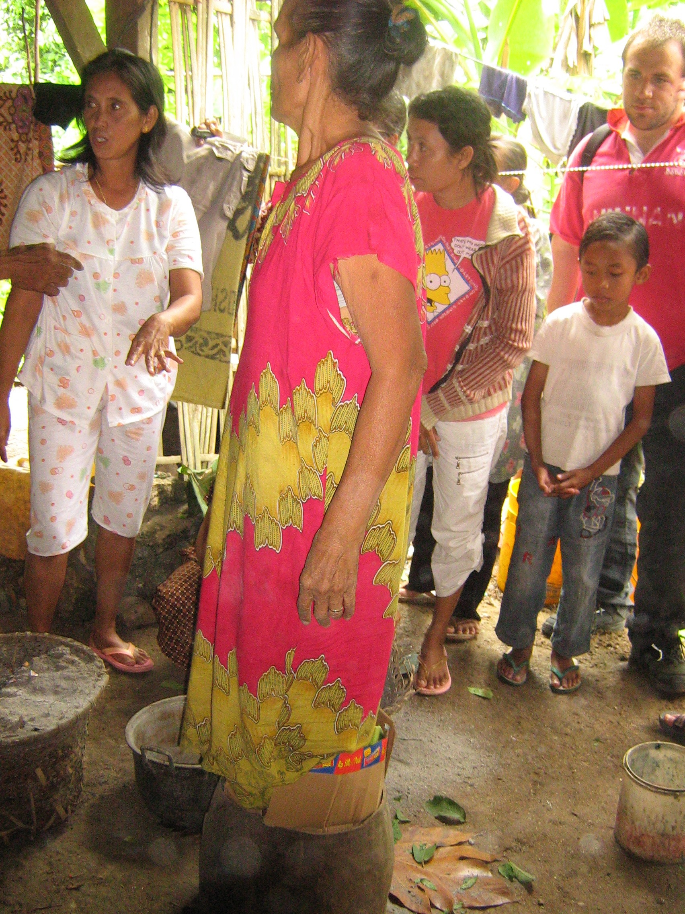
(Above: Women in process of making traditional sarongs and adorable Indonesian boy watching)
Today we also went to different parts of other villages and saw interesting fruits and vegetables, which we got a tasting of such as opa, a vegetable that is fried and sort of tastes like potato
-This is also positive because when the Westerners reflect enjoyment in their food, it not only adds to their cultural pride but this vegetable is very sustainable, because they do not clear land, and can grow with coconuts and is their main carbohydrate, in season
-It is also a very traditional Kaledupan food as it is only is Kaledupa and they ate it before rice
-It is also a vegetable they will eat for breakfast, lunch or dinner
-(This could also be offered to tourists as a sustainable snack, as many of them are not used to eating the rice and fish diet, and are used to their comfort foods such as chocolate and chips, if these are available on the island, they are sourced from the island Bau Bau. Therefore this vegetable can cook what is similar to potato chips and sold as a snack, which would also reduce the amount of packaging created from outsourced food, which adds to the waste on the island)
Ollo village:
-Coconut trying. Watched them do cooking.
-Village trips and Fishermen trips are offered for the volunteers
FORKANI Representative Lecture, Rugi:
-For (Forum), Kani (Memories of Past, bring to the Future) –In poverty, want to initiate change.
-This non-government organization was formed as a way of involving Kaledupan communities in conservation initiatives
-Operation Wallacea works really closely with them and helps them in conservation development
-This was designed as well as the realization to protect their reefs from illegal activities such as fish bombing, or illegal boats from places like Korea
-There is a contact person in all of the 17 villages (which took 3 years to establish)
-This is organized through their, own funding
-Want to base activities on traditional ways
- How to cultivate the area well
- Education and awareness
- Conservation of coral reefs
- Benefits of sustainable development to Kaledupa
Operation Wallacea has educated them about sustainable fisheries. They find this very important not only as a means to protect their environment but because they are thinking about the future and want their grandchildren and future generations to prosper from the environment like those in the past, which poses a threat as the way they are exploiting the resources at current.
-As they have no money, they are trying to motivate people through training
-As the Wakatobi National Park is made up for 4 parts, which are huge and very isolated from each other, this group is only Kaledupan, although they have future plans to include all of the Wakatobi
-They would need a new site and have to figure out a way to bring together all the NGO’s from the other islands
-It would take a long time to work with others especially with the money struggle they are faced with
-Are not working with the government at all, but may be complicated as the government is corrupt
-There are two representatives from the Bajo, which emphasizes a positive step the two communities are taking to work together: one of them is the head of the community and therefore there is a lot of respect for him
-Deals with land conservation issues as well such as maintaining the first source of food in special areas
-There is a women’s group, which is important as from a Western perspective the women are still in a rather ‘oppressed’ society (Although by no means are Operation Wallacea there to change women’s role in society, as it is not their say to tell them what is right, they can make positive changes such as women earning an income through tourism, and reinforcement on some of their cultural activities such as dance and traditional sarong making)
-This group is entitled to help women’s empowerment
-Although the aim of the women’s group is still quite limited in scope as many of them make sarongs individually and the aim is for them to work together
(Operation Wallacea may be able to play a role by encouraging other women’s initiatives)
Rugi thinks that by having Operation Wallacea the money goes to government, then back to the societies in Kaledupa. (Which raises another point, if the UK office keeps ½ the money, and ½ goes to Kaledupa, how much of that is given to the government).
-Rugi thinks when the mangroves are cut down, Forkani step in and socialize all members and introduce them to rules and regulations. Determine why they break the law and how to solve the problem. Therefore act as a mediator.
Traditional Dance:
-The ladies of Kaledupa, came to the outside of our office and shared their culture with us by showing the traditional dance
-At one point one of the Westerner’s got up a joined in after the serious synchronized dance occurred
-Then a couple of the other boys joined in
-This showed the enthusiasm on both ends for showing the culture and the Westerners eager to be involved
-The Westerners seemed very enthusiastic and showed an interest to be involved in traditional dance
-Therefore a recommendation in the future would be to have the Westerners even dress up in costume, and learn to dance in synchronization with them
Sampella and the Bajo Community:
A community built above the sea right off Kaledupa
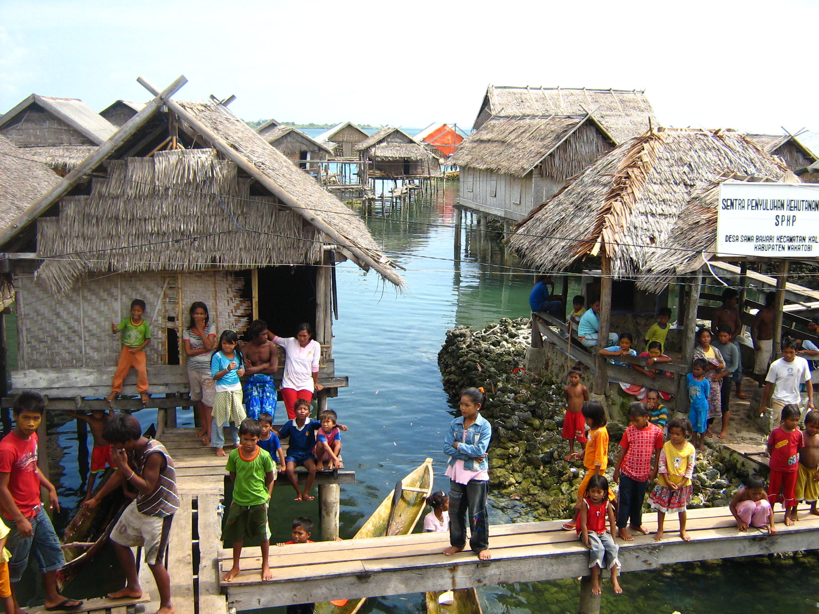
-The area is heavily contaminated as their leakage goes directly into the sea
-The sea is very polluted near them and the children still live in it, which causes for many sicknesses
Reef and inshore fishermen
-The Bajo stressed the marine resources through fishing
-But they fish so much to help feed the Kaledupans who are the consumers, so it’s not completely them to blame
-Exploit the coral reefs
-In the past practiced fish bombing, and now there are regulations although they are more in theory than in practice
-In my time on Hoga being underwater scuba diving for three days, although this is a very limited period of time, I did not hear any bombs in the water.
-Operation Wallacea also plays a large role in stressing local food sources, as they purchase their fish from the Bajo community
-There is an apparent tension about the Bajo community, for Westerners seems to think they are ruining the reefs.
-Although it’s a controversial topic about if the reefs should be for them the Bajo’s lifestyle or have no fishing zones in place for tourist enjoyment
-As of now the Bajo community in particular, the children, are very happy about tourism, although there may be future issues about the no fishing zones. Right now there is not a lot of awareness, and to the Bajo it must look like these zones are for the tourist benefits and it is not understood that it is to protect the reef’s diversity.
The Shaman of Bajo: His Lecture on Traditional Healing:
Various degrees of healing
- When born, There is a spirit with the placenta which goes into the sea and stays there for the rest of your life and can help you become well again
- Ask the octopus for help if first did not work
- To the land and to the sea, land spirits got into someone’s body. Therefore they give something to the land spirit like chicken in hopes that it will go away
- Crocodile with five fingers like a human make sure it does not do anything to pregnant woman or child.
Threat: If traditions get lost.
-Some people are getting lazy about treatment and he is protesting against that and is always open to give treatment to people
-Passed along in traditions, he learned through an apprenticeship with his grandma
-Willing to offer services for tourists. If he will do ceremonies for different kinds of animals so why wouldn’t I for different kinds of people.
-This shaman is also amazing because of the health care discrimination here, as the Bajo have no yellow cards, have to pay lots of money for healthcare as they are still not considered proper citizen and are faced with the corrupt government.
-The Bajo seemed to envy the Western culture, to an extreme I have not seen, they were more excited to see me before they spoke to me or knew my name, then friends that I have not seen in years
-Therefore by showing our interest in the shaman maybe it can help to reinforce the importance of traditional healing, traditional knowledge and continuing these unique ritual practices
-The Shaman is willing to teach his practices to tourists
-Very interesting experience with the children who loved playing with us, giving us high fives, following us and offering us food.
-Provide a chance for the adults to have a bit of a break as they are not really in school, there teacher is from Kaledupa and makes an appearance for a couple of hours a week, therefore many of them are uneducated
(Another initiative Operation Wallacea should consider giving to as well as improvements in infrastructure
-Children canoed us through the village, had to duck down for the bridges
-Walked us through the village as well
(More involvement from the women necessary)
-They were obsessed with the photos, which is positive as of now, but may lead to implications if the Bajo desire the westernized materials. Printing photos and collages may be a nice way of giving back to the community as so much excitement came from looking at a photo.
-Sporting activities with the bamboo ball
-A recommendation would be to help clean up Sampella, as they are literally living above their sewage.
-Bajo home stay
Limitations:
-Illnesses such as pink eye are highly prevalent by the majority of the Bajo community. Tourists may have trouble accommodating to the lifestyle.
Positive:
-The toys that were supplied to the children, although this should have been done in a different manner by the Westerners as they were throwing balloons from a second floor building which caused a riot for the children which is completely unsafe in their village. The children were pushing each other off the bridges into the water, and it was really unsafe and had to be stopped.
-Economic Benefits
-Buy fish from the Bajo
-Tours through the community, which the children are happy to run
-Children are ecstatic to see the Westerners and absolutely love them and play with you the whole time you are in the community
-The adults are also so friendly, you can not go over 10 seconds without saying hello to someone, so you can tell everyone genuinely appreciates your presence
-Lecture with the shaman, who is a way of supplying him money, which is nice as he works for free, and deserves it as he has amazing morals and will help all kinds of people and animals. This was also a cultural experience as it opened our eyes to their religion and beliefs such as their worshipping of sea spirits
-Those who are sick can come and see the doctor on Hoga (in season) if the Shaman didn’t cure them.
Week 2: Hoga Island (Marine Based Activities)
-Its been pretty interesting as when you first look at Hoga, you look at absolutely gorgeous untouched beaches, in a sense it gives you a feel of the movie, “The Beach”, based in Thailand. Originally, if I had just been placed on this island and had not experienced Kaledupa, I think in a sense I would have been just another tourist. I am so thankful that I stayed on Kaledupa first, and now I feel as though I am looking at everyone from a complete outsiders perspective. It seems as though everyone is very ignorant to the culture on this side, and it’s all about “their” reefs. I have not had much time to speculate yet, but so far I have seen a lot of women walking around in skimpy shorts and skirts and tank tops, which is really inappropriate and disrespectful to their culture.
I arrived here on a Wednesday, which is the weekend and day off here so there were drinking based activities going on at night, which I also found to be quite inappropriate. There were heaps of Westerners sitting outside drinking beers and playing rather inappropriate games such as, this orange game, where you hold the orange on your neck and pass it along in a line, which is intended to be funny as rather sexual gestures our made whilst doing so. This is such a bad influence on the Kaledupans who are all sitting around watching this occur, as male/female touching is completely not appropriate. I have also seen a couple holding hands in public, which was also mentioned in the sustainable tourism introduction at the beginning not to do this.
The situation seems as though the arts director is responsible for the rowdy drinking activities that occur on this island, and that creates a bit of tension with the other staff members who appear to have a lot more respect of the culture of the Kaledupans. As she ran the games, and was constantly drinking throughout the night, I could observe the tension among other staff members particularly those doing social research. I would be very curious to see her perspective on everything that occurs here in terms of sustainable tourism.
She does bring an element of fun into the picture and tries to incorporate a level of involvement from the Indonesians. One of the locals appeared to be very happy to get involved in the games, and he was trying to encourage his Indonesian friends. I never noticed any of the women getting involved. Apparently in the past they have done traditional dance for the volunteer staff.
Main source of attraction to Hoga:
-Bar none, the scuba diving and experiencing the marine life and beautiful reefs
-Or for those who want to do research and their dissertation
-This is not a cultural experience as you are mostly associating with Westerners while the Indonesians work for you. That is unless you put in the extra effort to become friends with them
June 6th
Today I became involved in a clean up the beach activity, which I think made a very powerful impact. Many of the Kaledupans are used to littering and putting their rubbish everywhere. Today as we were picking up garbage in the forest, along the beaches and wherever possible, along the way two of the children became involved with us. This is the type of positive benefits I like to see from tourism. Particularily because it is promoting a positive environmental image in young children and getting the message implanted in their brains early about the importance of not littering and acting environmentally responsible.
One thing that I like in comparison to Kaledupa, is the students all seem to be making use of the water cooler rather than buying plastic bottles. (I think this may be because our fresh water on Kaledupa was basically hot). Although there was also options to get water from the home stay you were in, and I don’t think you need to worry about the freshness as in many ways it is probably cleaner than in the Western World. Although it is hard to cover all aspects of how to act sustainable, I think this point is worthy of note, as the plastic just ends up being incinerated on Kaledupa.

Lectures of Stakeholders on Hoga:
The diving instructor Lecture:
Brief Background of her: She has taught diving in the North of Sulawesi, the Red Sea, and the Caribbean, Australia as well as other locations. Therefore, she has quite a holistic approach in terms of how diving impacts the coral reefs.
She sees her job as a Catch 22. As she praises her practices as she teaches people how to dive responsibly, but then sees it negatively as she has now initiated them to receive qualification, which leads to a world of sights they may dive into, which may not encompass eco-friendly practices. She has seen the positive benefits such as in Egypt, the employment benefits, economic benefits and improvements in society such as in schools. On the other hand, she has also seen how no regulation and irresponsible tourists have ruined their corals. One of the solutions she outlined that Egypt came up with to improve operations was to have buoys so it was not necessary for ships to throw anchors. This only led to multiple boats going to the buoys causing a lot of stress to the environment in the surrounding area.
Picture Taking: In order to get a lot of the excellent pictures it involves the divers to grab onto the coral for their security. The flash in also harmful to the animals particularly the tiny ones, which she compared to how the father reacts in Finding Nemo, to the human taking a photo. She does allow her divers to take photos, (a thought would be to have them turn off their flashes, which may not go over as well as they are far from sunlight).
She also touched on her experiences in Thailand, and said how there were loads and loads of dive sites filled with tourists, which were not properly managed and had serious concerns over their long term viability.
She also saw the liveabroads as a concern. How to manage leakage and how as tourists increase leakage was of utmost concern to her.
-Areas are zoned and seemed to be working
-Dive rangers check numbers and make pay a dive tax
-There are dive center meetings so that everyone works together and co-operates
-Dive operators are expected to pick up rubbish
-Informed me about Wakatobi Divers another dive operator at the Wakatobi, although a different area
-Hoga is specifically a research site for Operation Wallacea
-Should a lot of concern about Wakatobi Divers, as they are on a 5-year plan with the government, and after that their business will open up
-The target market for Wakatobi Divers are rich Americans paying over 2 000 USD a week
Manager on Hoga Lecture on Dealing with Home stay Issues:
-Lots of conflict between the landowners
-Tourism is new area of economy from them, so they are going through trials and tribulations and have not yet become fully aware of how the market and economy works
-Since 2003, there is still conflict because some of the landowners do not get accommodation and their home stays are unoccupied
-The number of home stays has increased, which is a probably due to the rise in number of tourists
-Operation Wallacea wants to pay equal pricing for all the houses as the volunteers are paying a pre-paid package but this raises an issue as there is a difference in the quality of the housing in terms of size, facilities, etc.
-Tourism development has occurred in a couple of ways
-Similar to Bali there are price competition issues
- The landlords have to lower the price to meet the needs as Operation Wallacea as they have threatened to leave (Which is a whole other topic of sustainability. If you ask me this makes it seem like what the sweatshops do in third world countries, build a factory, and when they can find a place to pay less for labour, up and leave and have the whole society completely reliant on this as their economy and then left to further suffer from poverty as they have gained this dependence).
-As they are continually trying to raise the price every year but Operation Wallacea is not letting this go over too smoothly
-Although this is community based land so Operation Wallacea does not have control on the price of the land
-System of price: At the moment is equal pricing for the different housing although Operation Wallacea as well as the students are not satisfied with the quality
-Owners that have the high quality houses complain as they are offering them for the same price
-Locals want to establish a pricing system that allows the students to decide if they want to pay more for quality
-Therefore this year, for those who are staying two months and have a long-term commitment can have the option of paying more for the increased quality housing
-There is now an empty building on the island that was previously built at shore, as a Curry restaurant to expand food opportunities as an alternative from tuna and rice
-It was a great entrepreneurial idea, although no one would eat it, as it was not a preferable taste for the Westerners
-Then it was transformed into a disco club with booming music until 3 a.m. in the morning
-This club was in the middle of the community and was not appropriate at all considering the nature of drunken Western behaviour and the disrespect to the Muslim community as well as the noise disturbance on the community and wildlife
Local Landlords Lecture on Home stays and Conflict:
-A rich family from Kaledupa owns a huge chunk of the land on Kaledupa
-When Operation Wallacea was implemented and the number of guests expanded the family always got priority and made the money from the accommodation
-Operation Wallacea as a conservationist company (social side accompanied) tried to break this corrupt system
-The family wanted to get the managers evicted as the land is theirs and they wanted priority
-They would not take social justice as a solution at all
-Now they are on a contract and must stick to their promises
-They do not think of social justice, they just want their own benefits (This seemed to be a theme I noticed with their corrupt government, police, businesses and all other high authority figures in Indonesia who unmorally and unjustly collect money. A theme in Indonesia where the richer get richer, and the poor get poorer)
-Although they are only a minority in the community, they will shout out about any monetary issues in other for them to get the reward, the majority of the community just stays quiet about it, and that’s why they have come further in economic gain, because the Kaledupans do not like to put up a fight and will avoid it
-Nobody in the community wants to sell their land, as they have seen the potential tourism has brought
-Every year meetings are held to find solutions but it always ends up badly
-This has become such a problem, which again is influence of government corruption & bribes playing a big part of their lives
-This manager is not a part of the family and thinks that equal income is of high importance.
Personal Observations about the housing issue:
-From a social standpoint there is quite a controversy, as they have not had the tourism and marketing history and it is a new concept to them. They are failing to understand the basics of business in a sense, which has led to a lot of controversy on Hoga over land issues
-I think having the influence of a government that is inclined to get rich fast, and will not decrease their wages to benefit the community has shaped some of the Kaledupan ideals on Hoga
-The two greedy Indonesians are willing to be the loud ones and cause a fight over it, while the rest of the community who are suffering for their greed are still quiet and avoid confrontation (which has to do with the Kaledupa culture).
The draw to Hoga is the remoteness and literally how far away it is from the ‘real world’ or the ‘Western world’ or whatever one may want to call it
-Therefore it is also very important to keep this development of housing under control to maintain this feeling of being in a deserted place, far from development
-Loosing vegetation for development is compromising the sustainability of the island
-Operation Wallacea should ensure that development that occurs when they are not operating on the island is done so in an environmentally fashionable manner
Lecture by the Local Manager on Hoga Island:
-The Kaledupans who are to be employed need language and organization skills
-Indonesian time is very different from Western time as it is not as scheduled and to the minute, so they must adapt to that for the sake of the tourists.
-July-September work for Op Wall and then usually go back to fishing
-Operation Wallacea has become a job of interest to many of the locals even though they have the potential to make more money while fishing
-Local empowerment
-The locals still hold their own culture even though they may be influenced it hasn’t led to transformation
-Local and Operation Wallacea prefer to work together and share their feelings and give advice with no violence involved.
-The Indonesians were told about the Western world before they started their job with Operation Wallacea
-In future they are interested in hiring more local staff except they still need the link of the Western staff to transport people over to the island
-Aid in language skills, teaching to dive and operate modern equipment is also essential
-Wants to keep Hoga a clean island so that it will not affect tourism in the future
Markets:
-There is one market that is on the direct route from the housing to the dining hall, in which receives most of the benefits from the Westerners particularly as it is easily accessible to buy drinks
-Therefore encouragement to go to other markets should also be made by to the volunteers
-The markets have drinks and very minimal Western snacks, as well as souvenirs that are also very widespread throughout Indonesia, particularly tourist hotspots such as Bali and Jakarta
-Therefore more of a focus on traditional Kaledupan craft should be a focal point as tourists will be more willing to spend money on an item that will be representative or memorable or their stay at their stay at the Wakatobi National Park
-Although some of the tourists may end up needing a new t-shirt, or if they have a long enough stay may buy one of the hammocks, generally they are not going to stock up on tourist supplies that they have to carry around on the long haul journey when they could get the same item at the end of their trip
-Bali also offers very competitive prices and would be able to offer the same souvenirs at an advantaged price
Pollution:
-The coral holes on the island, I came across pollution in, quite a few times
-Although you cannot point a finger at anyone, and for the most part the Westerners on this trip are quite environmentally sensitive, and they may not be able to change some Indonesian’s ways of littering, but throwing garbage in bins can act as a positive role model on them
-The clean up day was very important, not only to show the company cares about the island, but to create a positive influence on these children at such a young age.
Social Issues:
It is obvious that Operation Wallacea brings great economic benefit to this society although it needs to be intact that this causes many social justice issues and the amount of stress that tourists put upon the environment needs to be controlled. Prior to working for Operation Wallacea the local staff were informed about the Western World
Sun-bathing:
Today I also had a chance to have a wander around Kaledupa, seeing many people tanning in very skimpy bikinis. Which is quite horrible considering many of the Kaledupans are embarrassed by this behaviour, some may be curious but for the most part it is quite offensive and not leaving a good impression. It particularly worries me about the youngsters, and I can imagine a lot of the Indonesians are worried about how this is going to influence their daughters and sons. At least they made one beach that is more isolated where this form of sun bathing can occur. As this is a tourism business and there are going to be people who rebel. Most of the participants are here for the purpose of research but some still revel the sun, sea, sand destination so they are trying to accommodate both peoples needs. I still do not think this is appropriate, as the Westerners are treating the island as if it is equally theirs. There are so many places they can travel to afterwards in Indonesia where sun bathing is now appropriate because of the high volume of tourists. I think they should have the decency to swim in their clothes to prevent problems with the locals if this is a necessity for them. Once again it seems as though it is Operation Wallacea’s duty to warn the Westerners about their dress prior to coming to the island and again at the Welcome talk, but after this, they do not seem to regulate or enforce it and the volunteers do not seem to abide. This sunbathing zone is used as a compromise because there is less access to the locals.
Consumption of Alcohol:
-Beer is sold at the bar, although many of the students go elsewhere with it, particularly the beach that is not appropriate
-The Muslim community does not drink and if they ever were to, it would be in the privacy of their own home and not in a public area
-Once the alcohol is consumed they may also witness very inappropriate behaviours as there are such huge differences between the Western and local Indonesian cultures
-Bottles were always brought back and not left on the beach
-Hoga Island in comparison to the village, was less strict with the volunteers as they seem to dominate the island and everything is based upon them
-Therefore the Indonesian are okay with the alcohol consumption within reason
-The welcome meeting says you are only allowed a few, but I never saw any staff members try to limit individual consumption thereafter
-The drunkenness seems to be in control by the tourists, although they are going far beyond the two they are supposed to, and remaining out at late hours. This is disrespectful to the surrounding community. Especially because you can hear everything through thin wooden housing
-Borat on television at the bar, which the Indonesian men love, is an example of how Western culture is introducing negative mannerisms into their culture
Diet:
-Staff playing a role in trying to change the menus to appeal to the diet
-Instead of eating a traditional meal, breadcrumbs were introduced and the staff member asked the audience to applaud if they like it
-On American Independence day fish burgers and fries were made
-Although cuisine should be more traditional, you could metaphorically look at it as the blending of cultures
-The managers seemed to be more liberal Muslims and were not as personally affected by tourist’s behaviour that was very disruptive to others. They took part in drinking alcohol.
Dress:
-On Kaledupa the supervisor’s would say something if a man or woman was dressed inappropriately and showing too much skin
-Dress has not been abided by, and staff and volunteers were constantly exposing body parts such as the knees and shoulders.
-The dress is more lenient on Hoga, because Westerners dominate it, but by no means does that make it a sound reason.
Relationships:
-The men there have to be careful not to get involved with Western women as it may lead to trouble
-For if a girl makes any accusations afterwards they could loose their jobs
-The Indonesian men have trouble tolerating their alcohol, so they must be mindful to this.
-They also become attached to these women and have high unrealistic hopes of seeing them again
Diving:
My time will be spent obviously looking at the reefs and the diversity around it, but will be paying particular attention to how the tourists behave on these reefs.
I am ecstatic about going scuba diving. Originally I was just snorkelling and at that time felt as though I was not a disturbance at all. I did not go near the reefs and was always alone or in a tiny group and would swim rather then take a boat to the reefs. I took a boat one time when I went with the scuba divers and snorkelled when I was originally doing coral reef ecology. As much as I try to ‘leave no trace’, mistakes are bound to happen with tourists, whether or not it was our intentions. We do affect the environment such as when I lost my shoe in the water, but when searching for it alongside the beach afterwards, I had no such luck to find it, but did pick up other pollution. One of the girls picked up rubbish whilst on her dive, which I would like to do as well. Although given my experience and monitoring, I don’t think that I will have the ability or freedom to do so. There was lots of dead coral everywhere. It seems as though the only live coral is where the no fishing zone is. Which I will not be granted access to as my diving experience is very limited.
-Diving has given the opportunity to have staff working to rent out the equipment as well as clean equipment, re-fill tanks, etc.
-There are also three Indonesians who are dive masters and plan on completing the course to become instructors
-Dive instructors inform divers to act as environmentally responsible as possible, about not making any physical contact with the reefs and wildlife
-If for some reason they do have to touch the coral there is the one hand rule to be put onto dead reef
-You are also instructed on how to take control or your weights and it is stressed how important it is not to drop them (Although in an emergency the volunteer would come before the coral)
-In the dives I did, did not take divers under the over hang (Limited as we were beginner divers)
-Important as the divers bubbles really affect the atmosphere and the coral when underneath it
-After scuba gear is used it must be cleansed with fresh water.
-In order to conserve water there is a bath of water that all the dive equipment is put into
-Although this may affect the quality of care they are putting into cleaning the equipment
-And a lot of water is still required for this cleaning
-Open water divers are learning on a platform, which did damage when it was placed in there, but helps to prevent further damage from inexperienced divers ruining coral
-A rule may be that only experienced divers should be able to dive here. As with other companies open water divers usually learn in a swimming pool or at least begin there and not particularly don’t start off in marine protected areas
-As from my observations with the beginner divers and myself was remaining buoyant was hard, but came along easier with practice.
-A few circumstances were witnessed of the divers hitting the ground
-No picture taking was involved, but that is because it is not allowed when you are still in the process of becoming certified
-I did not seeing any tourists touching the coral
-Did not take us to the hangovers, but again this is because we were beginners
-If sediment falls from tourist activities coral cannot get direct access to sunlight
-Rope for the beginner divers to get back to surface with is tied around a balmy (does a miniscule amount of damage) (Although everything adds up)
-The research gathered from the divers can help reefs in other areas such as coral bleaching, changes in water, cutting mangroves, etc.
-The environmental damage derived from diving is an issue although it is a catch 22 because the research that they are producing from what they determine from diving can be very important
-On one hand it abusing something wonderful, although science could argue that you are diving to get data, transects, fish counts, etc.
-And the diver program is being offered to teach the volunteers in order to collect this data
-Pretty hopeful to say that the number of papers and what is learn should outweigh the damage done on the corals
- To my knowledge they were not using dynamite in the areas anymore (My journal articles may have been outdated as they made it seem to be a huge problem at the Wakatobi National park. Although it may be other areas of the marine park that outsiders from areas such as Singapore, Philippines and Taiwan come to exploit the resources)
Contingency Plan:
-One of the members had stepped on a stingray, and there was a whole scare over this circumstance
-The helicopter failed to arrive, which questions the safety of the site in emergency situations, so the male was transported by boat
-Fortunately he had a very lucky case and wasn’t poisoned and turned out to be completely fine, but in a true emergency, there would not be enough time to get to a hospital
-Therefore, the staff needed a few days to figure everything out and we were not allowed to go in the water at all in this time
-Which was why I found it quite ridiculous that there was no contingency plan, as we are paying a lot of money for this volunteer work
-For me, this was a time to do the theory part of my Open Water Dive certification as well as my research
-For many others, this was a time to catch up on their research
-For those who were here just to dive, they weren’t left with many options
-There was only one arts and crafts class that would only have been appealing to a niche market of volunteers
-More on land physical and cultural activities should have been initiated that involved the local staff (more economic benefits) such as Tacro Ball – their sport that is pretty much a mix of soccer and volleyball
- Hoga had a camp like atmosphere to it so activities that operate at camp that would be fun for an older crowd would be appropriate
-It’s understandable that the staff, were extremely busy at this time, which is more the reason to let the local staff play a role
-Most Westerners became bored and wanted technology at this point.
-They are not accustomed to the Indonesians cultural games and therefore this would have been a great time to introduce them
‘Bottom-up’ small scale activities-canoe races, play with children day
-Local control of resources
(More widespread economic and social participation)
Climate Change and Coral:
This was an optional lecture held after dinner one evening that quite a lot of people attended. All of the seats in your average sized classroom were filled
-Light, photosynthesis, mangroves
-At the ‘front line’ of climate change
-Increased CO2, raises of Co2 in atmosphere, almost doubling from what we have now 80-90 years from now
-Seawater tries to absorb it and the PH levels go down
-Sea level change: macro Algae and coral affected
(In some respects, coral could stay the same, but this is limited as they are tank experiments)
-Small changes are a good thing! Have taken these hits in the past. The worry is sporadic events such as El Nino (how warmer things are relative to It’s normal state)
Disclaimer 1 “When corals are healthy but appear bleached” –Coral card not effective
Disclaimer 2 “Some genetic types are going to take over the coral world”
-Rise in temperature also increases the metabolism of ‘disease inducing’ microbes
-Temperature goes up – Mucus production down – Bacterial community replacement
-Increase sediment (land run-off)
-Reefs in 100 years time? Only through appropriate management
Last Night:
-The local staff went to Kaledupa and bought nice fish such as shrimps, which was a refreshing break from our everyday tuna dish. They also bought chicken which they only have on special occasions and invited the other Westerners that were departing and I for a barbeque on the beach. Their generosity and kindness is just unbelievable. It is so amazing to see people with so little give so much, as in our greedy society it comes to the point where you are splitting cheques for a cup of coffee. I just found it so beautiful and they were doing all the prep and wouldn’t let others help and barely took any for themselves.
-Not only were they amazing hosts and showed me a different side of their culture then on Kaledupa. They also shared an experience with me that in my mind took the beauty and the art of giving to a whole new level.
Hoga Observations:
-Where food was conserved the lizards were eating it and getting very overweight
-Some Westernized food incorporated such as porridge and toast
-Rice was in all meals, and mostly tuna and eggs
-Local food, and small portions
-Fish was bought from the Bajo community (which helped to get them more involved)
-Mandy (bucket showers)
-Squat toilets, which used seawater
-Toilet paper was put into the bin
-Interesting modification to meet both needs (Sit down toilets, but still squat toilet style)
-Locals do not seem to be as friendly and not as many friendships here
-The only friendships that seem to occur are with the Indonesian men, and it’s not very positive as they are exchanging inappropriate sayings in each other’s languages and drinking beers together
-The Westerners, staff included, are not bothered to try to speak the language
-Hoga is much more isolated from the Indonesian culture.
-They are in an environmental bubble, similar to a resort without the luxury
-Whereas Kaledupa you feel as though you are in a different country and culture, which made it a lot more enjoyable (This seemed applicable to the other 3 students who switched over with me to Hoga)
-Burning garbage alongside the beach which takes away from aesthetic appeal
-Landlords on Hoga cannot do home stays on Kaledupa so there is not a disproportionate share of the tourism revenue going to one family/person
-Although a friend of mine realized a man renting homes on both islands, I don’t know the result but it may mean job loss for him or a more even dispersion of economic benefits to the community by offering the job to someone else
-There is a donation part where Western staff can give clothes, medicine, and whatever they would deem helpful to the local community, which the community is so grateful for
Departure:
-No briefing
-Although it was mentioned in the opening announcements to take plastic back to an area with recycling when I was leaving it was not mentioned again
-As there is a strong chance that some of the volunteers did not pay attention or forgot about that part of the speech
-It cannot hurt to re-emphasize the importance of recycling and leaving no trace behind
-After the trip they didn’t just leave us to make our way back to Bali or Jakarta, they continued their service
-We had a hilarious Indonesian guide take us on our huge boat trip back to our hotel in Makassar
-The next morning we were picked up by an Indonesian to drop us off to the airport
Summing up Benefits & Barriers to Operation Wallacea’s Existence on Kaledupa and Hoga:
Local Empowerment:
-Find ways of facilitating local empowerment of both the men and the women
-The concept of empowerment can draw out and lead to positive and negative impacts of eco-tourism on the locals
-Can provide them with a sense of pride and awareness of the importance of their natural resources and control over their own development
-Particularly the importance of their reefs and marine life
Positive Activities Contributing to Sustainability:
-Potential for promoting equitable forms of development
Social Standpoint:
- Co operation between dive centres is very positive
- Jo who is the Western head of social sciences on Kaledupa remains as uninvolved as possible, so the Kaledupans do not rely on her and can continue tourism when she leaves and they are coming a long way
- Positive synergistic relationship between tourists, local communities and environment
- Operation Wallacea assists in gaining respect within the community and helping to improve self-esteem
- Communication links are being improved such as Operation Wallacea raising awareness on the Kaledupa radio about their mission
- Doctor on Hoga helps locals, as they are not seen as citizens to local government and end up having to pay even though they have the yellow card that entitles them to health care
Economical Standpoint:
- Arrangements by a local tour operator, Losari Tours, although that money is not associated with the Wakatobi National Park
- Drivers and helpers at Makassar (Stopover area in between flights)
- Local Hotels along the journey
- Supporting local ships (although the environmental quality of them may be questionable).
- Differentiating their economy
- Providing jobs
- Paying local Indonesian staff an income that lasts the whole year, in case they are unable to find work in the 9 months that Operation Wallacea does not operate
- Westerners supporting the markets at both Kaledupa and Hoga
Environmental Standpoint:
- Going out of the Western comfort zone and adjusting to squat toilets, which is far more efficient in terms of Water consumption
- Having a “mandy”, which is the Kaledupan (and other Indonesian) form of shower, which involves dumping a cup of water over your head. Water resources are particularly strict on Hoga, as there is no well and it comes from Kaledupa, so the aim is to use 1 litre of water for a shower. In Kaledupa the tourists are doing a home stay and therefore have to be mindful and respectful to the families’ water supplies. Major reductions in water supply when comparing to water consumption patterns in the Western countries.
- The ships have many people crammed together, rather than having Operation Wallacea researchers separately transported on their own ship, they effectively use a more public form of transport. The ships squat toilet has a complete hole so that human waste is going directly into the water, as it is spread out over a long distance this is more environmentally friendly then western boats that dump waste in one area making it heavily concentrated, alongside the amount of water they consume, so westerners can have comfort when using the toilet and the option of showering in the boat. (The engines are rather old and you can see black steam and smell the fumes, so the environmental quality is questionable in that regards)
Implications and Negative Aspects of Operation Wallacea that take away from Sustainability:
Transportation: A business cannot be truly sustainable if you are flying to get there. Especially considering the volunteers are based in America, Canada and UK and therefore are travelling long distances to get to the site, and in this are doing way more harm to the environment then they are contributing to a contribution project. (See solutions for ideas of minimizing this impact)
Cameras: The kids are overly excited about the Westerners taking their pictures. It seems very innocent and fun but in turn may create the need for them, and they may end up begging their parents, in which this society is not wealthy enough to buy digital cameras or even regular cameras.
Economic Distribution: The homestay in which are the richest houses in the village.
The women in the homestay are the ones who do the laundry (This would be a great opportunity to spread the money around)
-It may be small but it is significant as they are some of the poorest areas in Indonesia
Leakage: -½ of the money earned from Operation Wallacea goes to Western staff
-When a volunteer does not bring the money for the supplies they buy and end up using the credit card machine, this money does not come back to the Indonesian staff
-Leakage to other parts of Indonesia (This occurs because they are trying to appeal to the Western diet and buying things such as jam, which is not locally produced from Bau Bau. Therefore it has to be shipped in from other areas such as Bau Bau)
Environmental:
-Plastic is incinerated, but it is a better solution than filling land
-Although more of an effort should be made to encourage people to use the fresh water offered for free on site, rather than continuing to buy plastic water bottles.
-They also should squish them together and carry it back with them to an area where recycling is offered
-Waste disposal could be improved
-Water consumption is requested to be no more than 1 litre per person for a shower, but the Westerners seemed to get greedy on the amount of buckets they used
Socio-Environmental:
It is imperative that the staff leads by example to the local and tourists, and I witnessed the opposite as I saw her pass a cigarette to another staff member, and asked him to throw it in the ocean. Although the Indonesians litter heaps, the Western tourists should act as they would in their own country, if not to the next level. This not only is hypocritical to the basis of conservation research and sets a bad example on everyone; it could also lead to potential problems. Seeing the staff act in such a manner only makes it seem just for the volunteers to do so as well. This becomes a safety issue as all the houses are built out of bamboo and will easily go up in flames.
Social/Economic Initiative: Project Ebo
A lot for a very little person
-Organized by students and staff from Sampella, Ebo is perhaps 3 years old, although it’s hard for the Bajo to be entirely sure, as they don’t have very much concept of age. -His father has left the family and his mother has to deal with many children on her own, with the kindness of her neighbours.
-He has a growth on his face that blocks him from seeing
-He spends most of his day sleeping at home or sometimes alongside the other children who are playing. As they all stare and don’t understand what’s on his face and don’t accept him
-Operation Wallacea is raising money towards helping him, as they do not have the kind of money to give him an operation in his family (as the family has resigned to his short life)
-Raising several million rupiah to help him out

Cultural:
-Certain culturally responsible tourists may not ravel to a destination that represses women
-May feel inferior as they do not have much say in the direction of the development
If not sustainable, is Operation Wallacea Responsible?
-Responsible travel to natural areas conserves the environment and sustains well being of local people
-It is inevitable that the intro of tourists to areas previously seldom visited by outsiders will place new demands upon environment associated with new characters, new activities and new facilities
-Forging of new relationships between people with different lifestyles and between a wide variety of sources for change and stability
-Scales: global to local
-Generates jobs, stimulates income, diversify economy and enhance standards of living
-Alleviates poverty
-Acts as a process, not a means to an end
-Not just economic but encompasses socio-cultural and environmental standpoints
-Does not prohibit well being of other activities and processes (Except for where the no fishing zones are in place but that is for the betterment of their environment)
-Sustainable tomorrow for a growing population
However, even footprints leave a mark
-Everyone makes mistakes and as much as they try cannot be completely environmentally or culturally sound
-Kaledupa is hopefully being led to a community led management approach to resource management. That hopefully will allow the Indonesians to eventually complete run the tourism operations. For now they are still in need of the Westerners to commute the tourists to their location and to help build necessary skills such as English.
Potential Solutions as well as Innovative Ideas:
- Zoning: Although zoning is in place, it only seems to be on paper and is not regulated. The rangers are unable to monitor the reefs, as they cannot afford to pay for gasoline for their boats. In this case, a stronger reliance on traditional ways of boating may be a solution. There is one no fishing zone area, but more awareness should be raised that it is for conservation reasons, and not just so the tourists can see more diversity. There is also still heavily use of resources around it, as fishing and farming dominates their economy.
- Carbon Off-setting:
Those who are going to travel to a destination should look into carbon off-setting which can be easily purchased on the internet as well as carbon calculators to determine the distance you travelled and how much you should give back to the community. Operation Wallacea is in many ways a sustainable, or more appropriately a responsible tourism operation and are a lot more proactive about conservation issues then many other tourism operations. The Operation itself is sustainable, and one of the many setbacks to considering it sustainable tourism is the tourist who does not offset their flights, which is not up to the company. Although they could play a strong role in promote this to their customers. They should advertise on the website and their emails to the volunteers about considering giving to carbon offsetting. Or better yet this should be included in the cost, as it is already quite a pricey journey, and most that are involved are either quite wealthy or have been funded for a lot of their journey, and an extra $20-50 to give back to the environment will not heavily effect their financial situation. Operation Wallacea could take this to the next level and their carbon off-set could go directly to environmental initiatives directly into the Kaledupan community such as working towards the reefs, as there has been a lot of research showing carbon levels in the reefs on Indonesia.
- Cultural Ideas:
-Handicraft shops such as the sarong making
-Cooking courses such as taking people to catch the fish traditionally and learn how to cook a Kaledupan fish (this would be a great way of interpreting more of their culture)
-Dance Class
-Natural healing lessons from the Shaman
-Contingency plan, which includes Cultural games.
- Economic Distribution:
The home stays already generate a lot of income also happen to be the people who do the Westerners laundry, which should be distributed to other villages. Although this may seem small, it is significant as this is one of the poorest neighbourhoods in Indonesia. The neighbourhoods in which Operation Wallacea does the homestays with should also rotate and more emphasis should be on those who are more economically disadvantaged.

- Leakage: When Westerners do not bring a sufficient amount of money to pay for their bills for Internet, scuba dive gear, etc. the company allows them to use their credit card, which then means the money goes to Western staff and not back into the community. Therefore, Western Staff should carry extra money with them to compensate for the volunteer, so they can give the sufficient amount back to the community and not the investment source.
- In comparison to the cost of living in Indonesia to that of the UK, it makes sense the uneven distribution of wealth between the local and Western staff, although this should be made well aware to the tourists.
- More of an effort by the Western staff and volunteers should be made to adapt to local foods. Although Westerners seem to have a heavy reliance on their ‘comfort foods’, they can indulge in local snacks, which are also enjoyable such as fried banana.
- Community development projects: To further spread the sustainable benefits and help out the environment. Operation Wallacea needs to continue to innovate and come up with projects to help out the villages
- Carrying Capacity: When I was doing my research there was a decent amount of people, although the numbers pick up later in the summer and it sounds like it gets pretty crowded on Hoga, so determining carrying capacity is important
- Old Mosque: This is the first Muslim mosque built on Kaledupa and is of great cultural importance to the island’s population. This could be a potential tourist attraction although the tourists would have to be very sensitive to not invade at times of prayer. And may raise issues with regards to exploiting the local culture. If an entrance fee were charged it would be a way of raising money to restore the site.
- Bat Caves could be another activity for those who are in the village although the habitat could be easily disturbed.
- Waste:
Plastic is incinerated, which is better than filling land, but this problem could be avoided in the first place. Rather than selling new water bottles to the students, they should recycle their plastic bottles with the fresh drinking water that is available on site. There also could be Nalgene bottles sold in case a water bottle is lost. I noticed this in particular on Kaledupa, and I think it was in part by the really warm fresh water that was supplied. Tourists should carry whatever they can back away from the island to be recycled, particularly items such as batteries.
Conclusion: Operation Wallacea has been operating for 11 years, and so far still remains very positive particularly from a socio-economical standpoint
-It may need long-term results to evaluate benefits/consequences such as the Western lifestyle juxtaposed with the Muslim religion
-In future, could be more locally run, although at present they still need Western staff’s link to get the people over to the island, and more conservation knowledge would also deem to be useful
-Quite a few of them have picked up on English very well, but still needs to be practiced, particularly if they were ever to run tourism on their own and they would have to know how to manage modern equipment
-Need to maintain the undeveloped, pristine environment in order to continue tourism in the future
-If Operation Wallacea never came to this site, there’s a good chance that it would not have been developed, or uncontrolled dive sites may have occurred, if Operation Wallacea didn’t provide the research that it should be protected
-The last thing Kaledupa needs is to become an example of another failed society from not properly managing tourism operations
-This research-based tourism was a great experience in getting to know an unfamiliar part of the world, see people for who they are and help to break down barriers between cultures.
-Can’t let this destination go through the boom and bust cycle must keep the beaches clean, protect reefs, and ensure there is an on-going friendly relationship with the locals
-One of the biggest potential threats to Operation Wallacea in the future is the airport that is being built at Wanchi. Although it will help the long and tedious boat journey, it may lead to implications on Kaledupa. The development of the beautiful beaches may take place at an unmanageable pace. Similar to what happened in Munado in North Sulawesi.
-Everyone will want to make money off this, and the cultural and environmental element of Kaledupa may be damaged.

